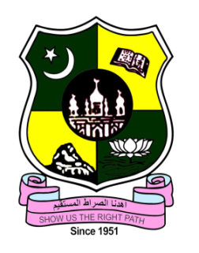
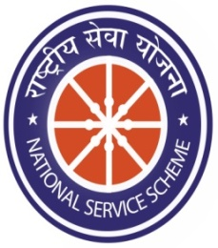
JAMAL MOHAMED COLLEGE (AUTONOMOUS)

College with Potential for Excellence

Accredited (3rd Cycle) with ‘A’ Grade by NAAC

DBT Star Scheme & DST – FIST Funded

(Affiliated to Bharathidasan University)

TIRUCHIRAPPALLI-20

NATIONAL SERVICE SCHEME
REGULAR ACTIVITIES FOR ACADEMIC YEAR (2022-2023)

TNSPC Coaching

On the Date of 01/04/2022, TNPSC Coaching was conducted by Jamal Mohamed College in NBAG Auditorium. In this Program, Thiru. NANDHAKUMAR IRS delivered his valuable speech about getting Govt. Jobs and getting Passed out in Civil Service Examinations.

Number of NSS Volunteers Participated: 12 Date: 01/04/2022

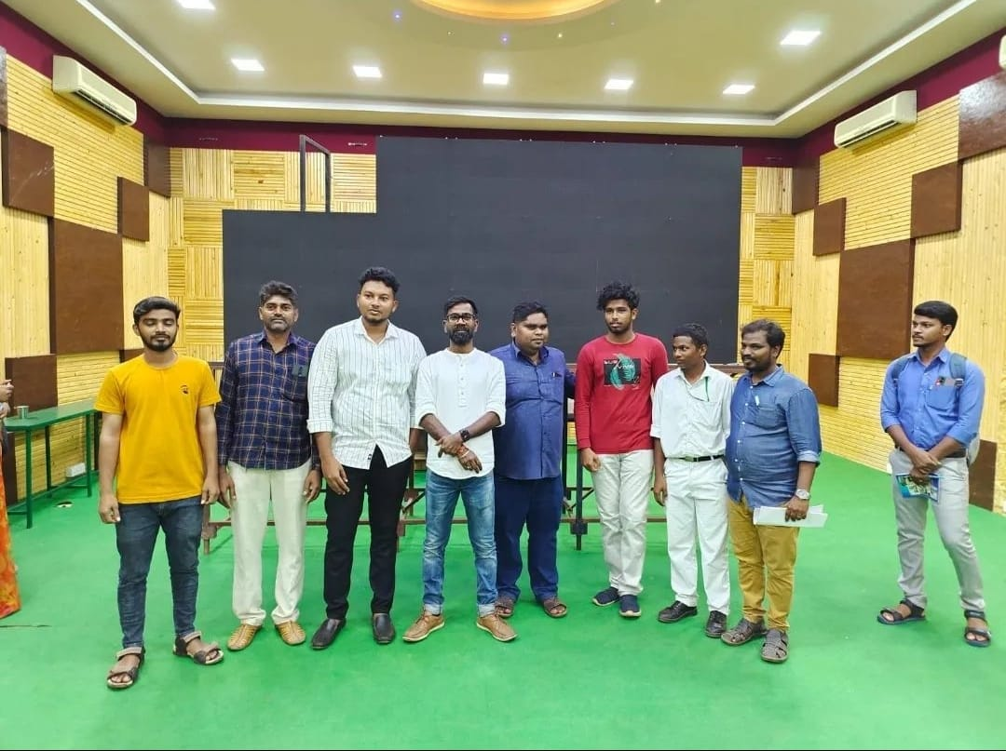
No Parking Awareness Program

On the Date of 05/04/2022 – 07/04/2022, No Parking Awareness Program was conducted in outside of College Campus. In this program, Our Volunteers instructed the stangers not to park in the No Parking Area and the program was completed in a good manner

Number of NSS Volunteers Participated: 10 Date: 07/04/2022
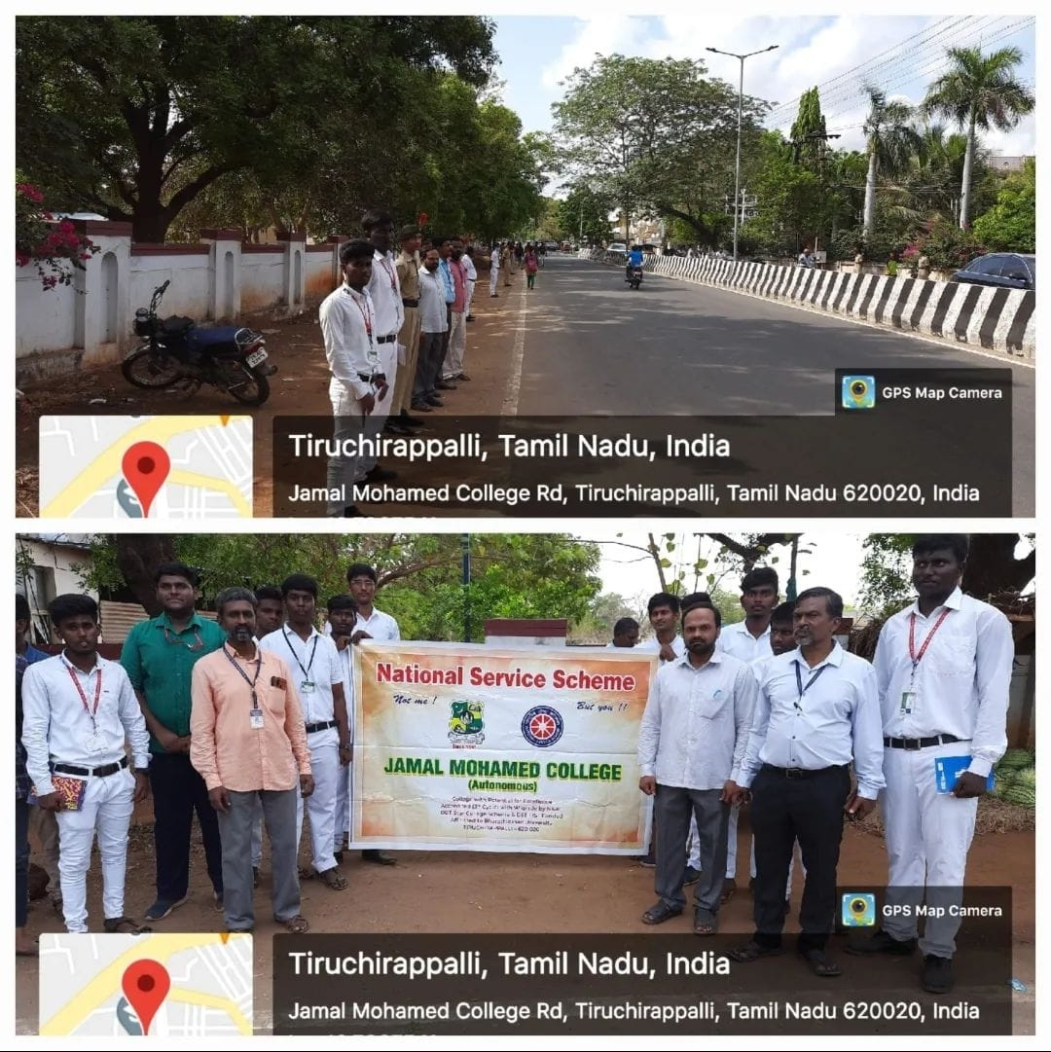
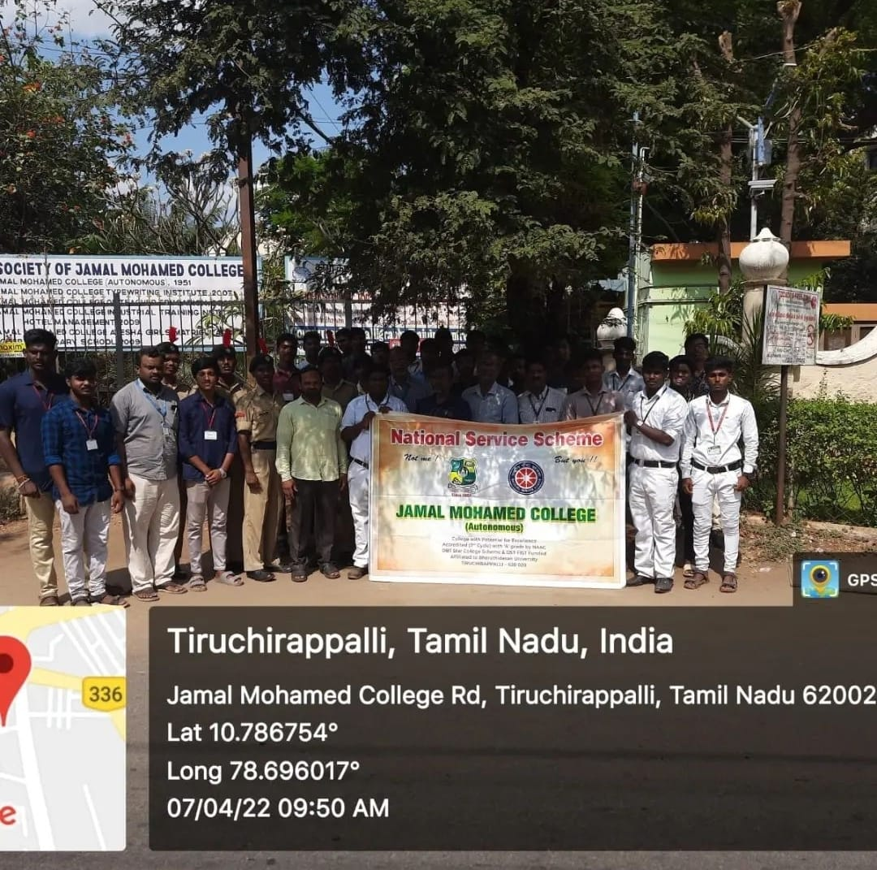

VOLS-SPL

On the Date of 22/04/2022, VOLS-SPL was organized by NSS Cell of Bishop Heber College. It was a state level inter collegiate competition. Our NSS Volunteers Bagged 5 prices in the events like Quiz, Documentary, Marching Band, Variety and Street play. The program was completed in a good manner with the instruction of NSS Seniors.

Number of NSS Volunteers Participated: 20 Date: 22/04/2022

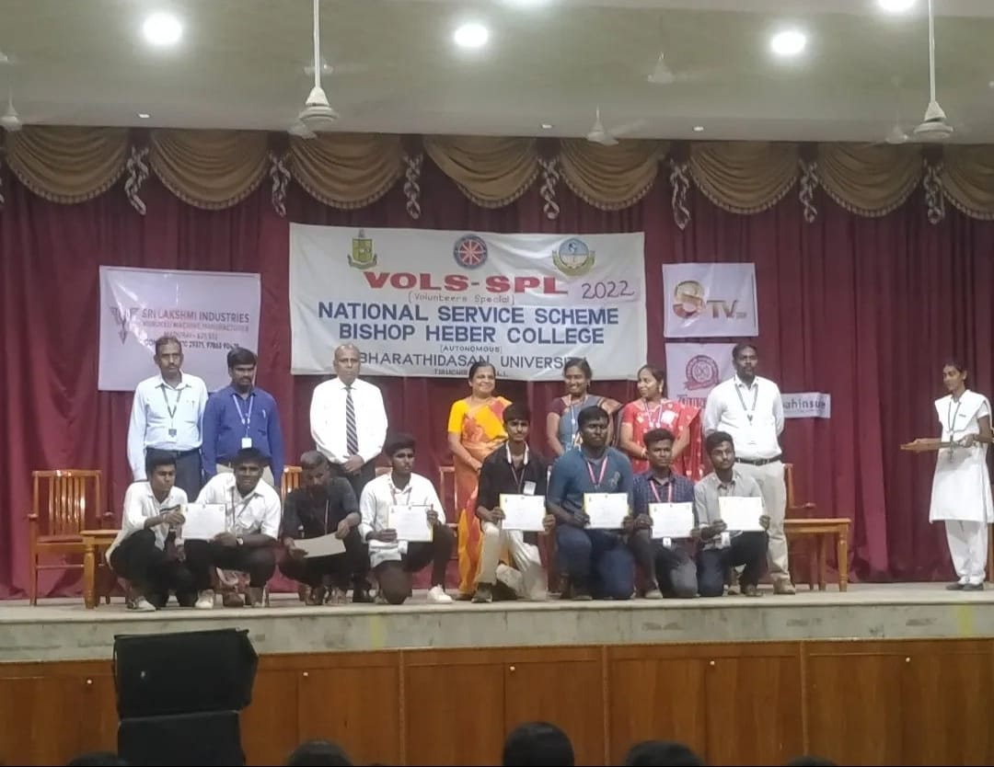
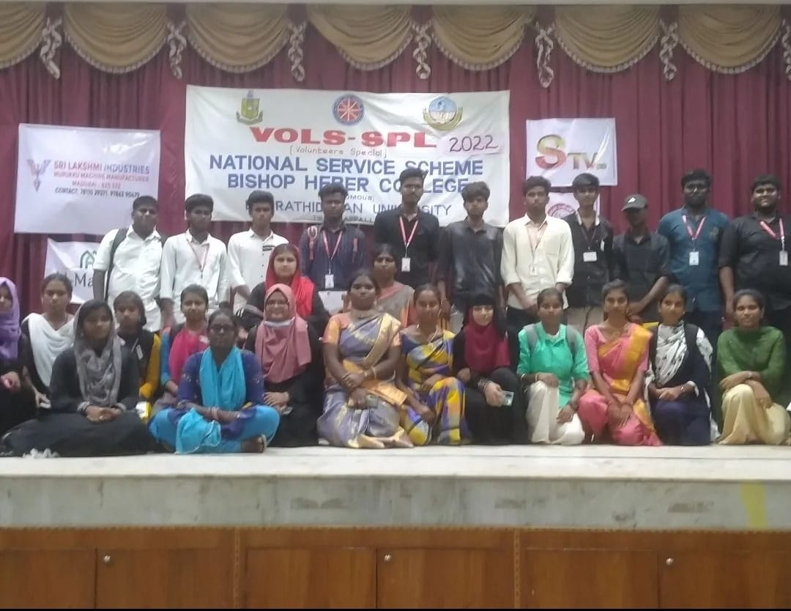

UGC Visit

On the Date of 21/05/2022, UGC Autonomous Body Council visited our Jamal Mohamed College Campus. In this program our volunteers and NCC Cadets welcomed the Chief Guests in a best manner. They Visited our College Campus and checked the facilities available in our College. Also, they saw the part – V activities. Our NSS Team displayed our Activities and Acheivements in front of the dignitaries. The Program was completed in a good manner.

Number of NSS Volunteers Participated: 30 Date: 21/05/2022
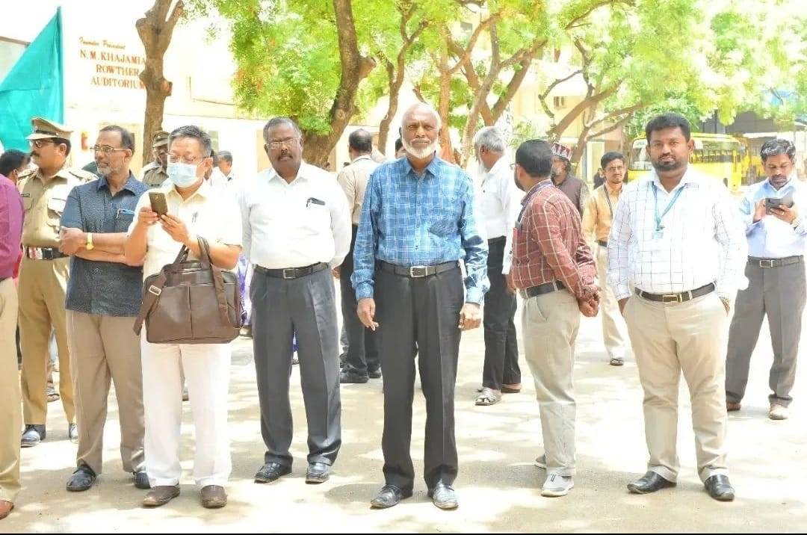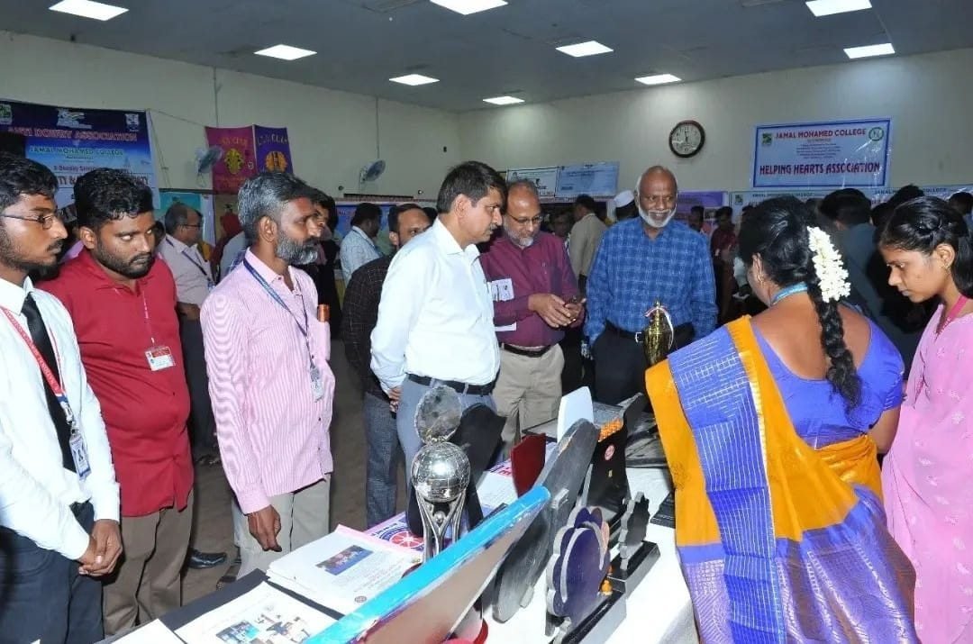
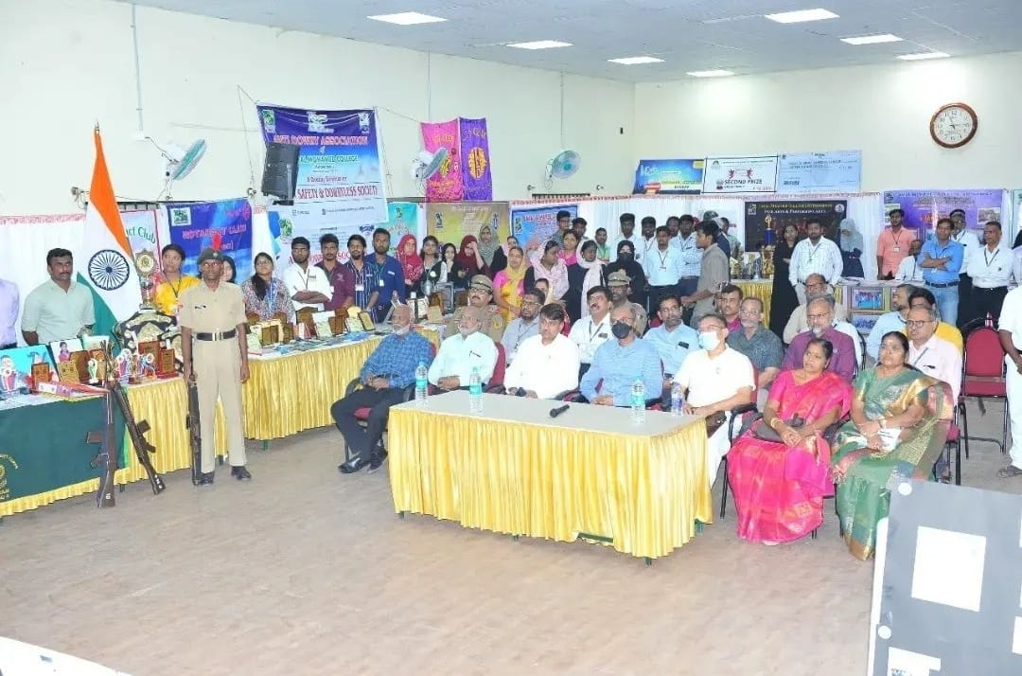

Milad-un-Nabi Festival

On the Date of 27/05/2022, Milad-un-Nabi Festival was organized by National Service Scheme of Jamal Mohamed College in NBAG Auditorium. Before this Program, Our NSS Volunteers distributed Sweets to Students and Staffs of All Departments. In this Program, Our Principal, Secretary and Correspondent, Joint Secretary, Treasurer and Vice Principal felicitated the program Distributed Prizes to the Winners of Moral Education and Deeniyath Education Exam. Our NSS Volunteers Provided refreshment to the Faculty Members. The Program was completed in a good manner.

Number of NSS Volunteers Participated: 30 Date: 27/05/2022

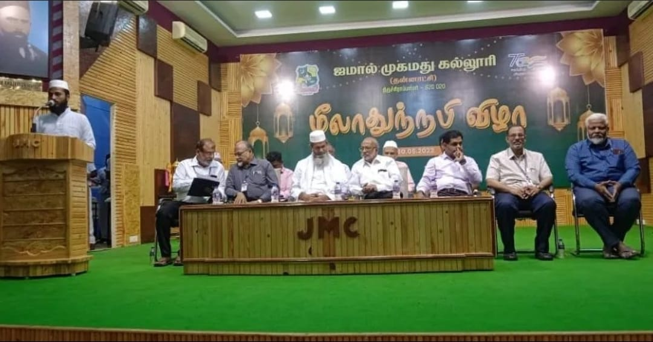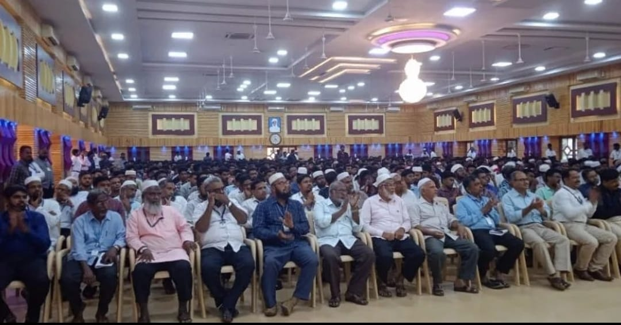
Mega Cleaning Program

On the date of 03/06/2022, “Mega Cleaning Program” was conducted by Tiruchirappalli City Corporation. Our NSS volunteers participated in the program massively and cleaned more than 7 places on Roadsides of Subramaniyapuram to Airport. The program was completed in a good manner with the instruction of NSS leaders and NSS officers.

Number of NSS Volunteers Participated: 125 Date: 03/06/2022
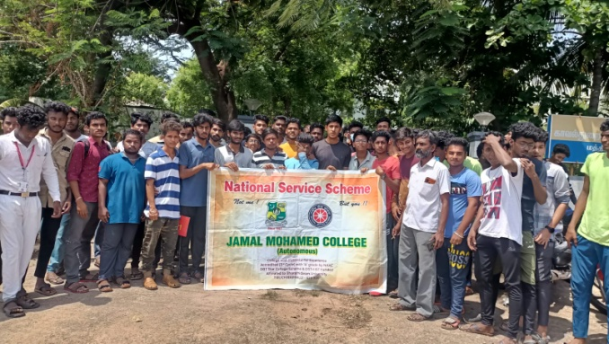 | 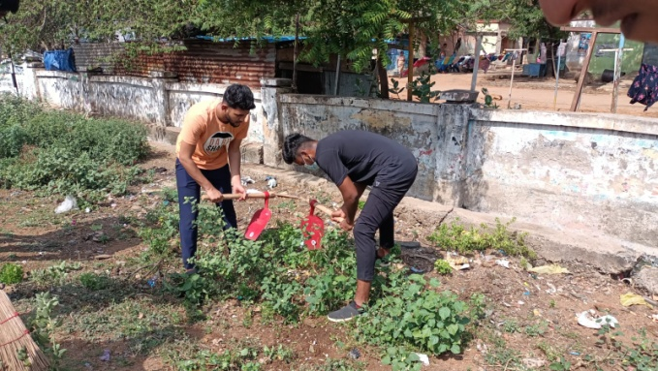
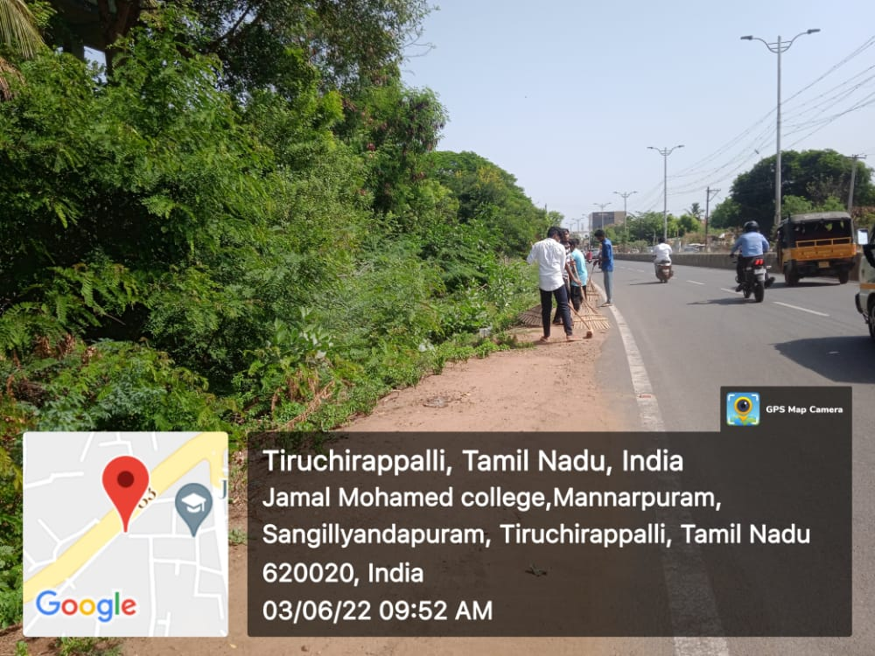 | 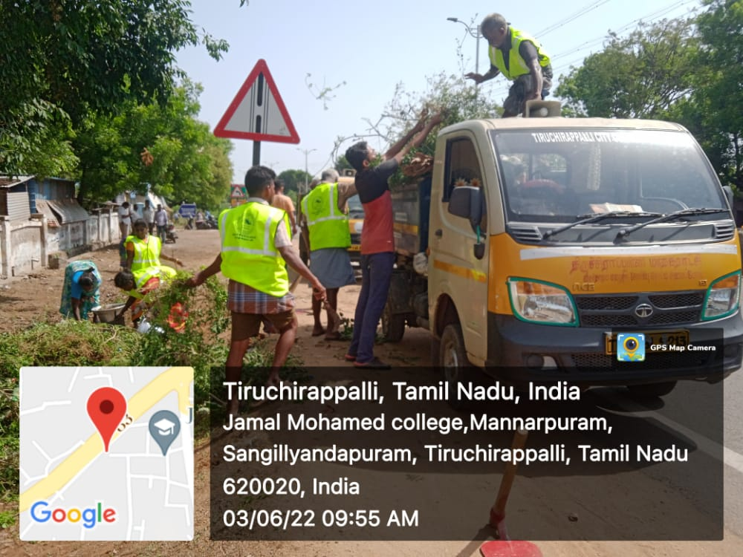
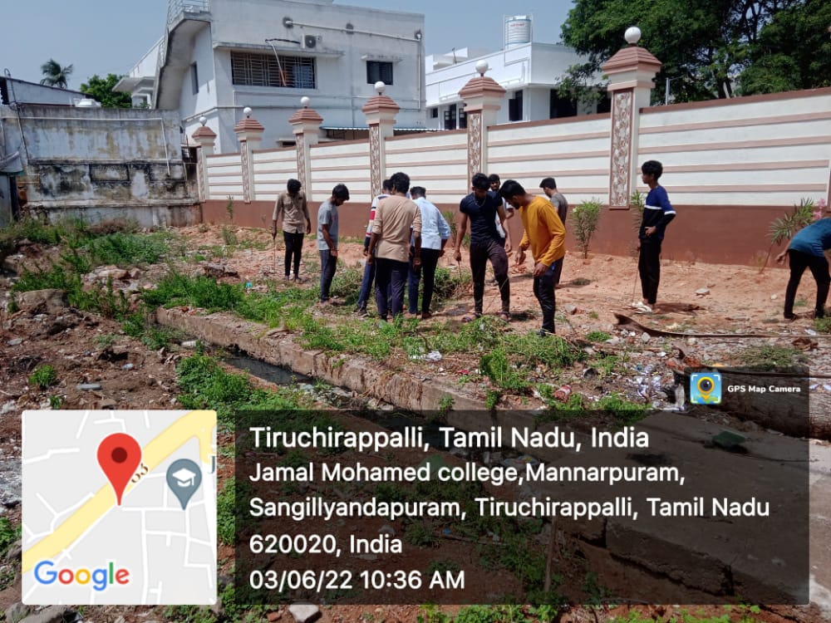 | 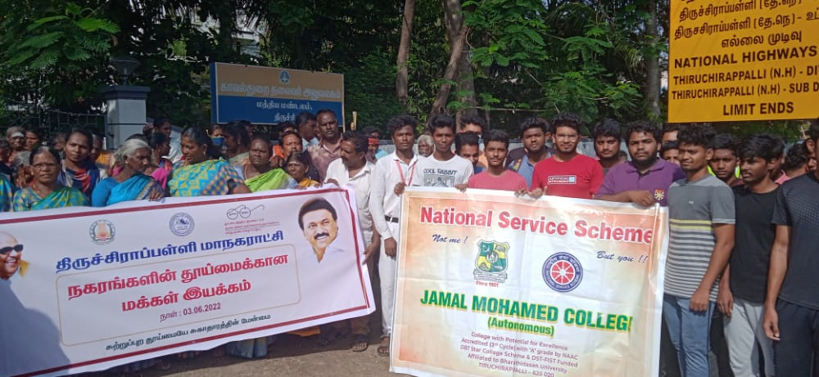
Cycle Rally

On the Date of 03/06/2022, Cycle Rally was organized in Bharathidasan University Khajamalai Campus. In this Program, Our NSS Volunteers participated in this Rally and did their duty in a good manner. Finally they were provided refreshments and the program was completed in a good manner.

Number of NSS Volunteers Participated: 30 Date: 03/06/2022

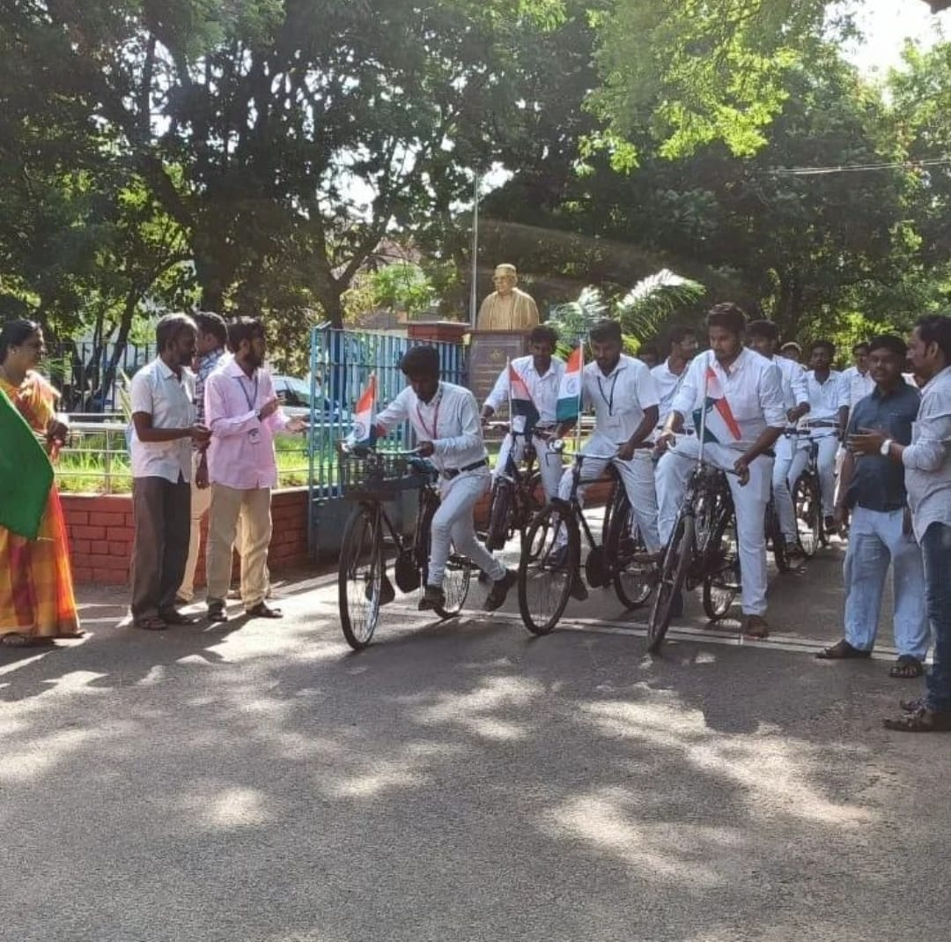
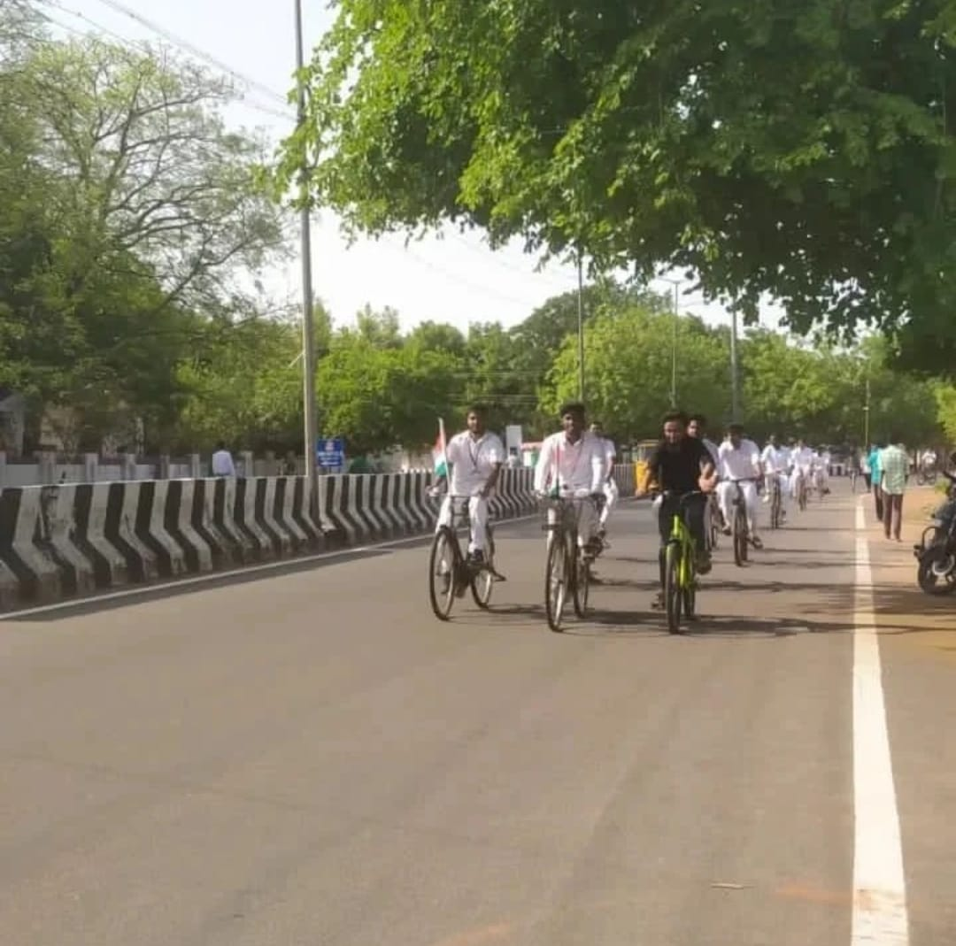

Campus Cleaning

On the Date of 04/06/2022, Campus Cleaning Program was held at Jamal Mohamed College Premises. In this Program, our NSS Volunteers cleaned the surroundings of our college in an energetic way. Our NSS Program Officers guide to the NSS Volunteers successfully and completed the program in a good manner.
Number of NSS Volunteers Participated: 20 Date: 04/06/2022

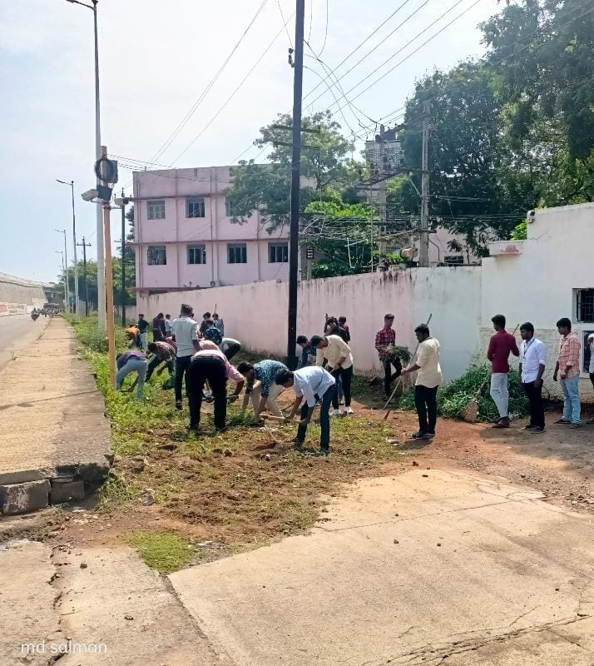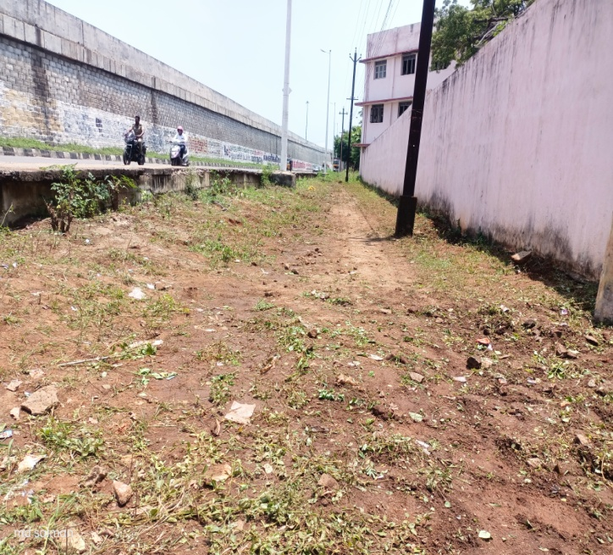 | 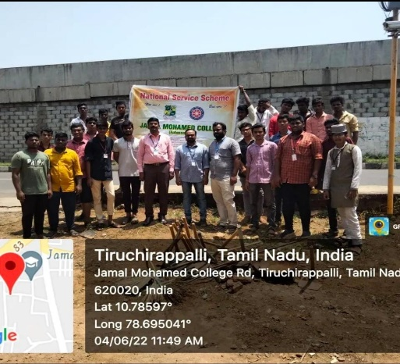

College Day

On the Date of 06/06/2022, College Day was celebrated at Jamal Mohamed College. The Program was at NBAG A/C Auditorium. Our College Secretary and Correspondent, Principal, Vice Principal were felicitated the program. College Annual report was addressed by our College Principal Dr. ISMAIL MOHIDEEN. and Hajee.S.M. HIDAYATHULLAH A.I.C.C. Member vice president, Tamil Nadu congress attends and deliver the college day address and distributes the prizes. Our NSS Officers instructed our NSS Volunteers to Organize the program and our NSS volunteers done their duty in good manner.
Number of NSS Volunteers Participated: 35 Date: 06/06/2022

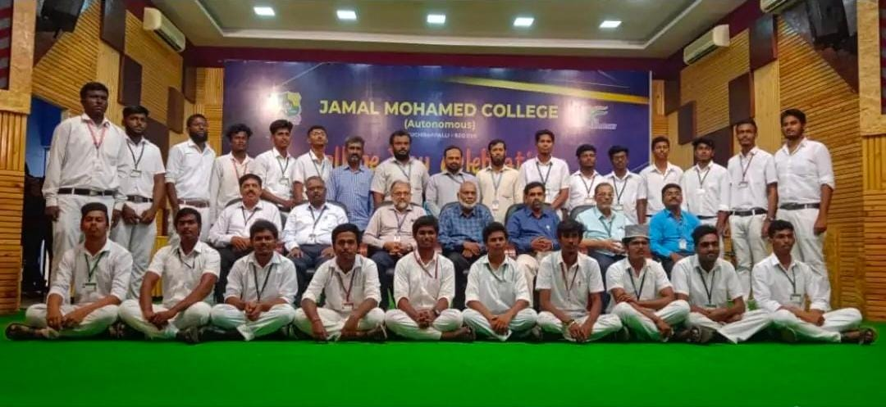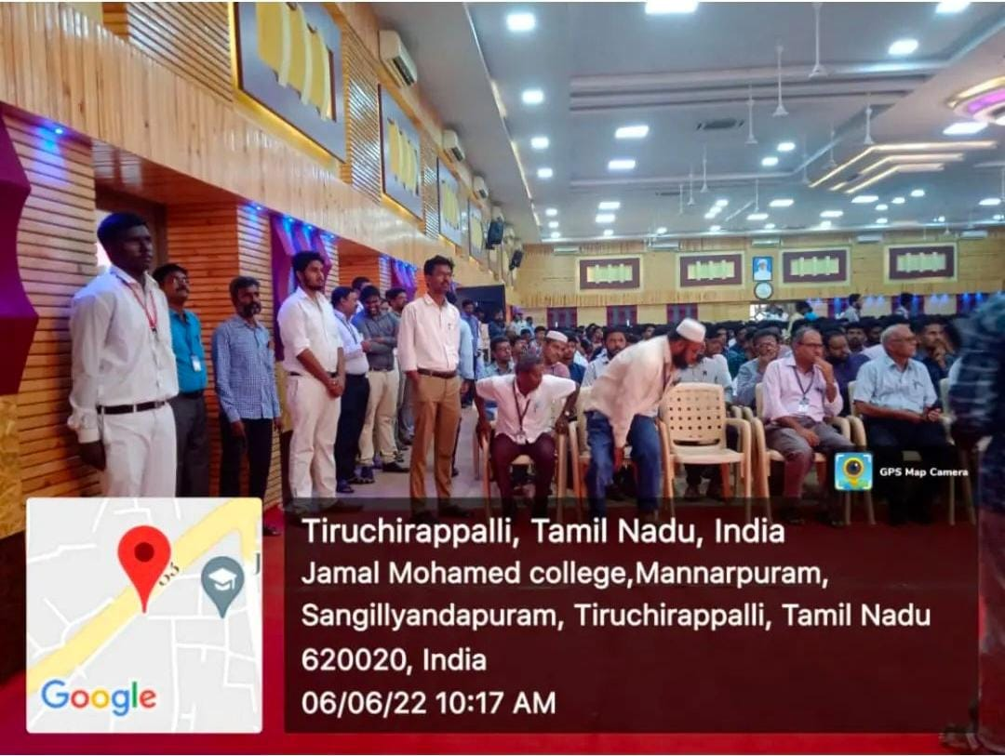

International Yoga Day

On the Date of 21/06/2022, International Yoga Day was celebrated in Bharathidasan University. In this Program, Our NSS Volunteers participated in this Yoga Session and did yoga along with the dignitaries. Finally they were provided refreshments and the program was completed in a good manner.

Number of NSS Volunteers Participated: 12 Date: 21/06/2022

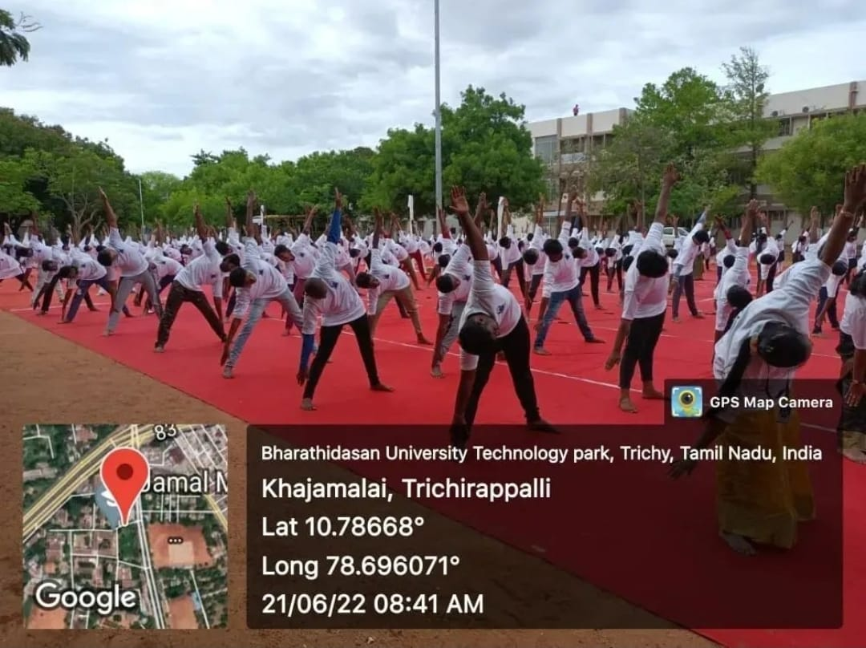 | 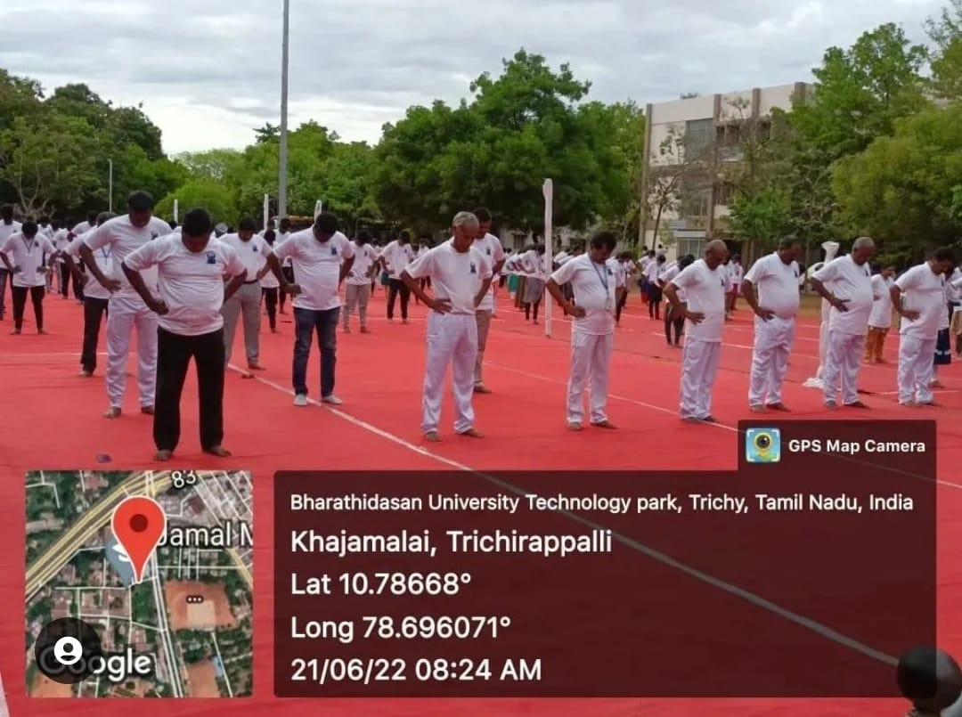

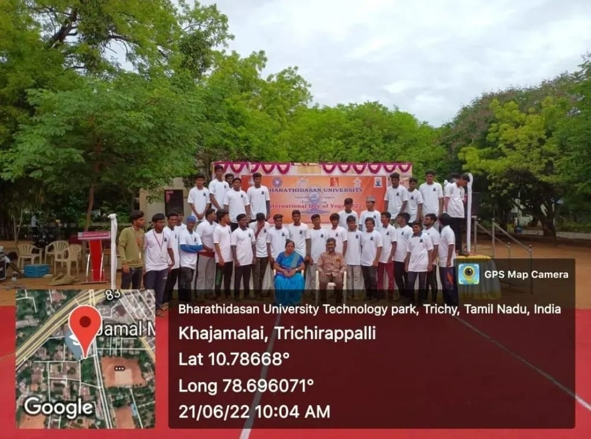

State Yoga Camp

On the Date of 21/06/2022, International Yoga Day was celebrated in Raj Bhavan, Chennai. In this Program, Our NSS Volunteers participated in this Yoga Session and did yoga in front of Our Hon. Governor R.N. Ravi. Finally they were provided refreshments and the program was completed in a good manner.

Number of NSS Volunteers Participated: 7 Date: 21/06/2022

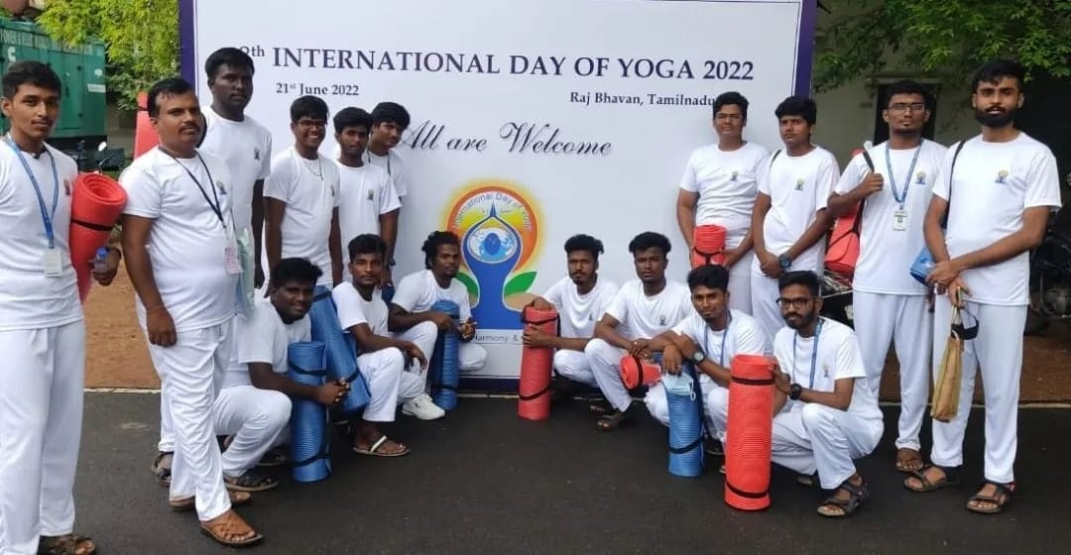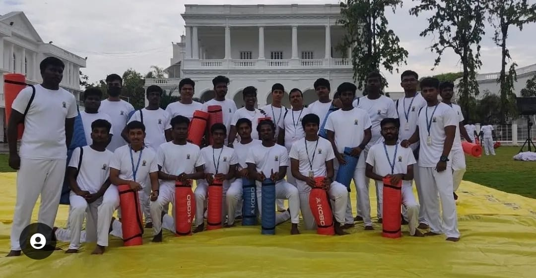

Mupperum Vizha

On the Date of 26/06/2022, Mupperum Vizha was celebrated at Jamal Mohamed College. It Consist of three functions namely Founder’s Day, Grand opening Ceremony that makes the history of the college and Global Jamaljan Block Foundation Stone Ceremony. Our College Secretary and Correspondent, Principal, Vice Principal felicitated the Program.
Honorable Chief Minister Mr. M.K. STALIN were attended as Chief guest on online mode. Mr. K.N. NEHRU, Minister of Municipal Administration, Dr. K. PONMUDI, Minister of Higher Education, Mr. ANBIL MAHESH POYYAMOZHI, Minister of School Education and Prof. K.M. KADHAR MOHIDEEN, National leader of Indian Muslim League were addressed and felicitated the program. Our NSS Program Officers Instructed our NSS Volunteers and they done their duty in a good manner.
Number of NSS Volunteers Participated: 150 Date: 26/06/2022

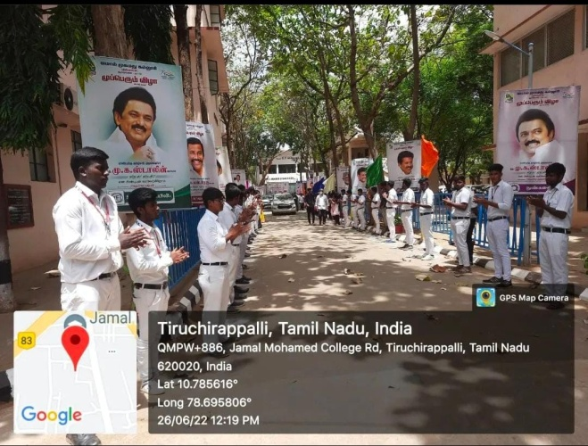 | 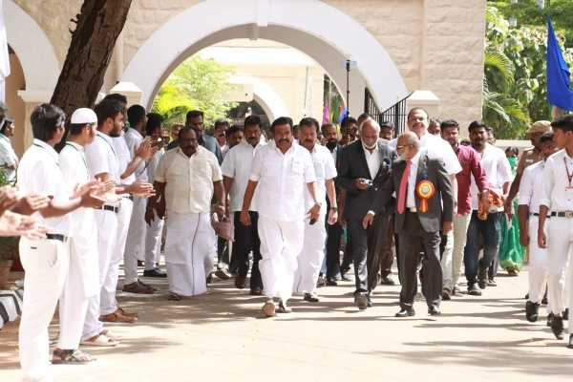

Tree Plantation
On the Date of 23/07/2022, Trichy Municipal Corporation and Jamal Mohamed College National Service Scheme jointly emphasizing that “PLANTING SAPLINGS IS MY RESPONSIBILITY”. The event was held by the Mayor Mrs. P. Jaya Nirmala and Assistant Commissioner of Police Mr. Akbar Ali. Tree Plantation was done in front of our College Campus and Created awareness about Pros of Tree Plantation. The tree plantation program was completed in a good manner with the instruction of NSS Leaders and Program officers.
Number of NSS Volunteers Participated: 15 Date: 23/07/2022

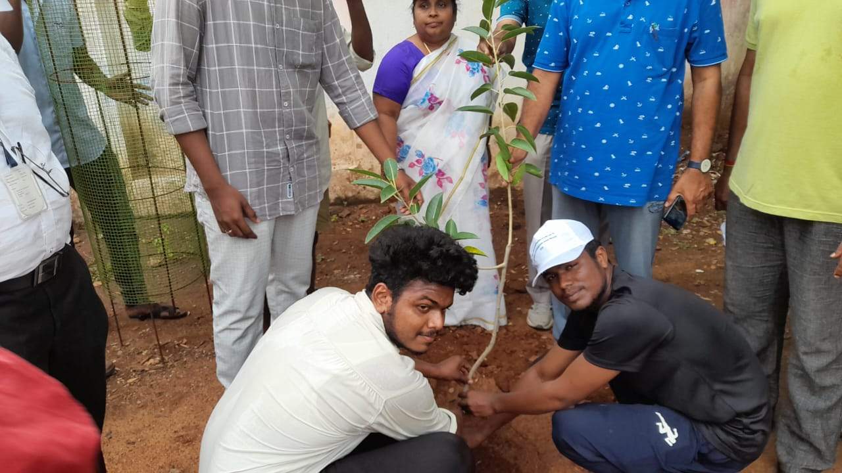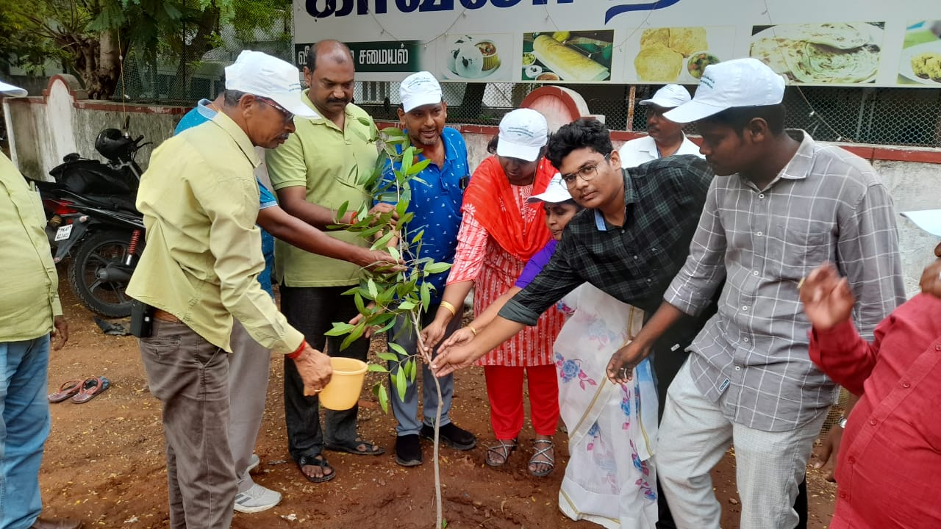

Mini marathon
On the Date of 23/07/2022, Trichy Municipal Corporation and Trichy Jamal Mohamed College National Service Scheme Conducted a Mini Marathon emphasizing that “MY GARBAGE MY RESPONSIBILITY”. The event was held by the Mayor Mrs. P. Jaya Nirmala and Assistant Commissioner of Police Mr. Akbar Ali and part – V Coordinator Mr. Sheikh Ismail and five National Service Scheme Program officers participated in these events.
The Mini Marathon started from the Jamal Mohamed College and passed through Anna Stadium, Government Law College, Bharathidasan University, and EVR Government Arts College and ended again in Jamal Mohamed College. The event was also attended by the Volunteers of National Service Scheme and Volunteers from other clubs in Part-V Activities. Mr. S. Gokula Kannan, a student from the Department of Bachelor of Commerce got the First Prize in the mini Marathon and Mr. S. Dhandapani got the Second Prize and a student from Bachelor of Tamil Literate Mr. P. Dinesh Raja got the Third prize, and Mr. S. Madhavan from the department of Bachelor of Commerce got the fourth prize, and Mr. A. Ruban and Mr. K. Satish Kumar got the consolation prizes.
At Last, the Program was completed in a Good manner.

Number of NSS Volunteers Participated: 65 Date: 23/07/2022
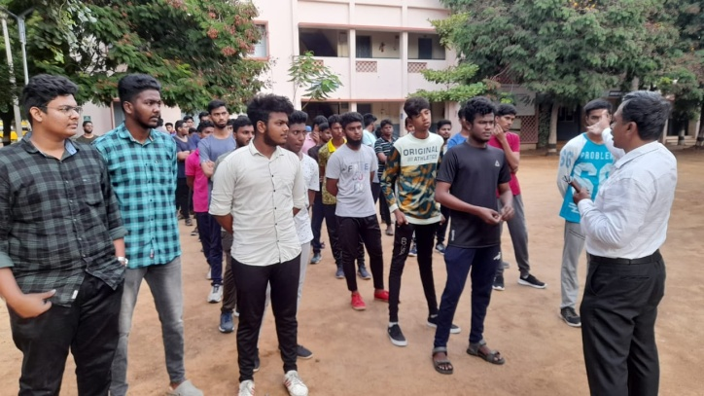 | 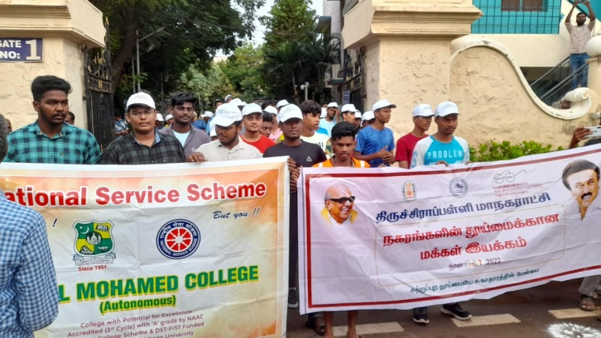
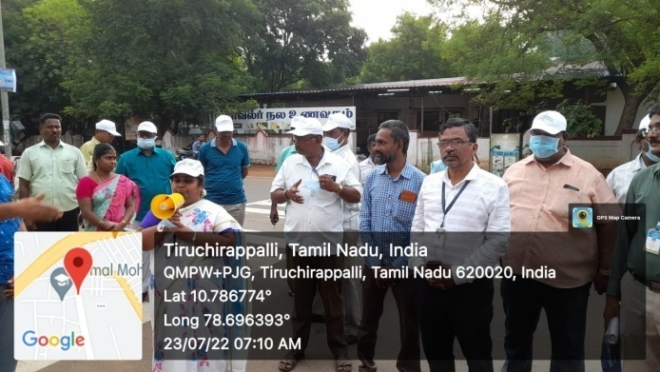 | 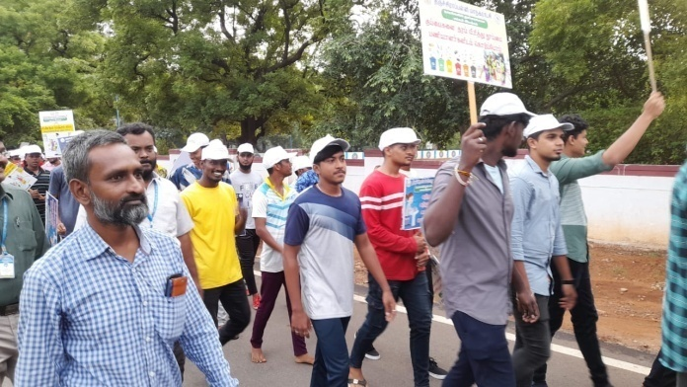
Signature for Food Safety

On the date of 25/07/2022, “Signature program was conducted by Food safety department at Jamal Mohamed College. The program was started by Hon. Secretary of Jamal Mohamed College. All the college students and staffs are given their signature to stand for food safety. This program was organized by our NSS volunteers. This program was conducted for 1 week. Our NSS Program Officers and NSS leaders instructed the volunteers to complete the program successfully.

Number of NSS Volunteers Participated: 10 Date: 25/07/2022

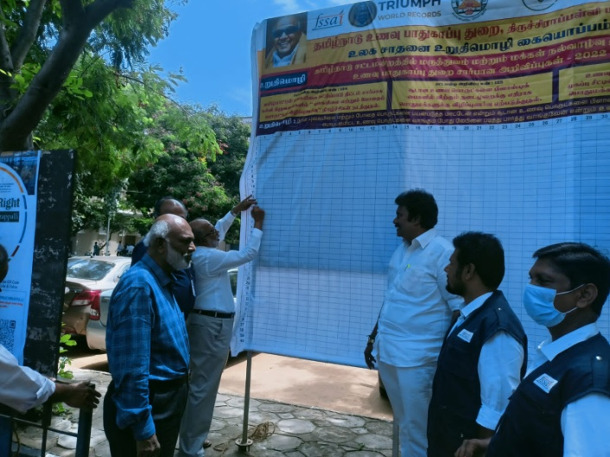 | 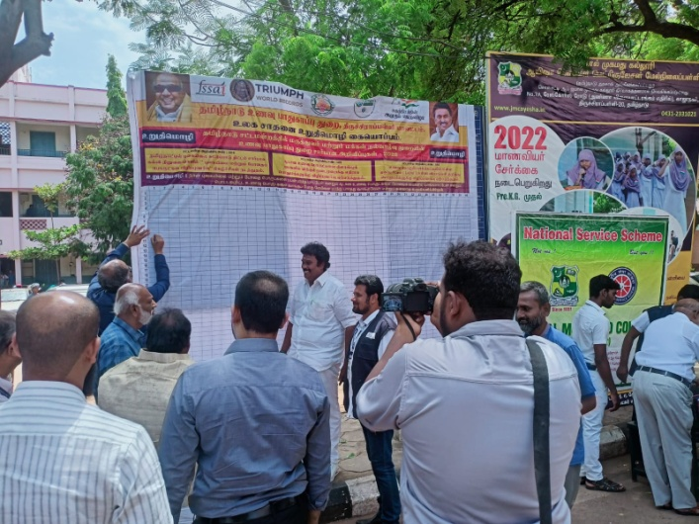
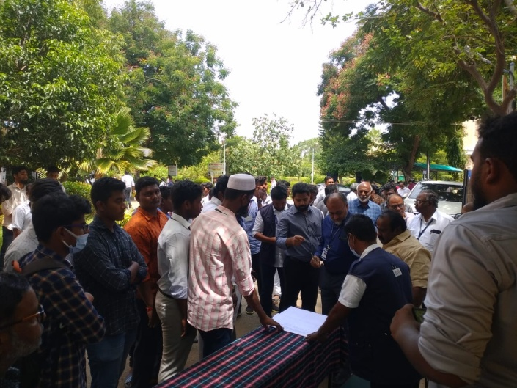 | 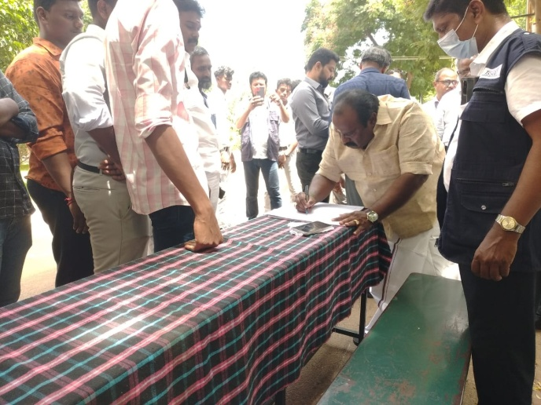
Drug awareness E-Pledge

On the Date of 27/07/2022 “DRUG ABUSE” E-Pledge was conducted by National Service Scheme of Jamal Mohamed College. In this program, Our Volunteers and Program officers taken pledge about Drug Abuse Awareness through online mode.
. The pledge was completed in a good manner by the Volunteers.
Number of NSS Volunteers Participated: 120 Date: 27/06/2022

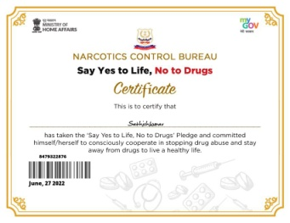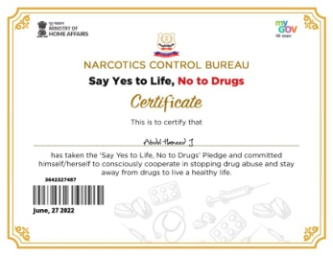 | 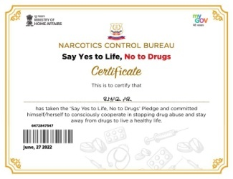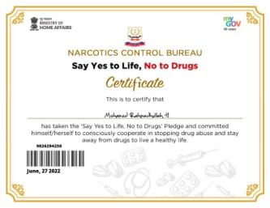 | 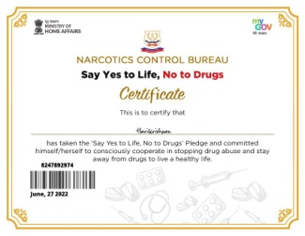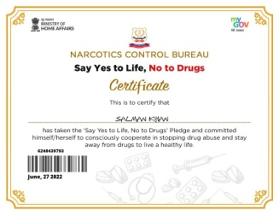 | 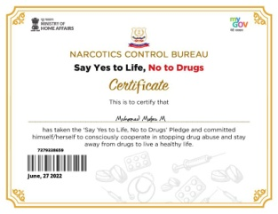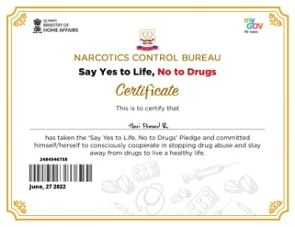
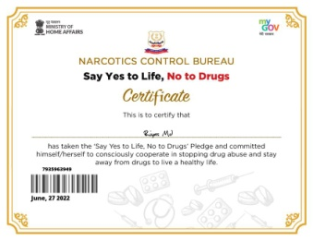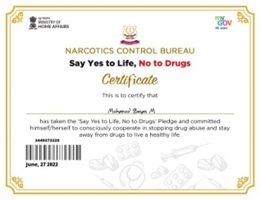 | 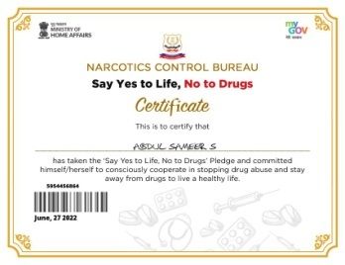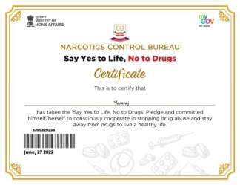 | 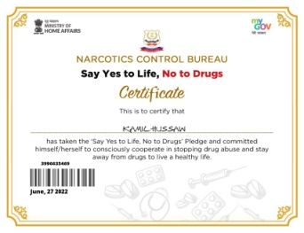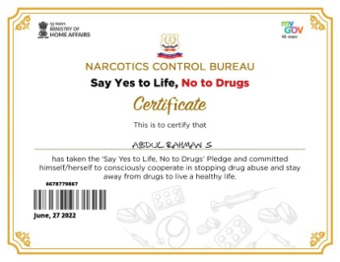 | 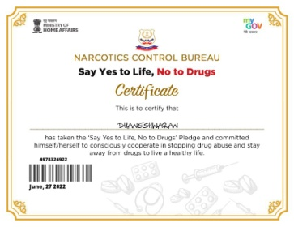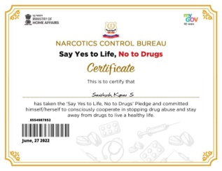

Placement Awareness Program

On the Date of 28/07/2022, The Placement Awareness Program was conducted by Placement Cell of Jamal Mohamed College in NBAG Auditorium. In this Program, they created awareness about getting recruited to the final year UG and PG Students. Our NSS volunteers organized the program and completed it in a Good manner.

Number of NSS Volunteers Participated: 12 Date: 28/07/2022

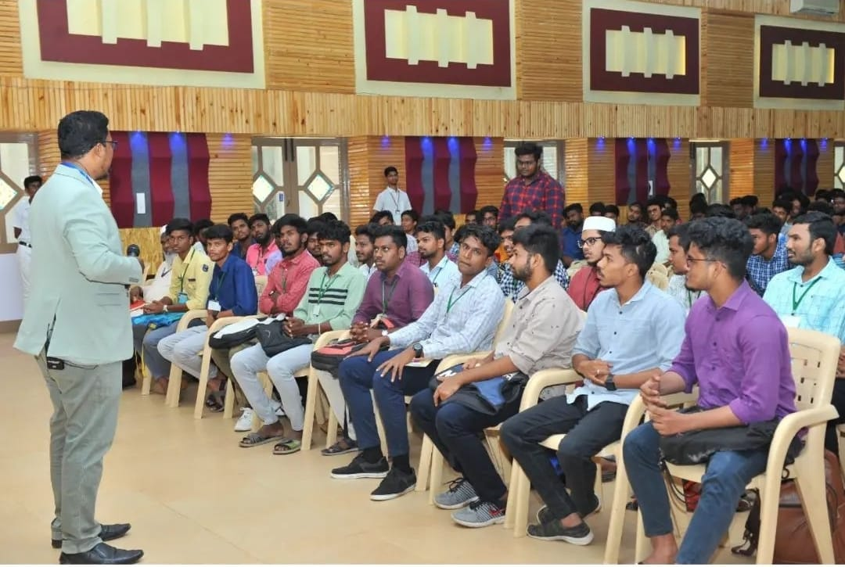 | 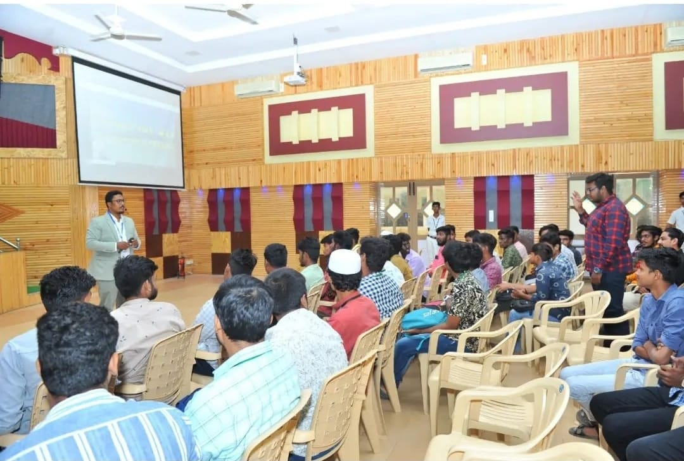

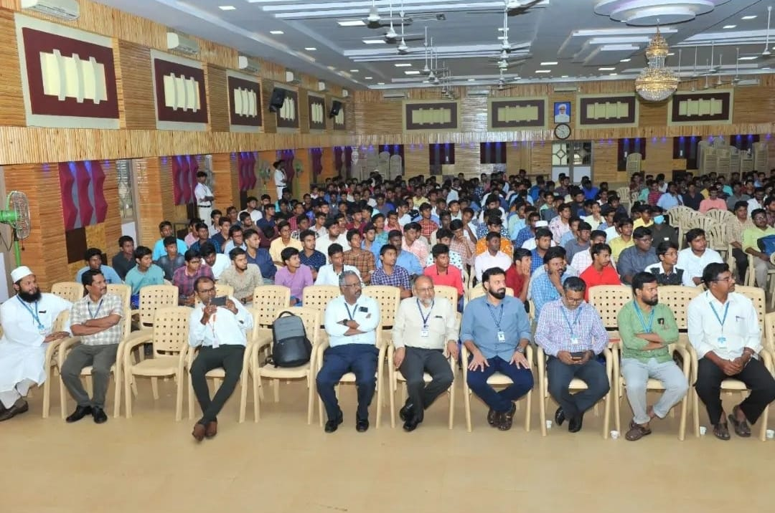

Placement Awareness program

On the Date of 04/08/2022, Placement Awareness program was conducted by Jamal Mohamed College. Our college students got awareness about how to attend interview and how to selected successfully in campus interviews. The program was organized by National Service Scheme of Jamal Mohamed College and our volunteers did their duty in a good manner with the instruction of our NSS Leaders and Program Officers.

Number of NSS Volunteers Participated: 10 Date: 04/08/2022
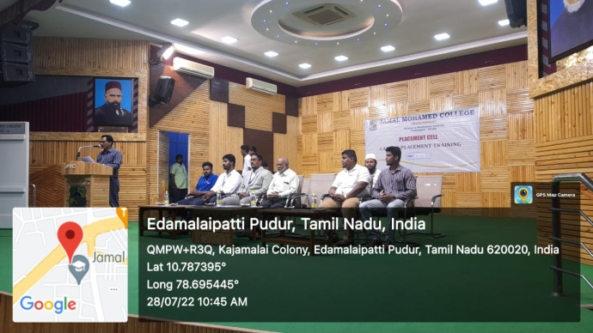 | 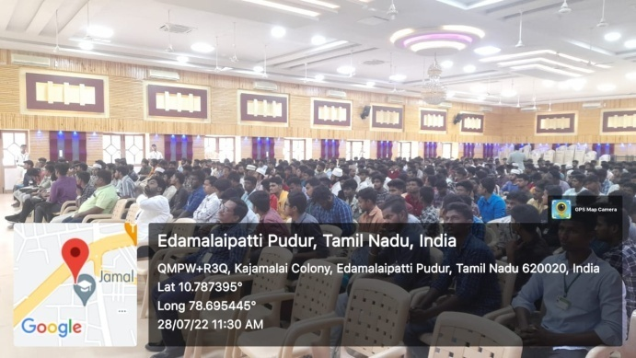
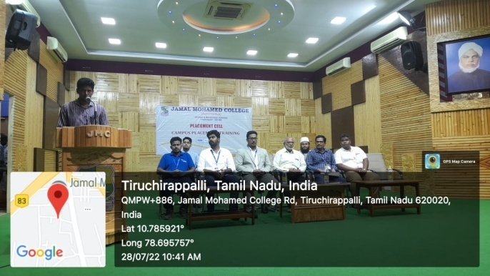 | 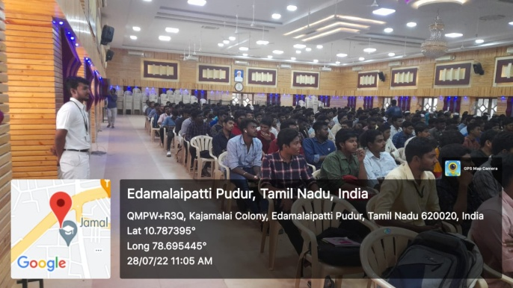

Walkathon Program

On the Date of 06/08/2022, Walkathon Program was conducted by Food and Safety Department (Tiruchirappalli) on behalf of “EAT RIGHT”. The walkathon was started from Collector Office to Bishop Heber College. Our college NSS Volunteers participated in the program with full involvement. Also our Part V Coordinator and Program Officers joined with us and done their duty in a good manner.
Number of NSS Volunteers Participated: 40 Date:06/08/2022

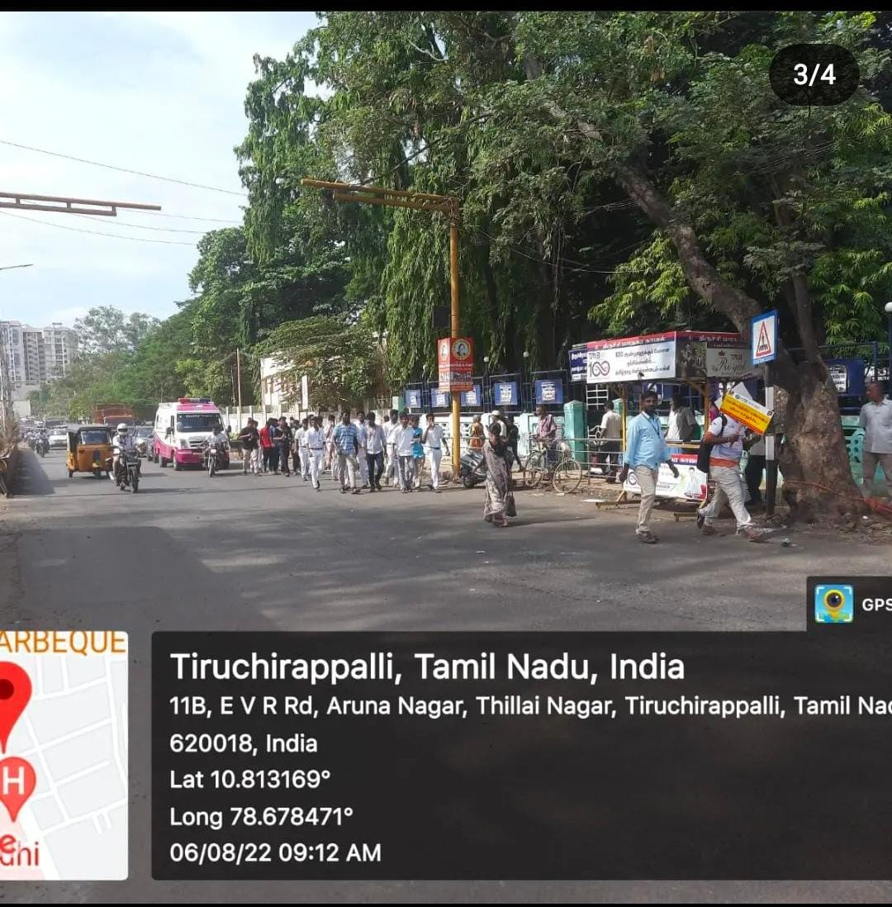 | 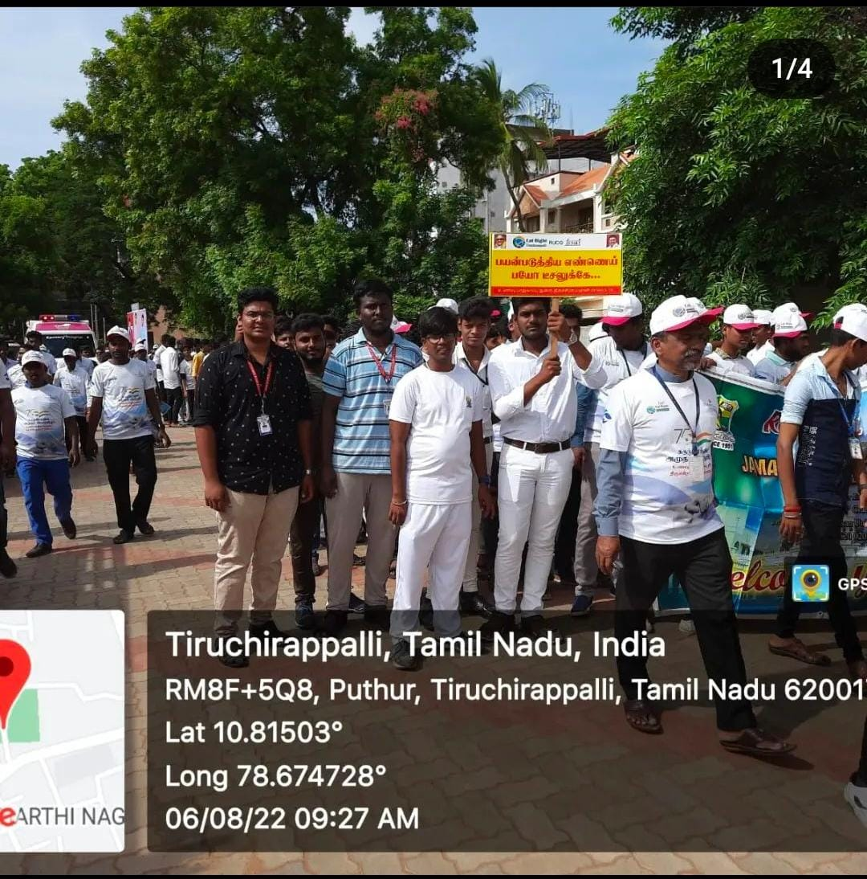

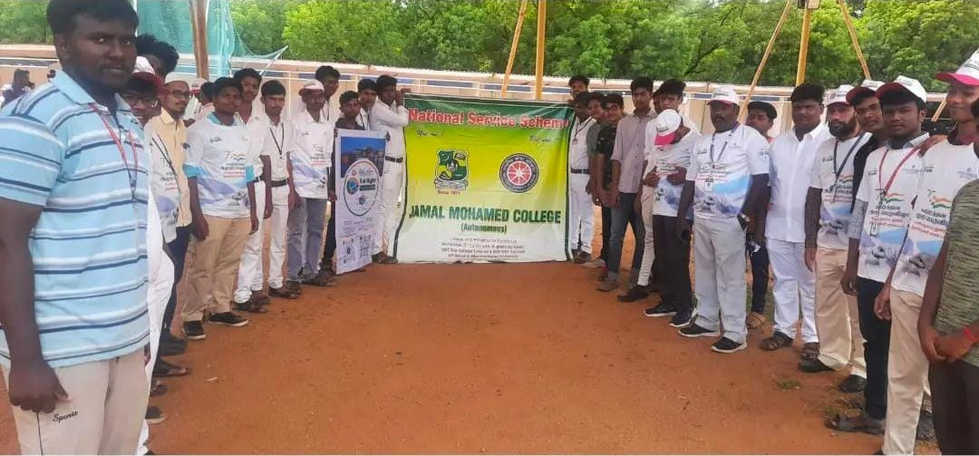
Flag Distribution at BDU

On the Date of 08/08/2022, National Flag Distribution Program was held at Bharathidasan University to celebrate the 75th Anniversary of our Country’s Independence. Our NSS volunteers organize the program. In this program Dr. M. Selvam Vice chancellor of Bharathidasan University distributed the flag to participated colleges.
The program was completed with a great success.

Number of NSS Volunteers Participated: 10 Date: 08/08/2022

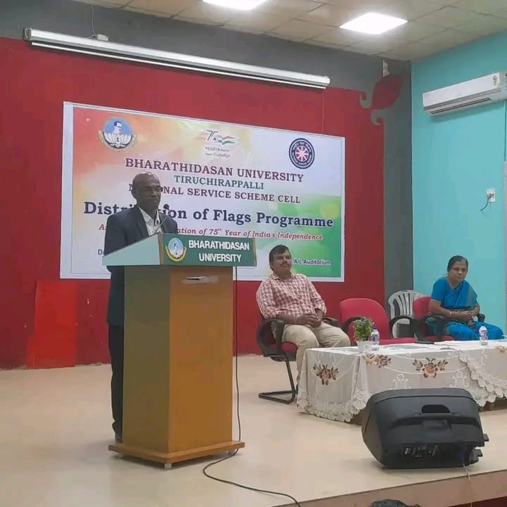 | 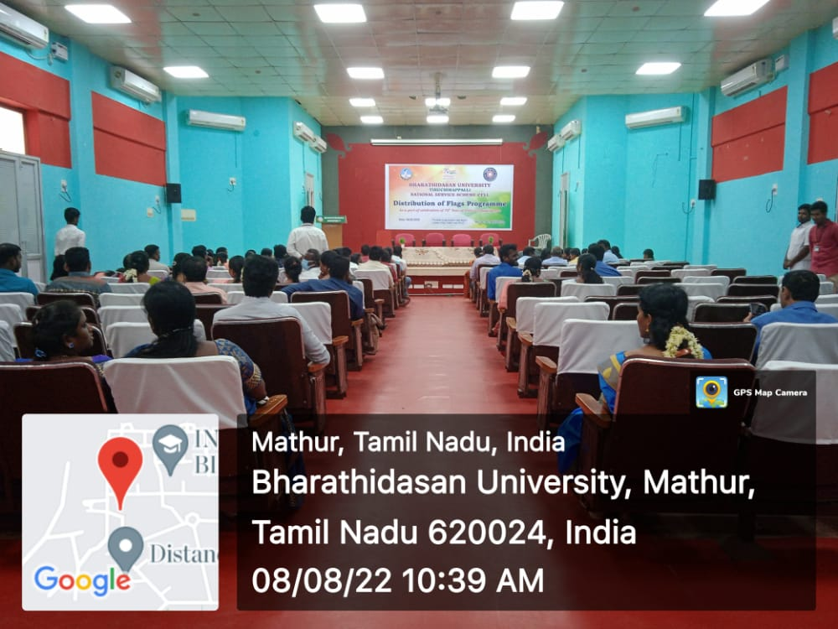
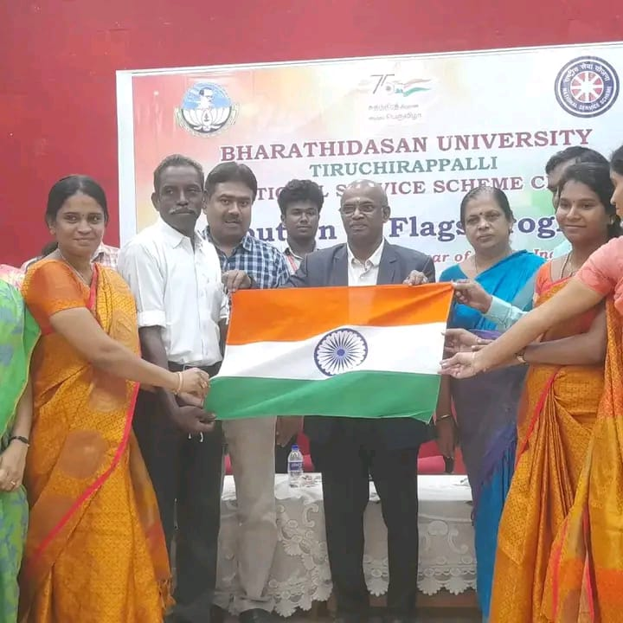

Eye camp

On the Date of 11/08/2022, Eye camp was Organized by Mahatma Eye Hospital in Bharathidasan University. In this camp, our volunteers registered the details of the patients who came to eye camp and Free eye checkup was provided to them. So many people got benefit from this camp with the guidance of our NSS leaders. The Program was completed in a Good manner.

Number of NSS Volunteers Participated: 25 Date: 11/08/2022

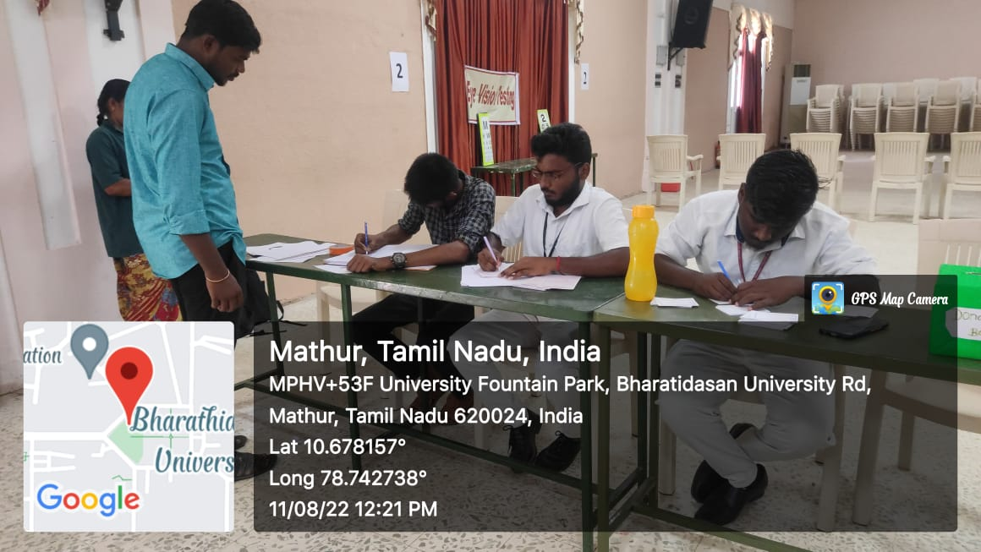 | 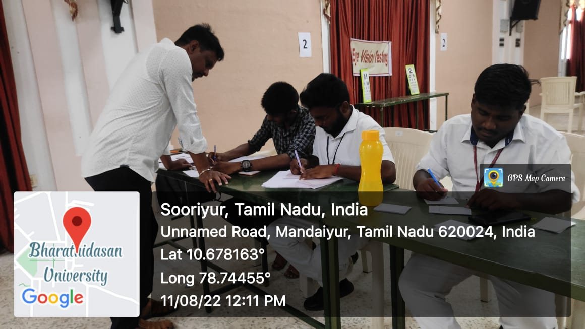
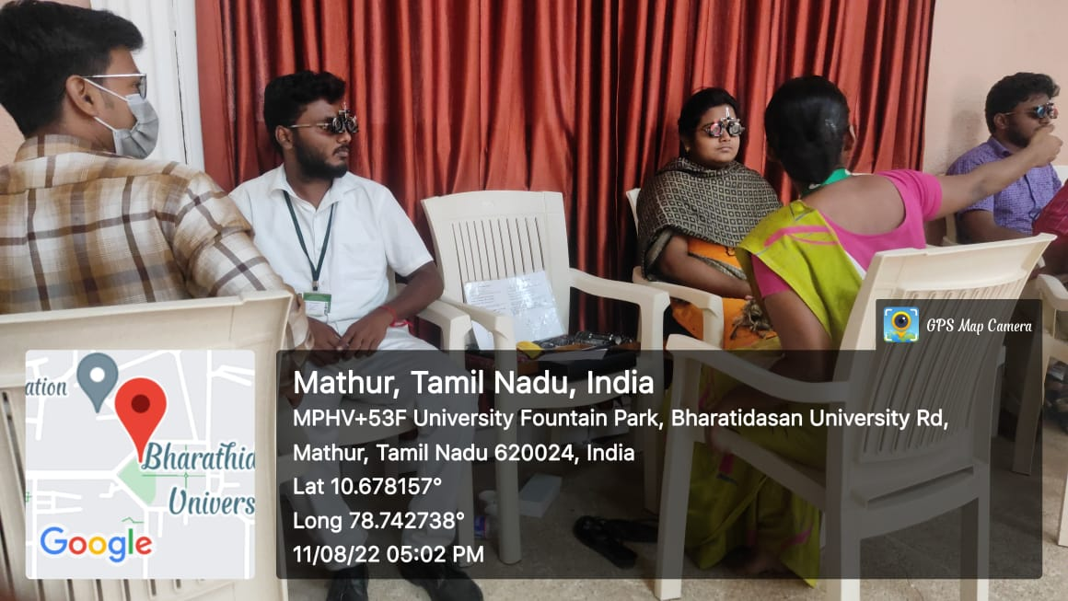 | 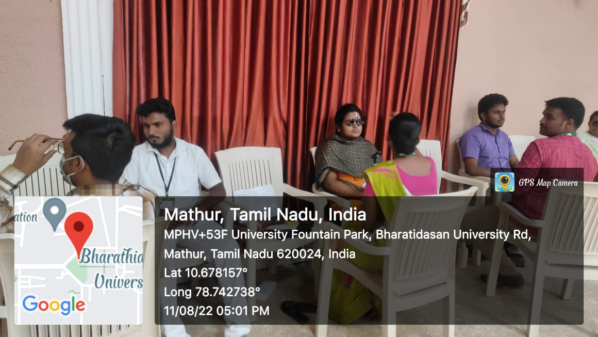

Pledge Taking

On the date of 11/08/2022. Pledge taking program was conducted by national service scheme of Jamal Mohamed College. In this program our College Hon. principal, Hon. secretary, program officers and students taken pledge in the title of “Drug Abuse Awareness”. The program was completed in a good manner.
Number of NSS Volunteers Participated: 35 Date: 11/08/2022

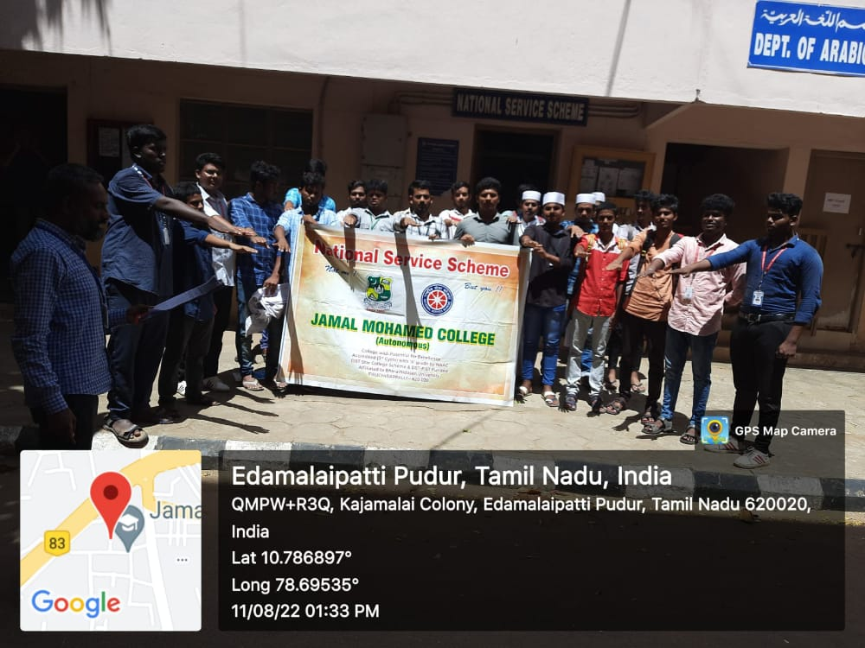 | 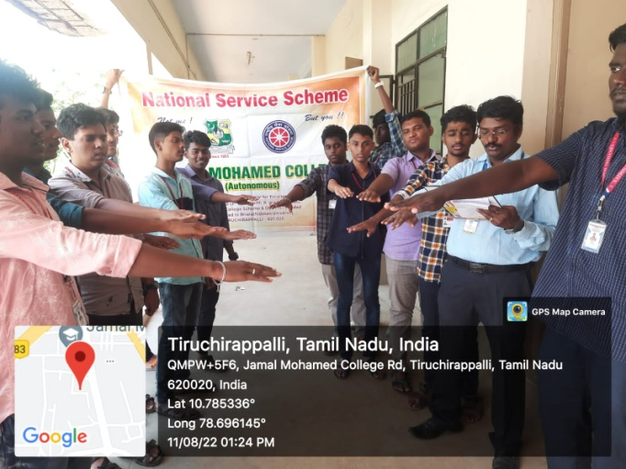
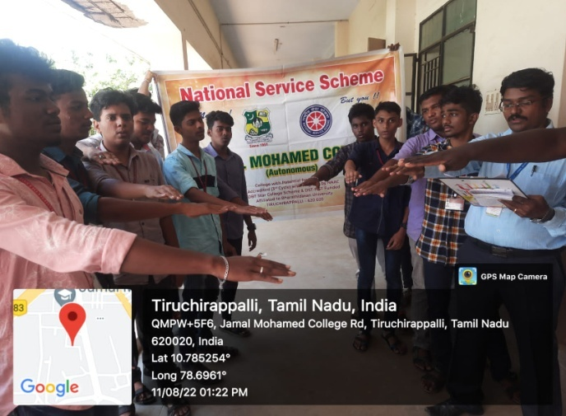 | 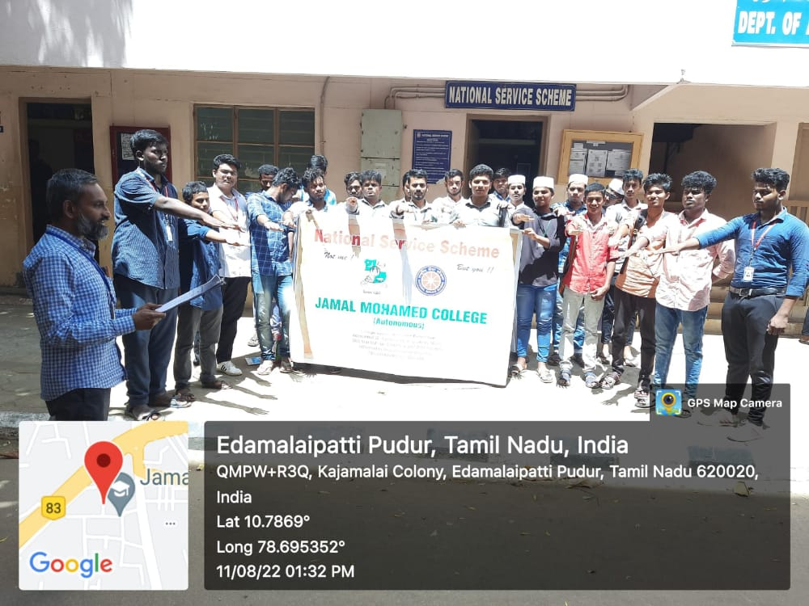

Har ghar tiranga rally

On the Date of 12/08/2022, har ghar tiranga rally was conducted by Joseph eye hospital and Bharathidasan University. In this program Vice- Chancellor of Bharathidasan university” Dr. M. Selvam”, NSS coordinator of Bharathidasan university” Dr. Lakshmi prabha” were participated. The rally begins from Cantonment and finished in Joseph eye hospital.
Our NSS volunteers costumed like freedom fighters and participate in the rally. The Program was completed in a Good manner with the instruction of NSS Leaders and Program Officers.
Number of NSS Volunteers Participated: 50 Date: 12/08/2022
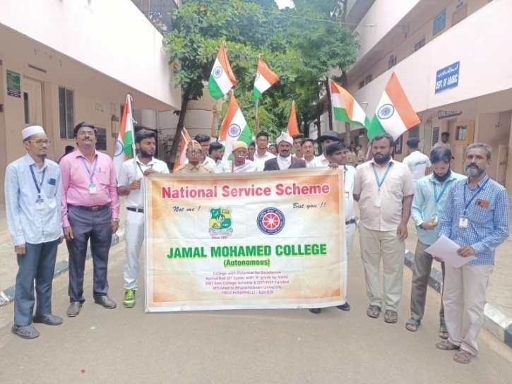 | 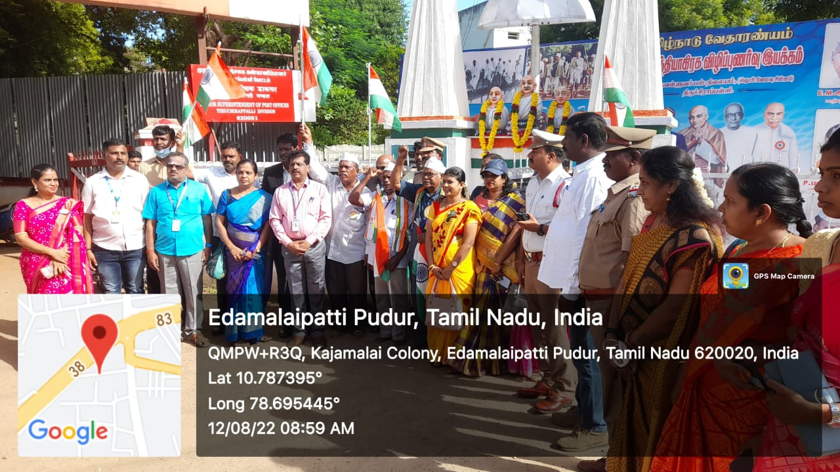
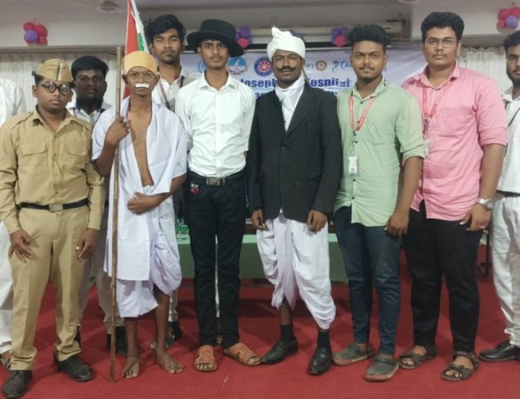 | 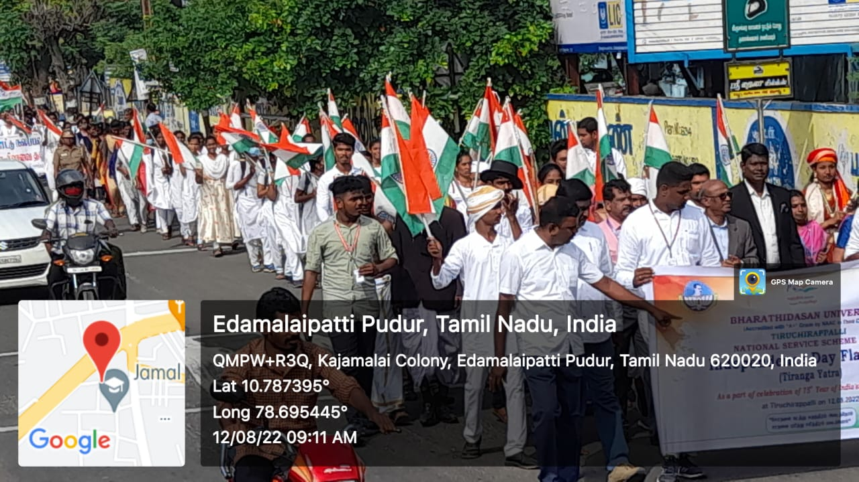

Mini marathon

On the Date of 13/08/2022, The Mini Marathon was started from Jamal Mohamed College by The Hon. Principal and goes through mannarpuram, Khajamalai, Anna stadium and ended in the TVS Tollgate which covered 5 kilometers. Our Volunteers were participated massively and I, II, III prizes were awarded in that program and the programme was conducted in a good manner. After the Mini Marathon, refreshments were given to the students.

Number of NSS Volunteers Participated: 95 Date: 13/08/2022

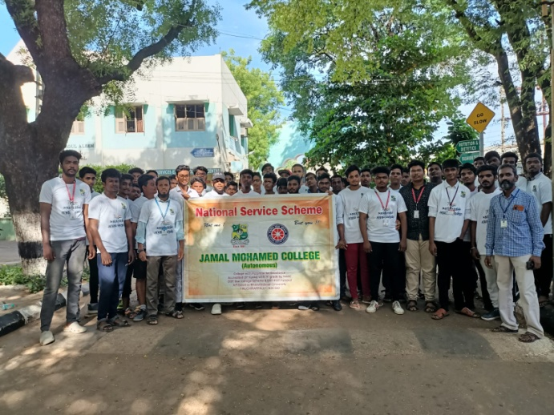

Flag distribution at Police colony

On the date 13/08/2022, Flag Distribution program was conducted by National Service Scheme of Jamal Mohamed College at police colony. Our honorable secretary and Correspondent sir inaugurated the program. In this program our NSS volunteers distributed flags to the people of police colony. The program was completed in a good manner with the guidance of NSS leaders and NSS officers.

Number of NSS Volunteers Participated: 45 Date: 13/08/2022
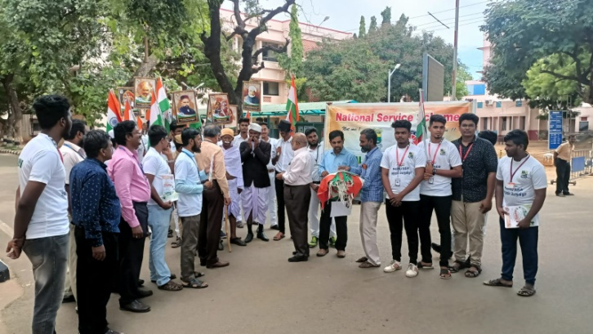 | 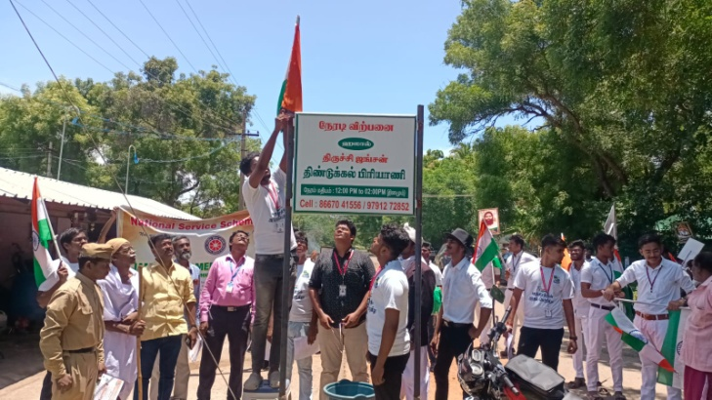
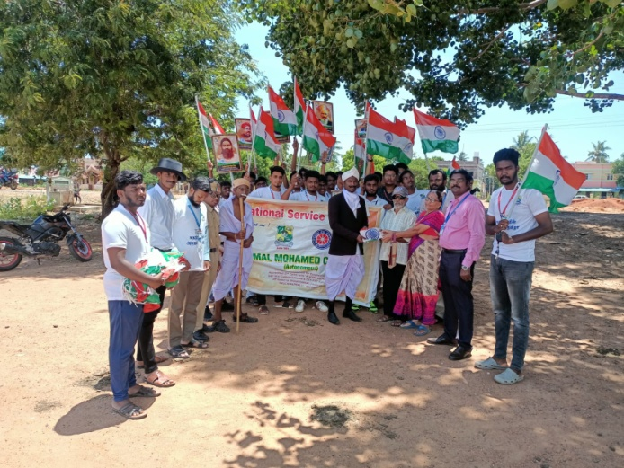 | 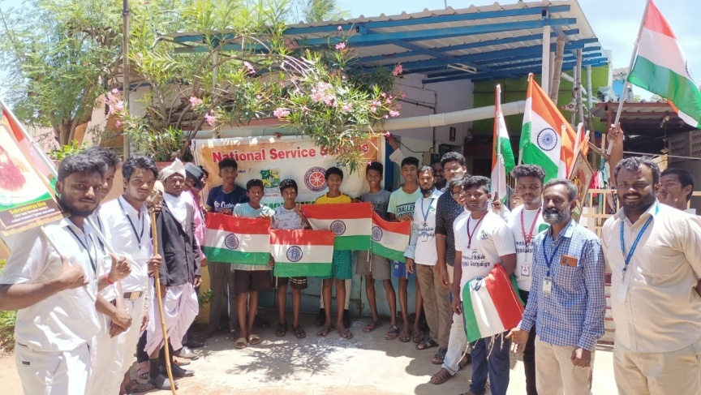
Alumni Meeting

On the Date of 15/08/2022, Alumni meeting named NOSTALGIA was conducted by Jamal Mohamed College at NBAG Auditorium. Old Students of Jamal Mohamed College participated in this program. Our Hon. Principal, Secretary and Correspondent, Treasurer felicitated the program. The program was Completed successfully in a good manner with the guidance of NSS leaders and Program Officers.

Number of NSS Volunteers Participated: 40 Date: 15/08/2022
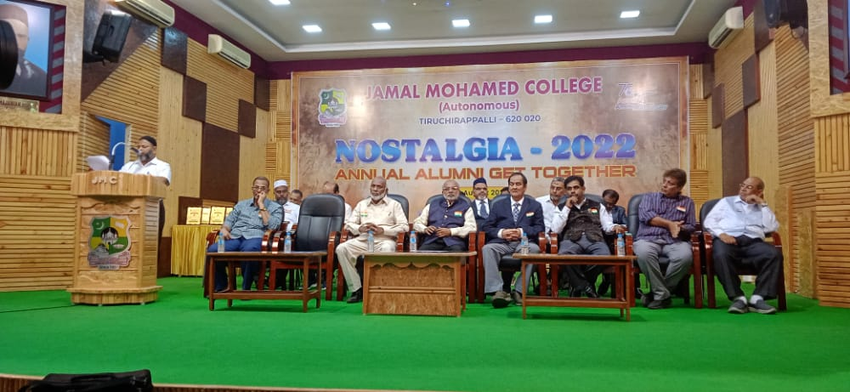 | 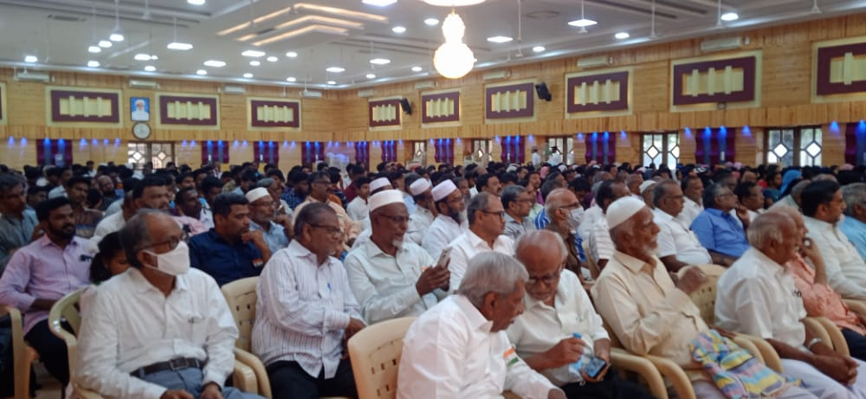
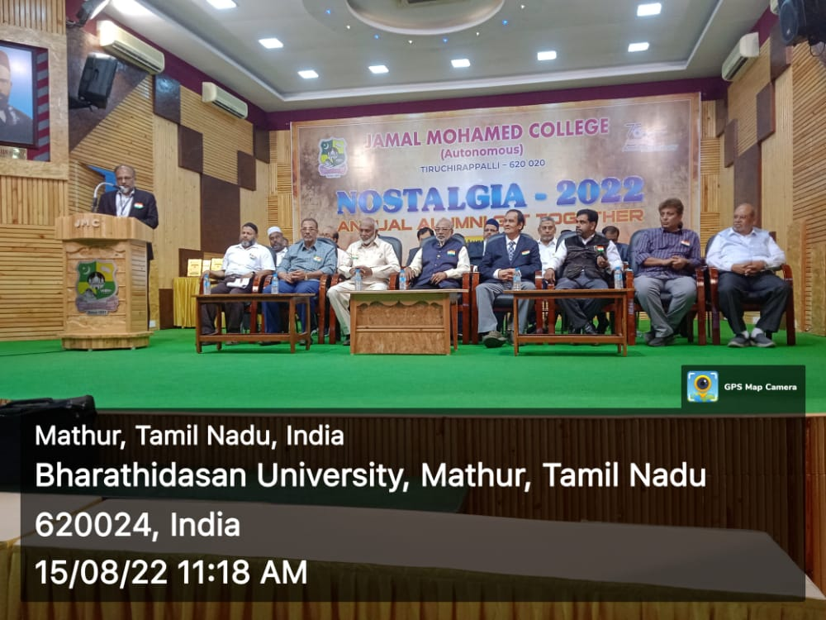 | 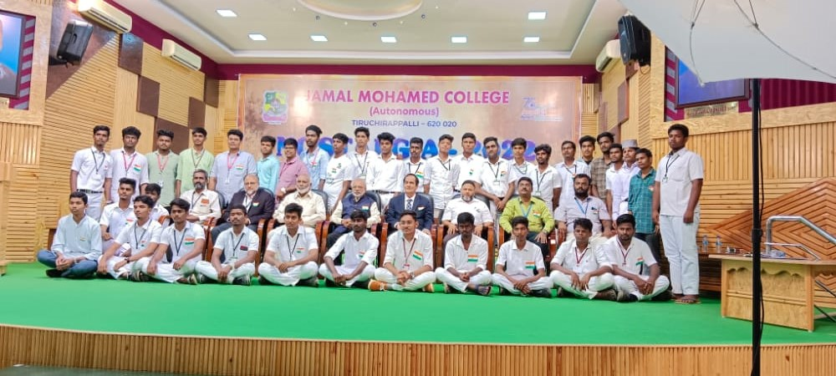

Independence day

On the Date of 15/08/2022, 76th Independence Day and 75 years of Independence was celebrated at Bharathidasan University. Our NSS Volunteers participated in the welcoming of the guest and Flag Hoisting Ceremony of Independence Day. DR. M. SELVAM Vice-Chancellor of Bharathidasan University presided over the program. Mrs. A. LAKSHMI PRABHA NSS Coordinator of Bharathidasan University, NSS Staffs and our college Program officer has guided our NSS Volunteers to make the program grand success.

Number of NSS Volunteers Participated: 40 Date: 15/08/2022
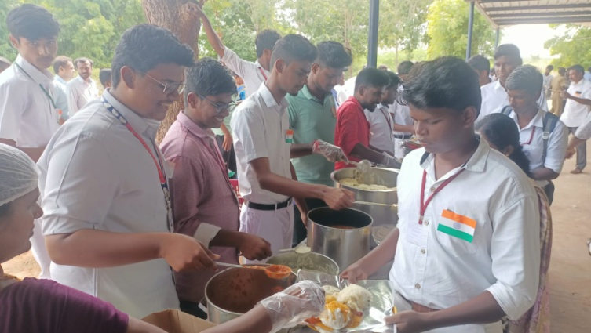 | 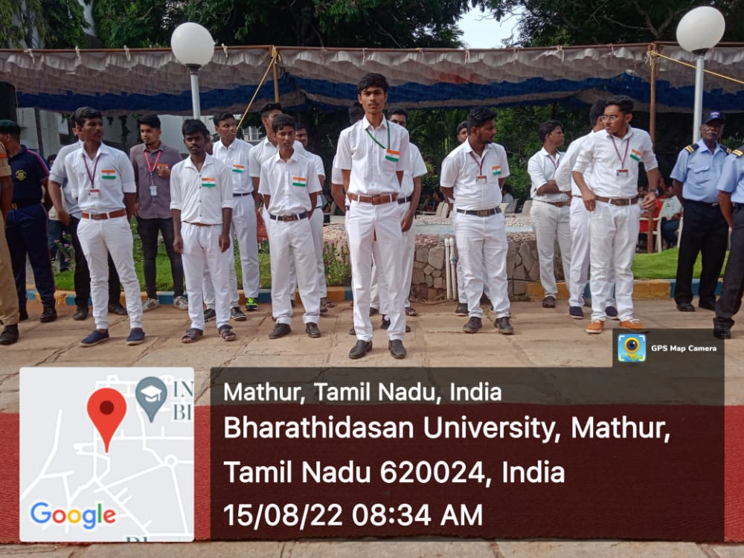
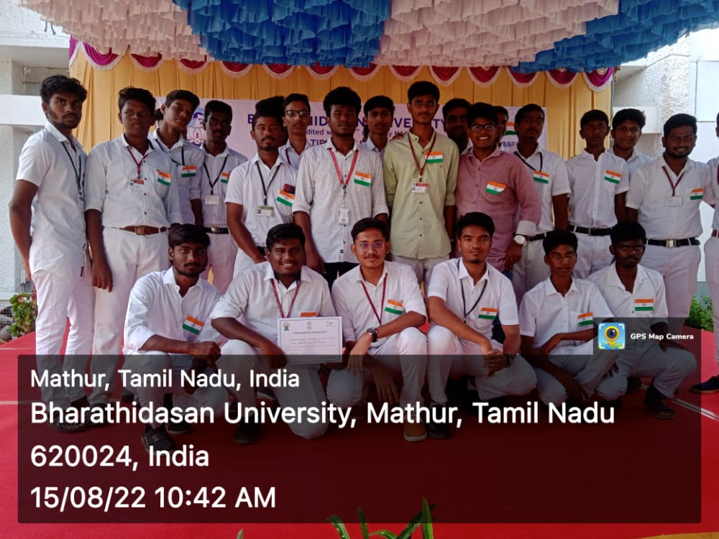 | 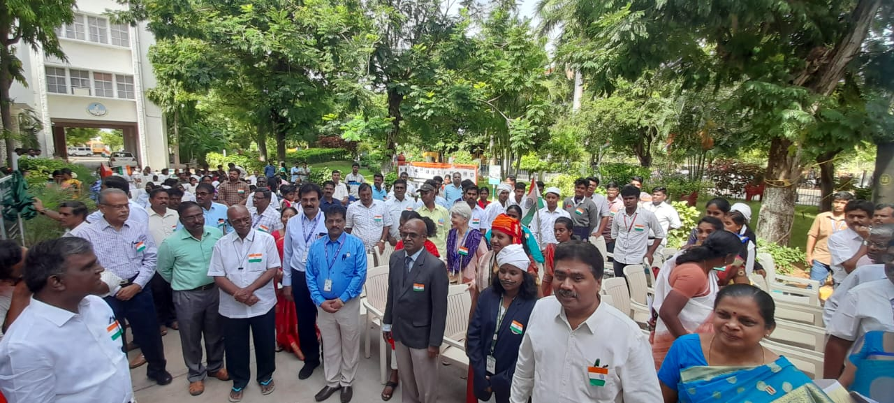
Women safety awareness rally

On the Date of 26/08/2022, Women safety awareness rally was conducted by “Department of social welfare and Women’s Rights”. The rally takes place from collector office to court. Our NSS volunteers participated in the rally. NSS Coordinator of Bharathidasan University Dr. A. Lakshmi Prabha attended this program and delivered her valuable speech about Awareness of women Safety. By the guidance of Program Officers, the program was completed in a good manner.

Number of NSS Volunteers Participated:30 Date: 26/08/2022
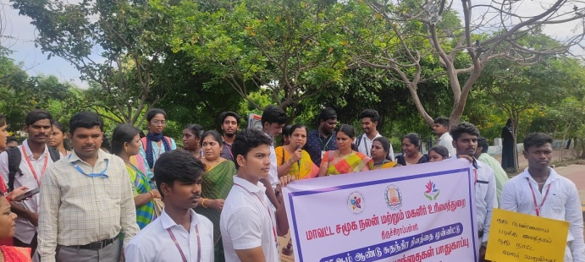 | 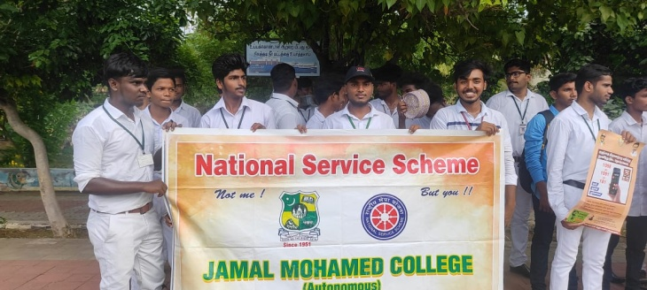
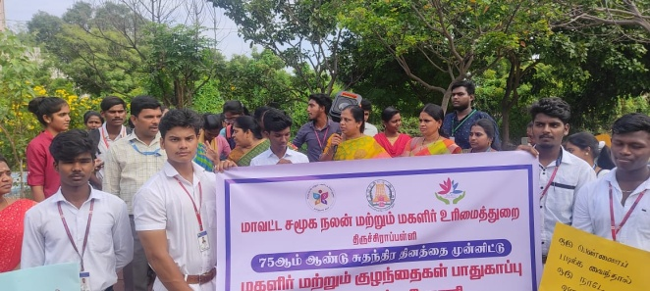 | 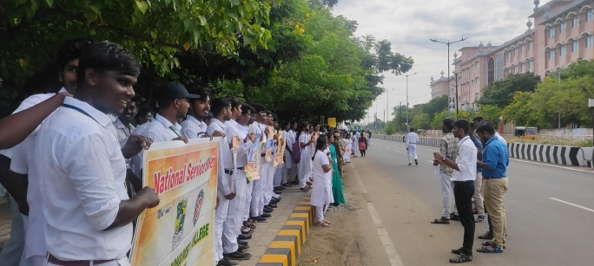

College campus cleaning

On the Date of 29/08/2022, College campus cleaning program was conducted by National Service Scheme of Jamal Mohamed College. Our NSS volunteers cleaned our campus with the given tools. After the Volunteers’ energetic work, the place was cleaned neatly and Leaders provided Refreshment to the Volunteers. The
Program was completed in a good manner.

Number of NSS Volunteers Participated: 25 Date: 29/08/2022
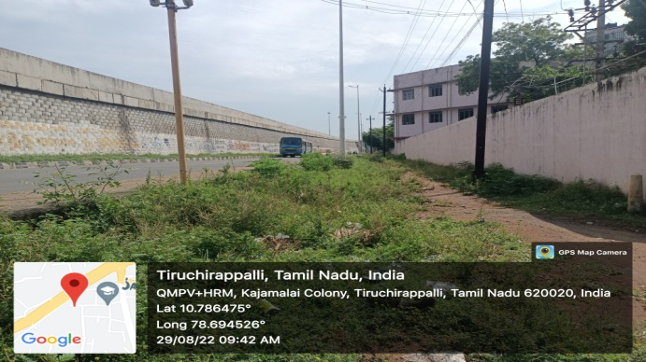 | 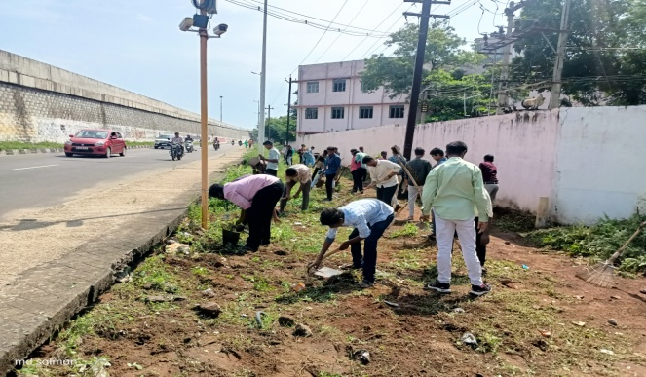
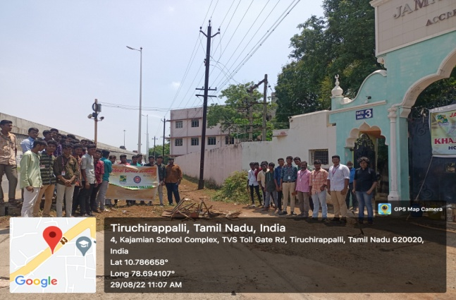 | 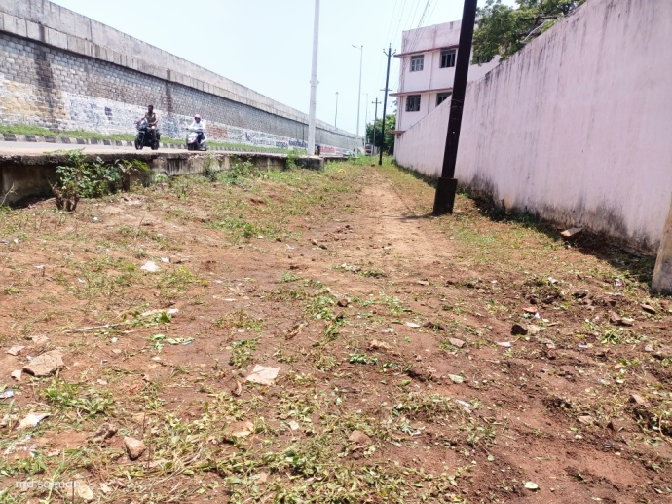

Cleaning Program at Police Colony

On the date of 30/08/2022, The cleaning program was conducted by national service scheme of Jamal Mohamed college at Police Colony. In this program, Our NSS volunteers cleaned the mosque and “samudhaya koodam” of Burma Colony. The places were cleaned very neatly by our volunteers with the given tools. The program was completed in a good manner with the instruction of NSS leaders and officers.
Number of NSS Volunteers Participated: 60 Date: 30/08/2022

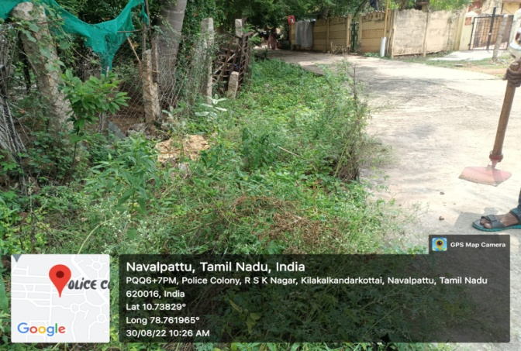 | 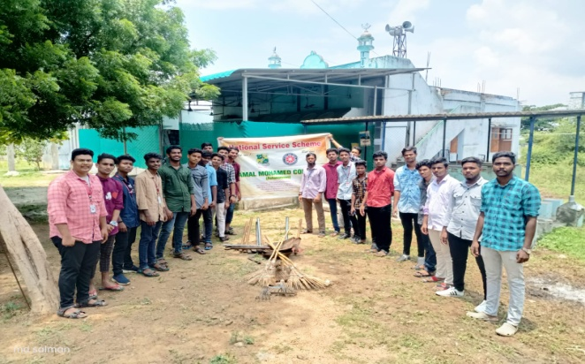
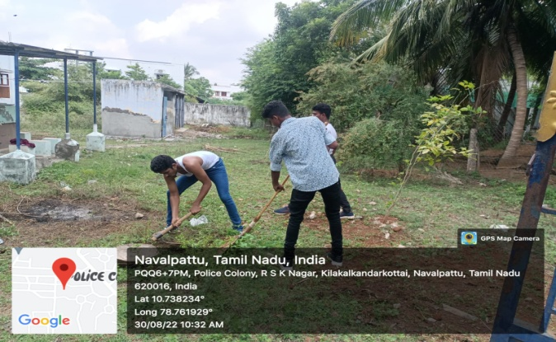 | 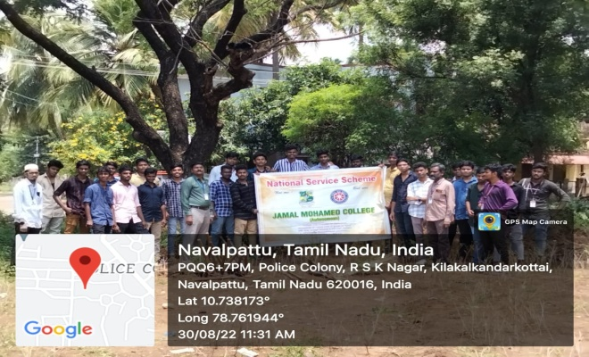

Science Workshop

On the date of 03/09/2022. Science Workshop was conducted by Jamal Mohamed College. The program was conducted for PG students of our college to improve their research and carrier activities. The Felicitation was given by Our Principal, Secretary and Correspondent and Some Assistant Professors of Respective Departments. Our NSS volunteers organized the program with the guidance of NSS leaders and NSS Officers. The program was completed in a good manner.
Number of NSS Volunteers Participated: 10 Date: 03/09/2022

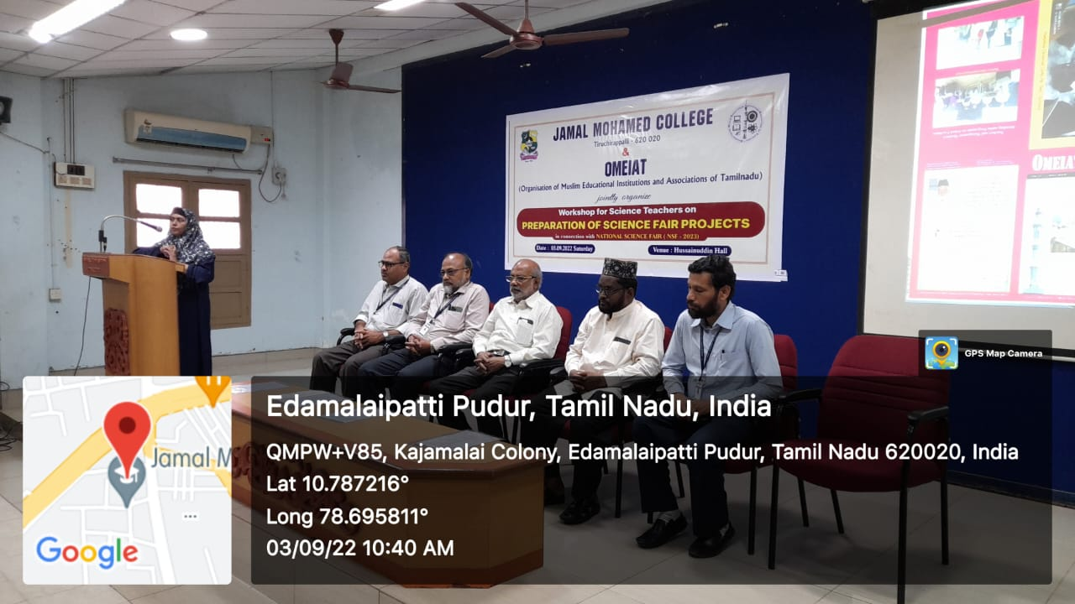 | 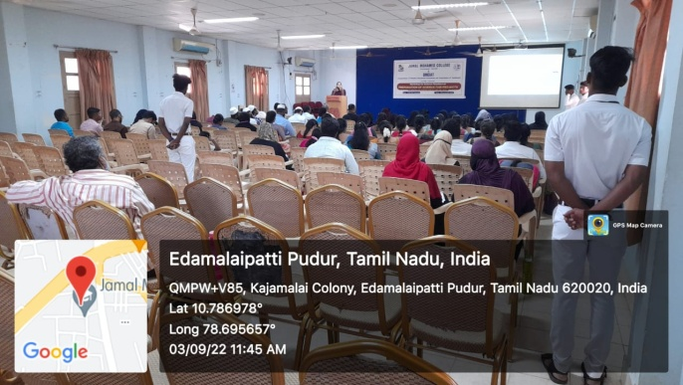
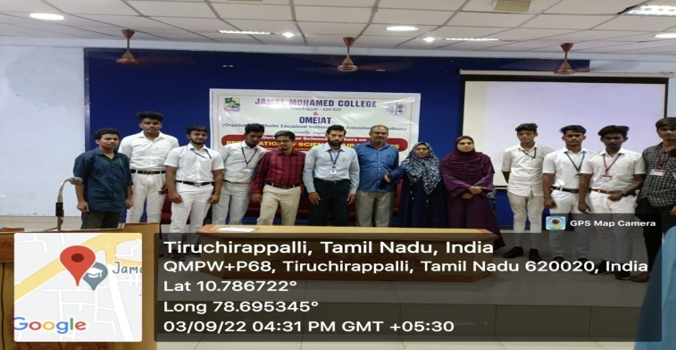 | 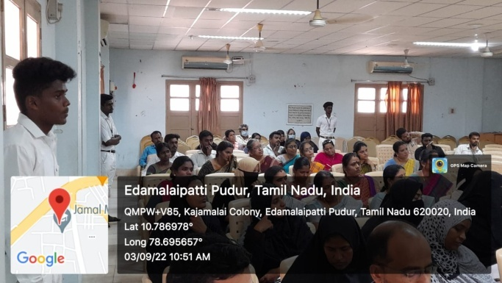

Teacher’s Day

On the date of 05/09/2022, Teacher’s Day was celebrated by National Service Scheme of Jamal Mohamed College. In this program, Our NSS Volunteers gave sweets to all Faculty Members, Principal and Management Committee with the instruction of NSS officers. The program was completed by good manner.

Number of NSS Volunteers Participated: 20 Date: 05/09/2022
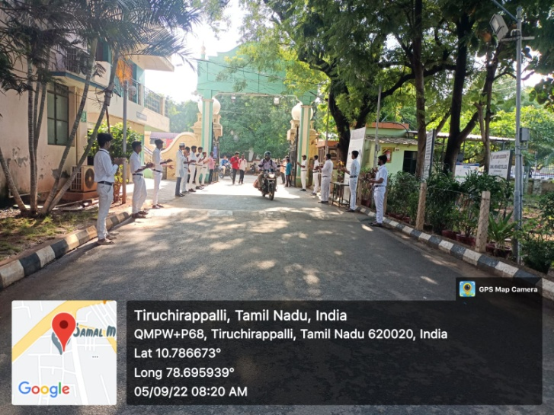 | 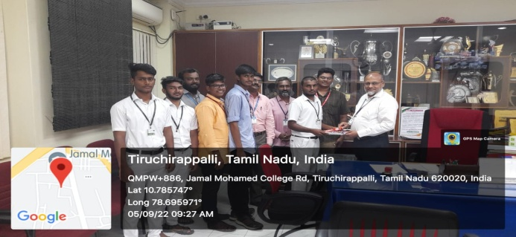
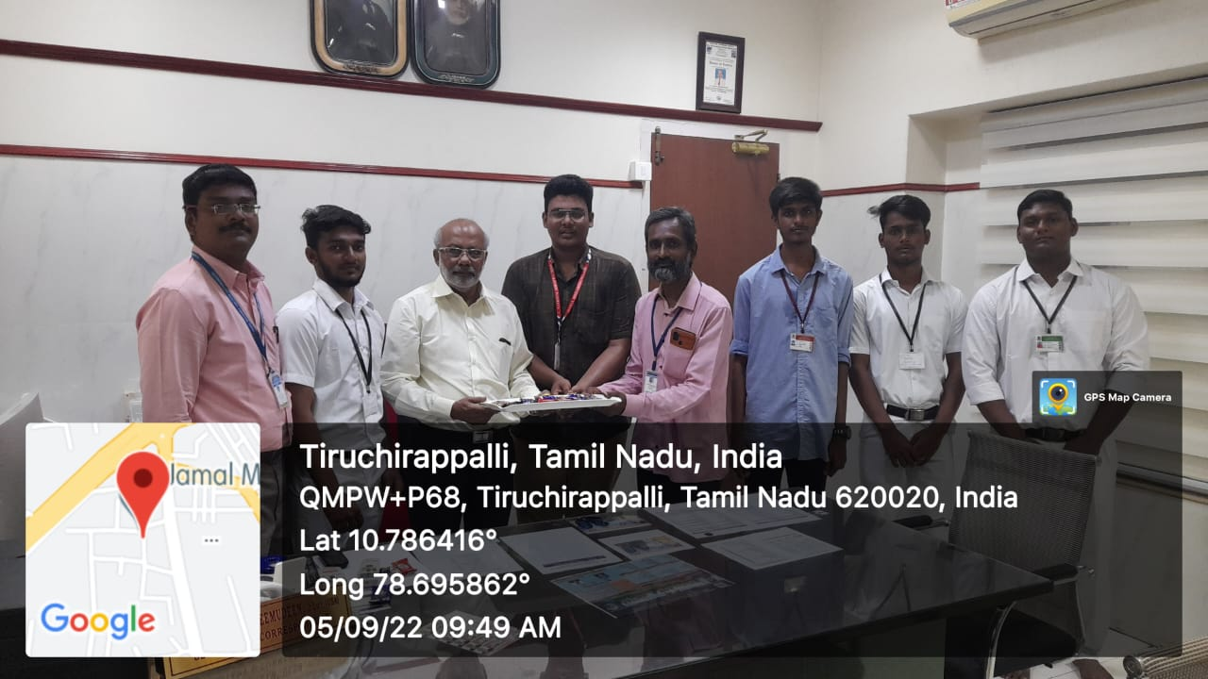 | 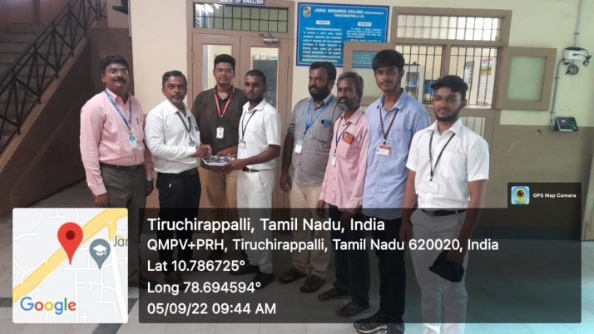

Drug Abuse Awareness Program

On the date of 06/09/2022, Drug Abuse Awareness Program was conducted by National Service Scheme of Jamal Mohamed College. In this program, special address (chief guest) was given by “Mr. Bharathi Mohan” (project director, DE addiction Center, Kajamalai Ladies Association). He delivered his speech about awareness of drug addiction. In this program, Our NSS volunteers, leaders and Officers attended this program. The program was successfully completed in a good manner.

Number of NSS Volunteers Participated: 125 Date: 06/09/2022

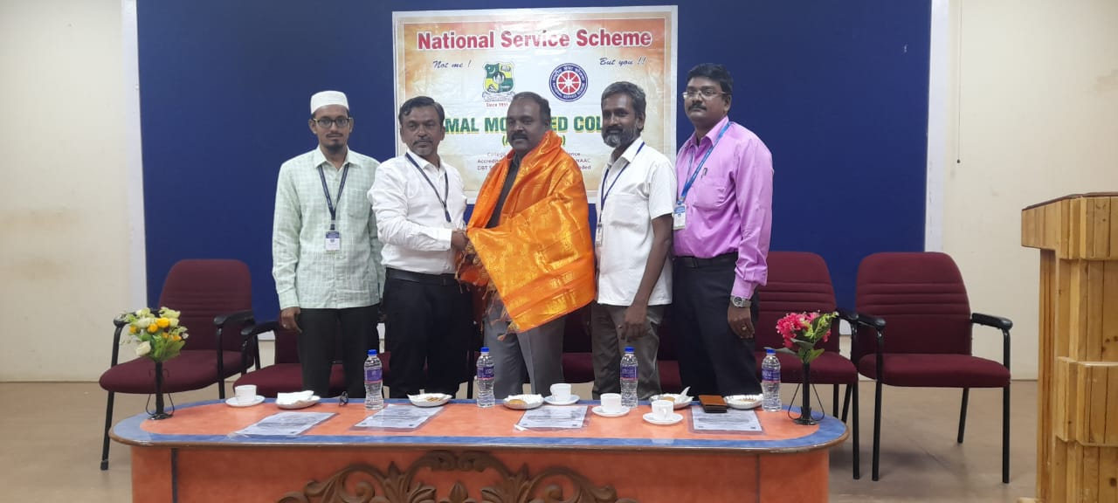 | 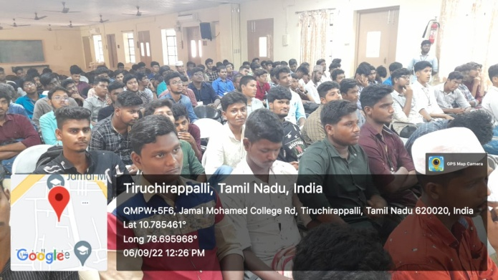

NSS Inaugural Function

On the date of 06 /09/2022, NSS Inaugural Function was Organized by National Service Scheme of Jamal Mohamed College. In this program, Our Part V Coordinator Mr. Sheik Ismail gave his Felicitation. After this our NSS volunteers were given refreshments and the program was completed successfully with the guidance of NSS leaders and Program Officers.
Number of NSS Volunteers Participated: 125 Date: 06/09/2022

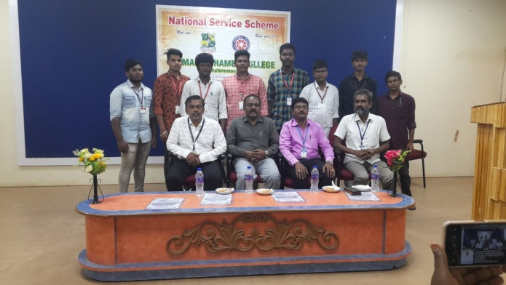
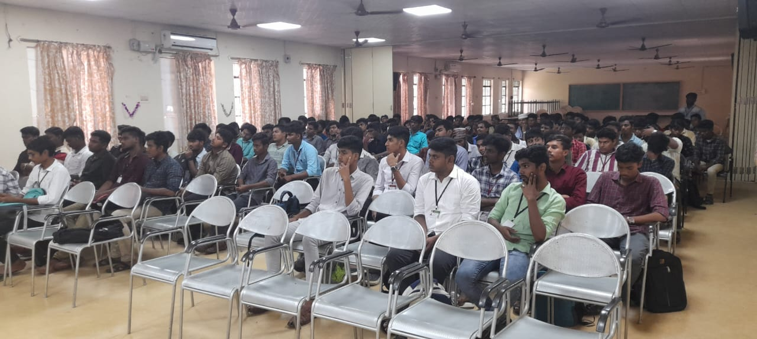

Rally for Book Festival

On the date of 13/09/2022, Rally for Book Festival was organized by Tiruchirappalli City Corporation and Government of Tamil Nadu. The Rally was started by Our District Collector Mr. Pradeep Kumar. So many Colleges participated in the Rally. Our NSS volunteers also participated and done their duty in a best way. By the guidance of traffic officers, NSS officers and NSS leaders the rally was completed by good manner.
Number of NSS Volunteers Participated: 50 Date: 13/09/2022

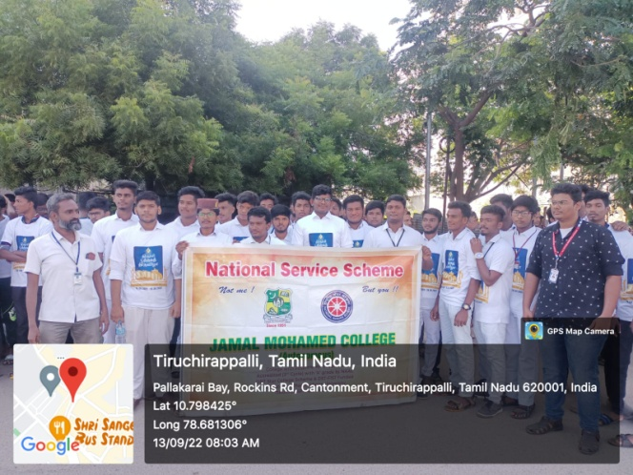 | 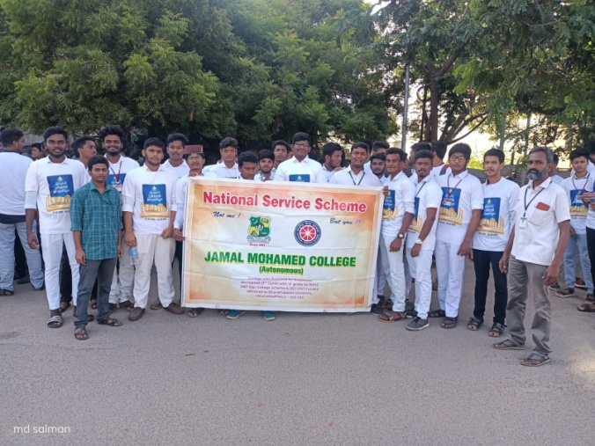
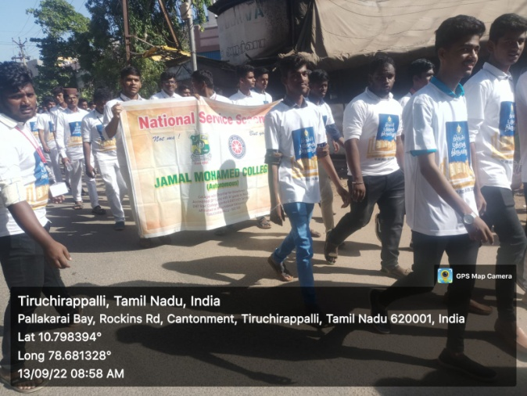 | 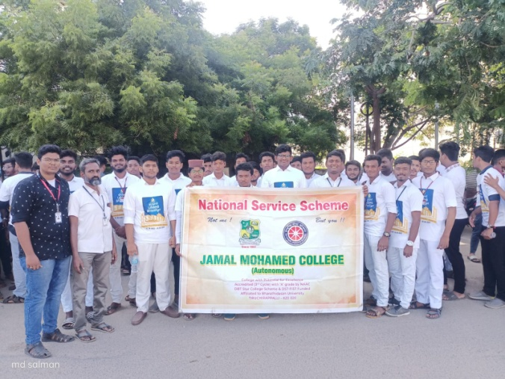

Sports Day

On the date of 16/09/2022, 71st Annual Sports Meet was organized by Jamal Mohamed College. In this event, our NSS volunteers participated in the march past event as two Contingents and got 1st prize. Lot of Sport Events were conducted by Physical Education Department and Prizes were distributed and felicitation was given by the Chief Guest Dr. M.A Mohamed Nizam Secretary & Correspondent of M.A.M. Group of Educational Institutions, Trichy. Some other NSS volunteers attended the Bike Rally Event of sports day. The program was completed in a good manner.
Number of NSS Volunteers Participated: 80 Date: 16/09/2022

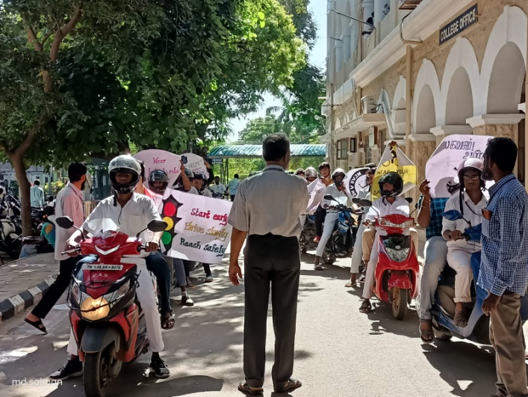 | 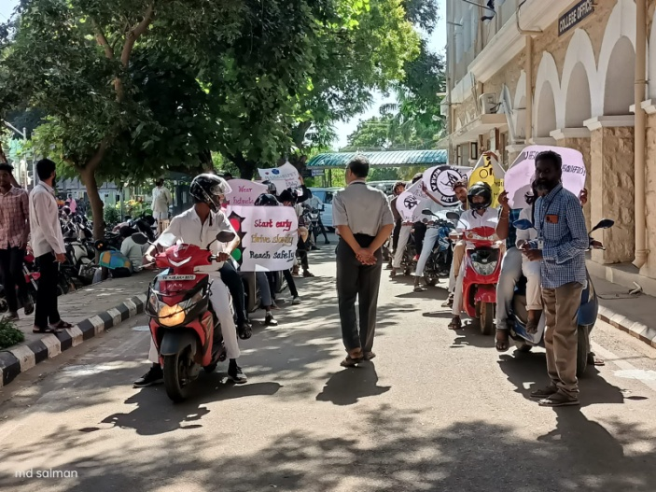
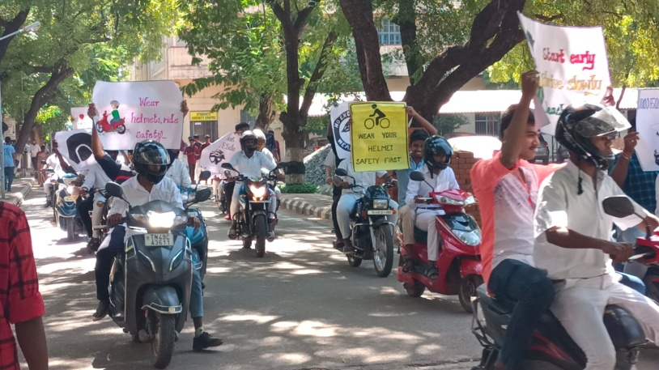 | 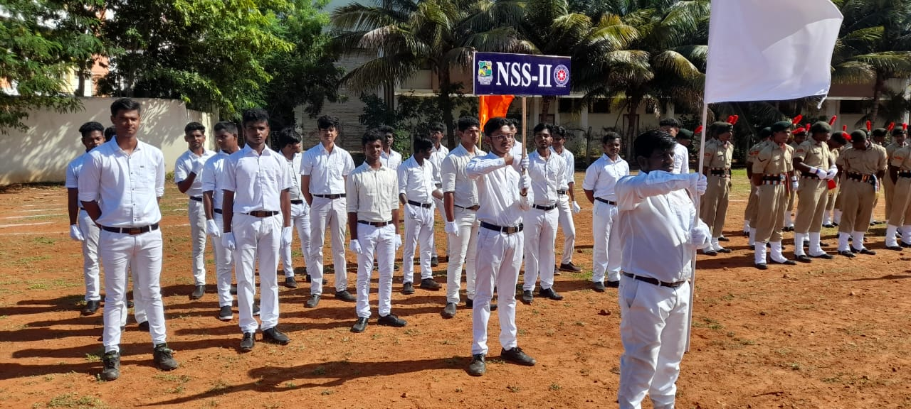
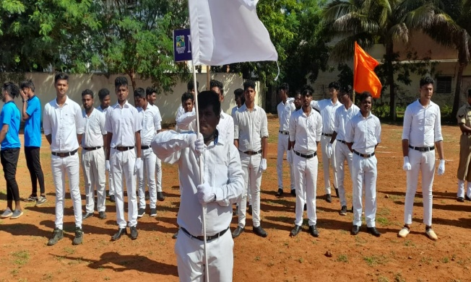 | 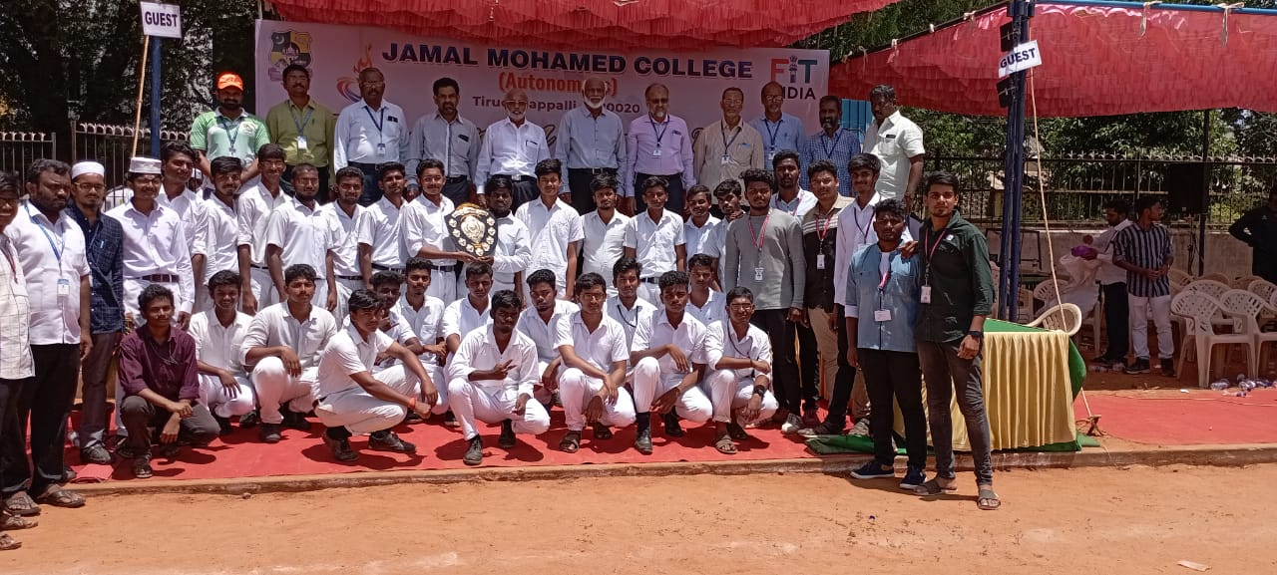
Pledge Taking (samuga nallinakkam)

On the date of 17/09/2022, Social Harmony Pledge was taken by Volunteers of National Service Scheme, Jamal Mohamed College. The pledge was taken in front of MBA block. In this program, our Honorable principal, secretary, program officers and students were taken pledge in the title of “samuga nallinakkam (Social Harmony)”. The pledge was taken in a good manner.

Number of NSS Volunteers Participated: 25 Date: 17/07/2022

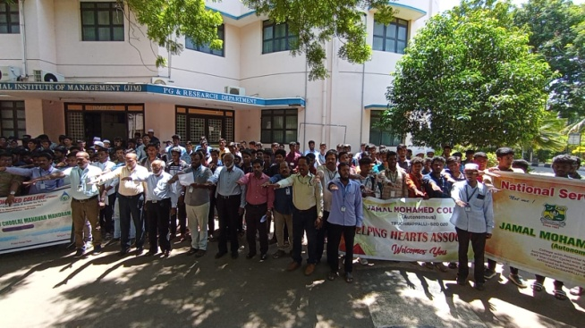

Deworming programme

On the date of 26/09/2022, Deworming Program was conducted by National Service Scheme of Jamal Mohamed College. In this program, deworming tablets are distributed by NSS volunteers to the students of Our College. Our Volunteers done their duty neatly with the guidance of NSS Leaders and Program Officers. The Program was a great success.

Number of NSS Volunteers Participated: 10 Date: 26/09/2022

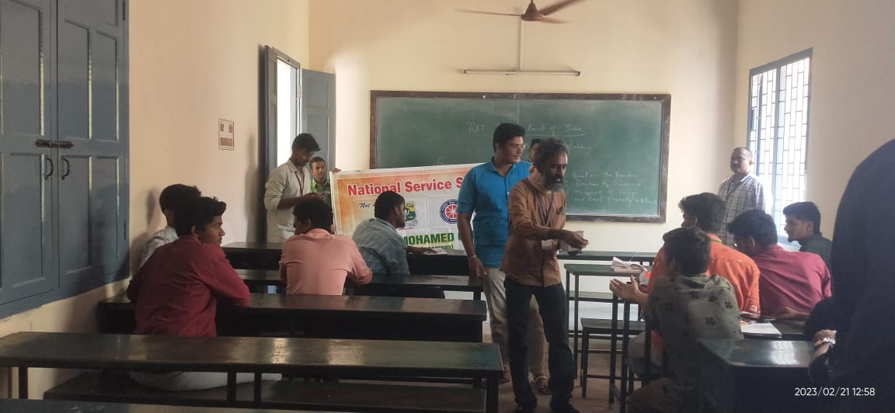 | 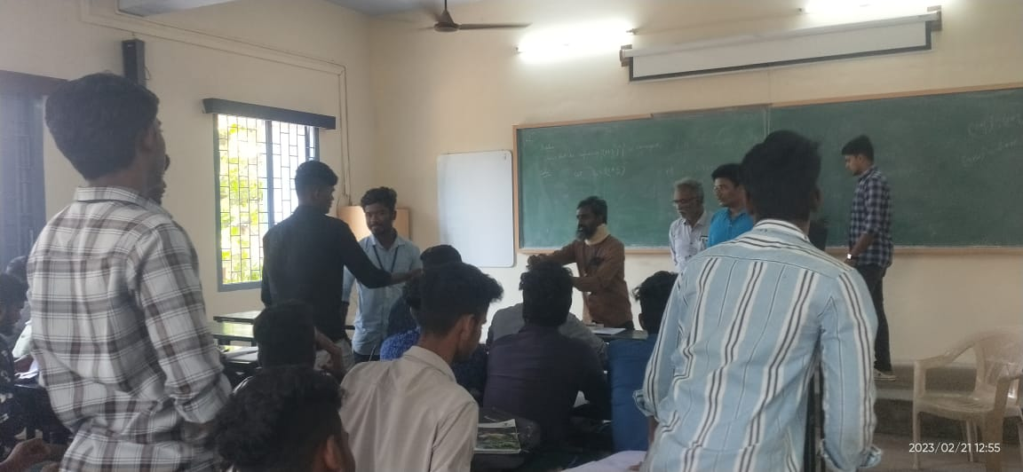

Book Release program

On the date of 27/09/2022, “Jamal Mohamed (Indian Merchant Prince and Nationalist) book was released by Prof. K.M. KADHAR MOHIDEEN (National Leader of Indian Union Muslim League) at NBAG Auditorium of Jamal Mohamed College. The Book was received by M. MOHAMED ABDULLAH (M.P). In this program, Author J.B.P. MORE gave special address. The Program was organized by NSS Volunteers in good manner with guidance Our NSS officers and NSS leaders. The program attained a great success.
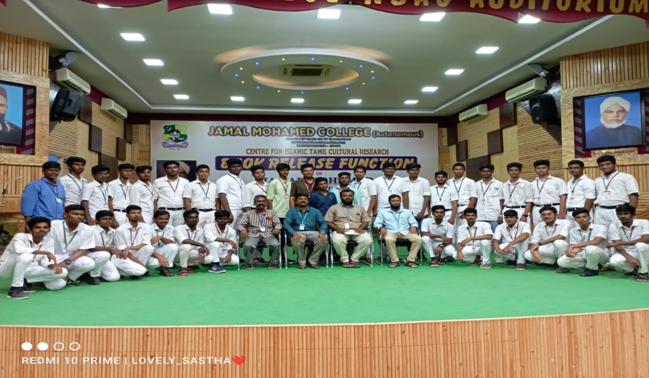
Number of NSS Volunteers Participated: 50 Date: 27/09/2022

NSS Day Celebration

On the date of 28/09/2022, NSS Day was celebrated by National Service Scheme of Jamal Mohamed College in Commerce(sf) Seminar Hall. In this program, Chief guest “Mr. Gregory, Project Director, Voice Trust, Trichy was given Special Address to our volunteers about Green Revolution and Entrepreneurship. All the NSS program done last year were showed as a PowerPoint Presentation in front of all the guests. After the presentation, the certificate given by Tiruchirappalli City Corporation was distributed to the students. The Program ended with a National Anthem sung by our volunteers and in a good manner.
Number of NSS Volunteers Participated: 150 Date: 28/09/2022

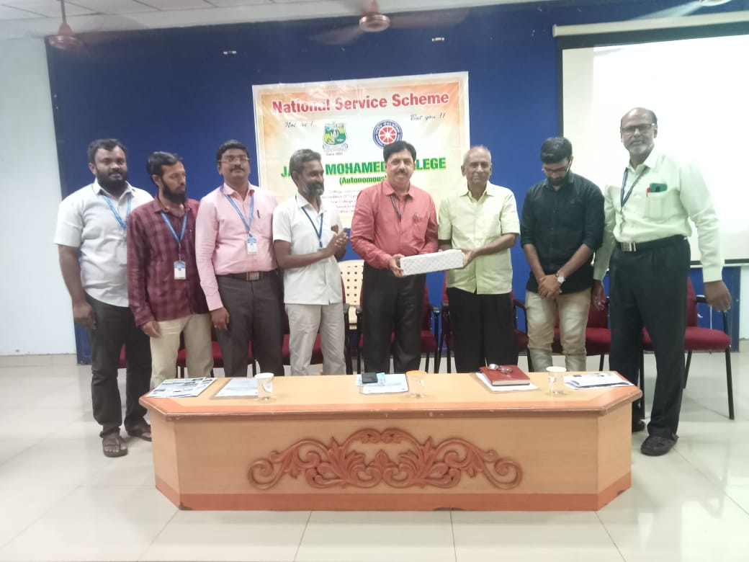 | 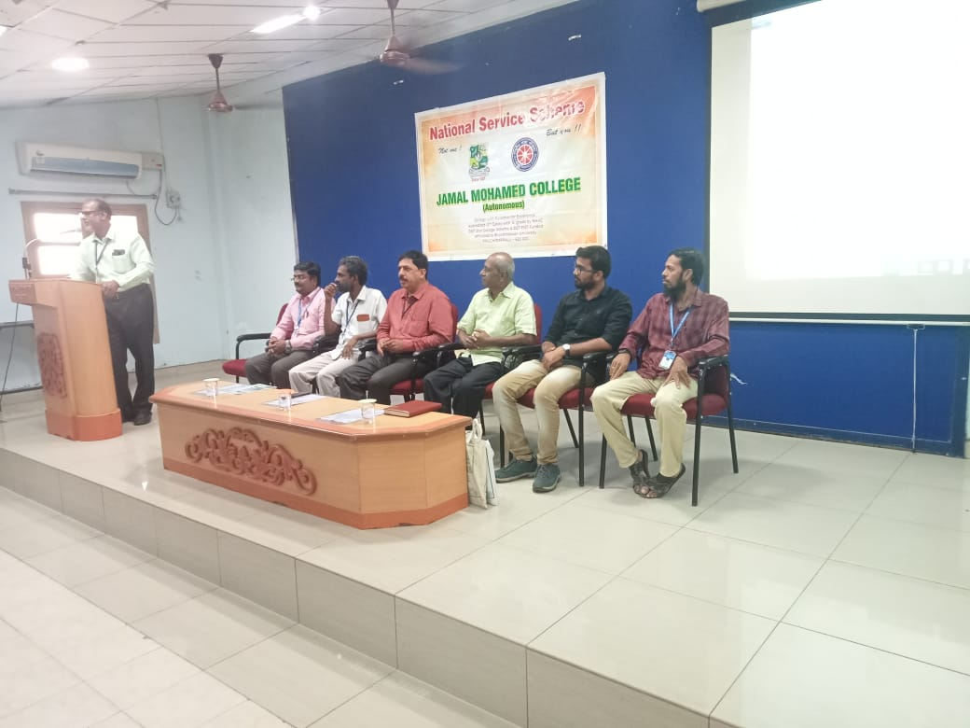
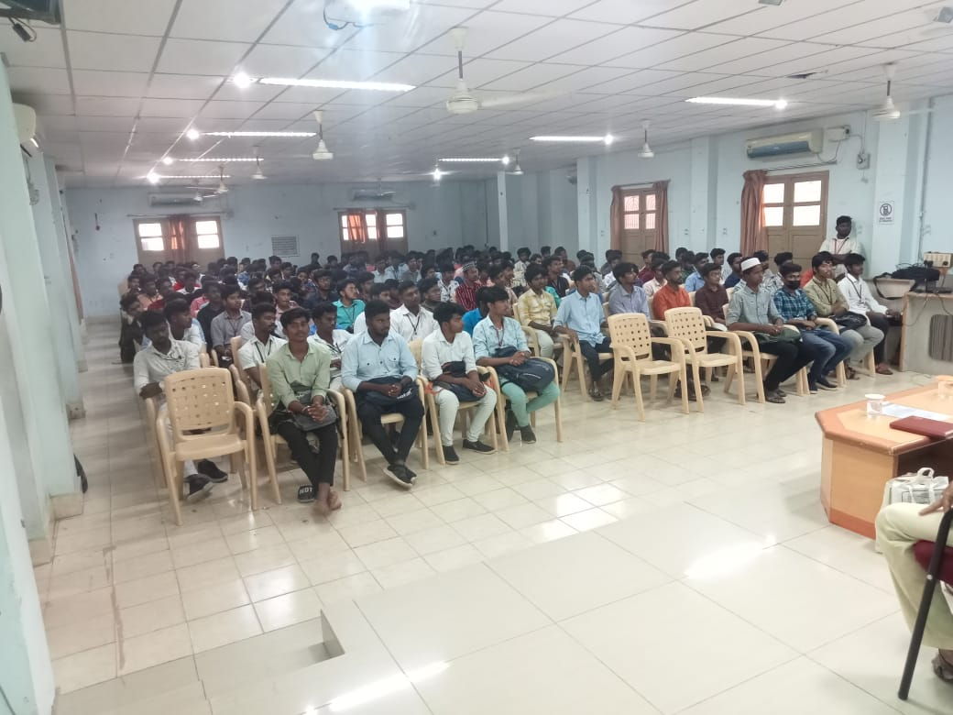 | 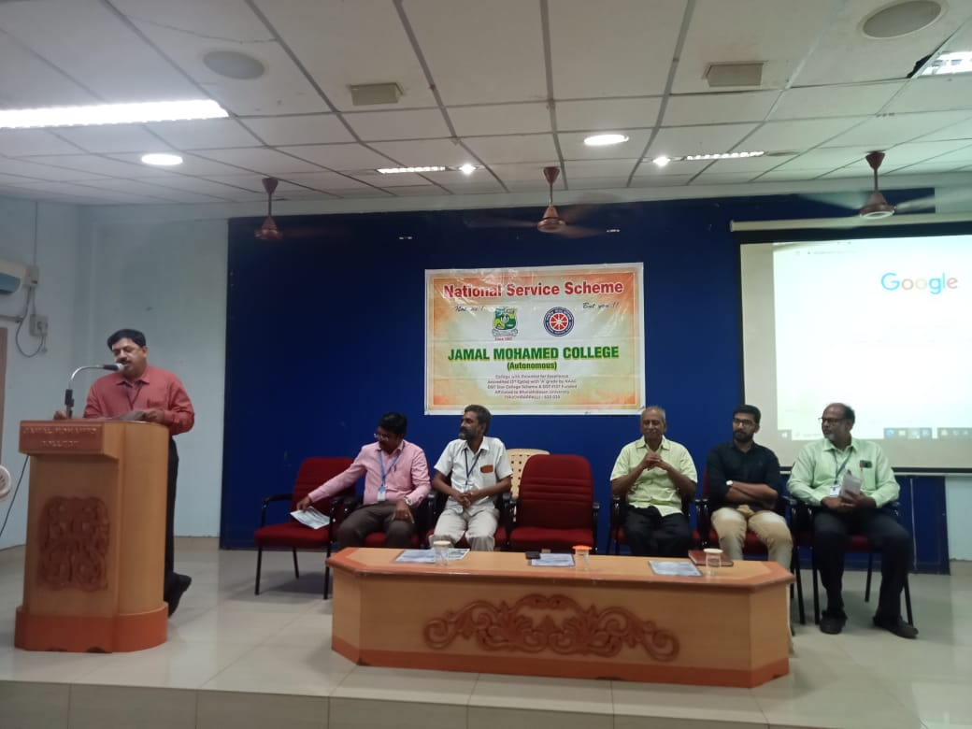
Program Officers Meeting at BDU

On the date of 29/09/2022, Program Officers’ meeting was organized by NSS Cell of Bharathidasan University. In this Program, Our Honorable Regional Director of NSS, Chennai Dr. C. Samuel Chelliah and NSS State Officer Dr. M. Senthil Kumar gave some Instructions to the Program Officers of all the Colleges under Bharathidasan University. Our NSS Coordinator of BDU Dr. Lakshmi Prabha also joined with them. They interacted with the program officers by asking their queries and needs. The program was a great success with the help of our volunteers.
Number of NSS Volunteers Participated: 20 Date: 29/09/2022

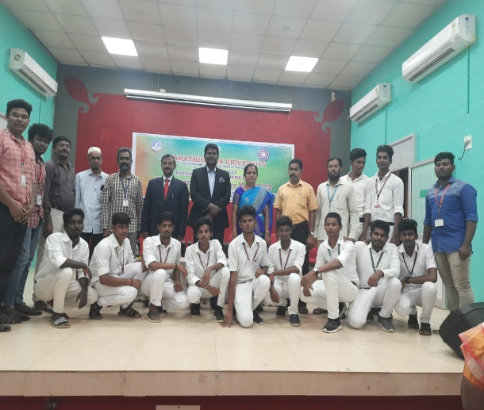 | 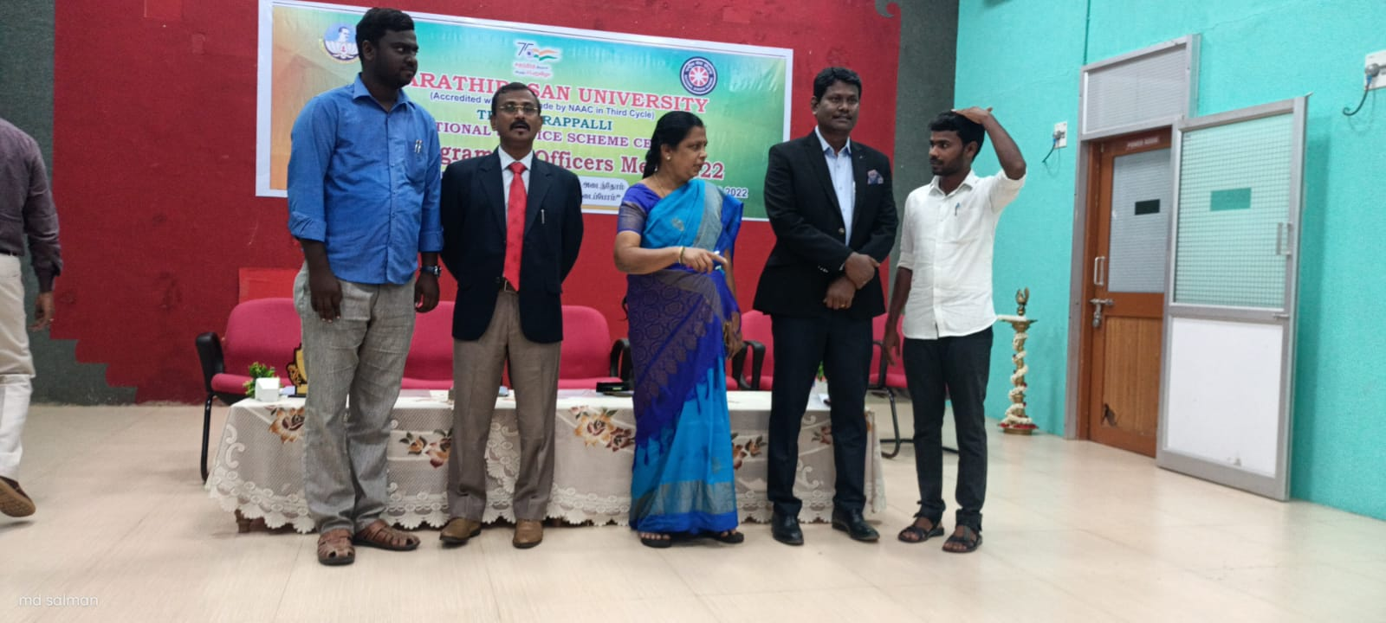

Pre RD Selection

On the date of 30/09/2022, University Level Pre Republic Day Parade Selection was held at Bharathidasan University. In This Event, Regional Director of NSS Dr. C. SAMUEL CHELLIAH has addressed about the Pre RD Selection and Dr. M. SENTHIL KUMAR State NSS Officer motivated all the participants and volunteers to actively participate in events. Our College NSS Volunteer S. ABDUR RAHMAN participated in the Parade Selection and gave his full effort. Our College NSS Program Officer instructed our NSS volunteers to attend the program and our NSS Volunteers done their services for the participants and did their best.
No. of NSS Volunteers of Participated: 25 Date:30/09/2022
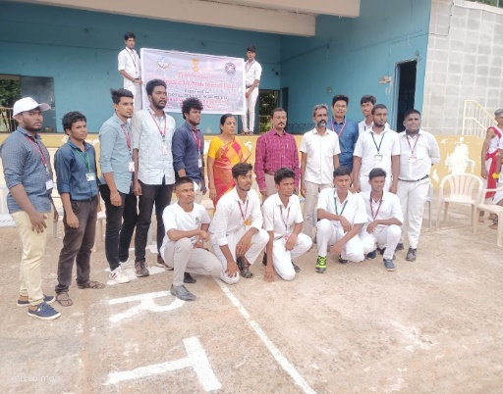 | 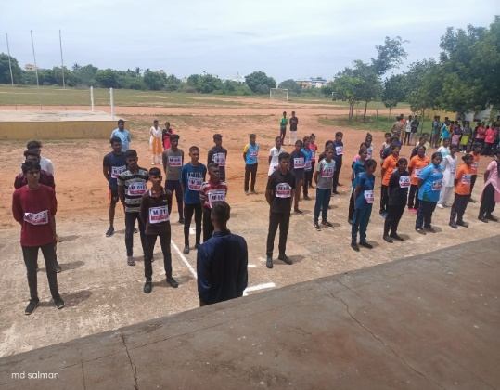

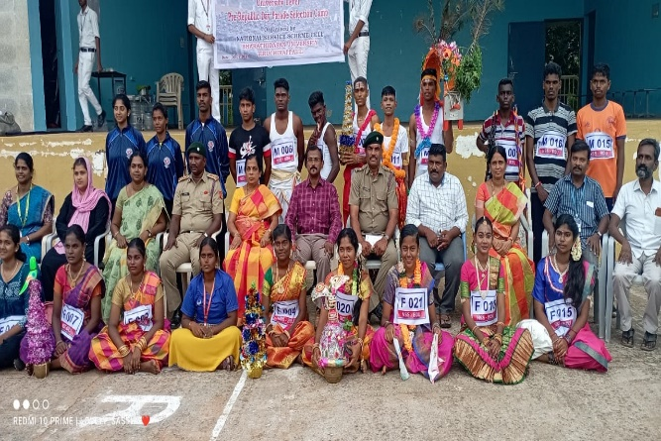

World Eye Sight Day

On the Date of 13/10/2022, World Eye Sight Day was celebrated at Joseph Eye Hospital. In this event, Deputy Commissioner of Police Mrs. Sridevi.
and NSS Coordinator of Bharathidasan University Dr. Lakshmi Prabha attended the Program and gave Special Address about Importance of Eye Safety and Awareness. In this program our NSS volunteer M. SIVA PRAKASH received appreciation certificate for highest blood donor in the year. After the Oath Taking Ceremony, The Event was Ended with a Balloon Release. The Program was completed in a Good manner with the guidance of our NSS Leaders and Program Officers.
Number of NSS Volunteers Participated: 115 Date: 13/10/2022
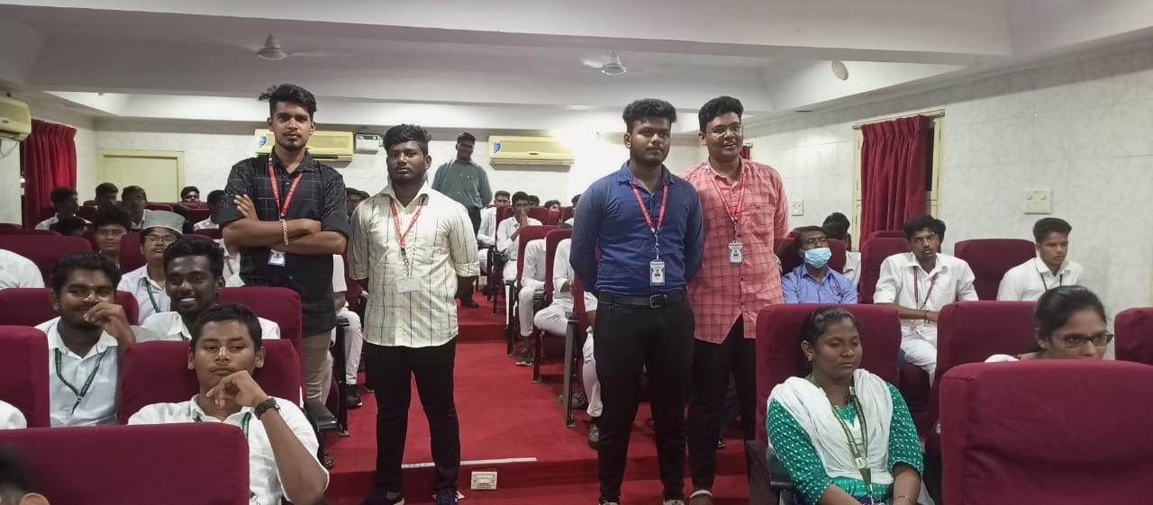 | 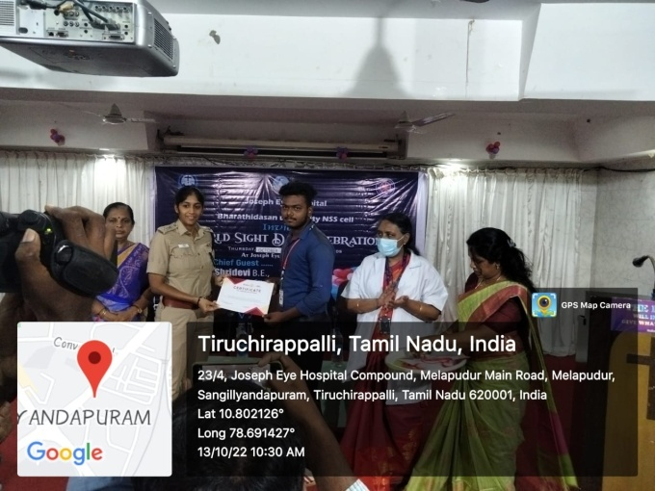
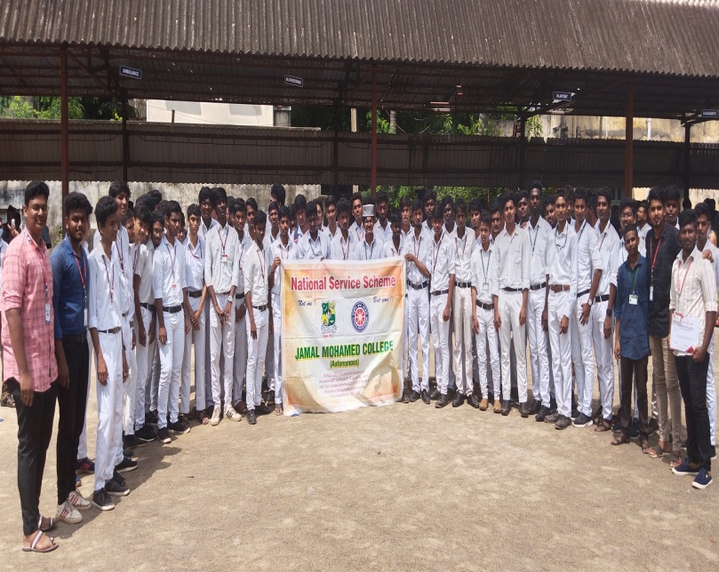 | 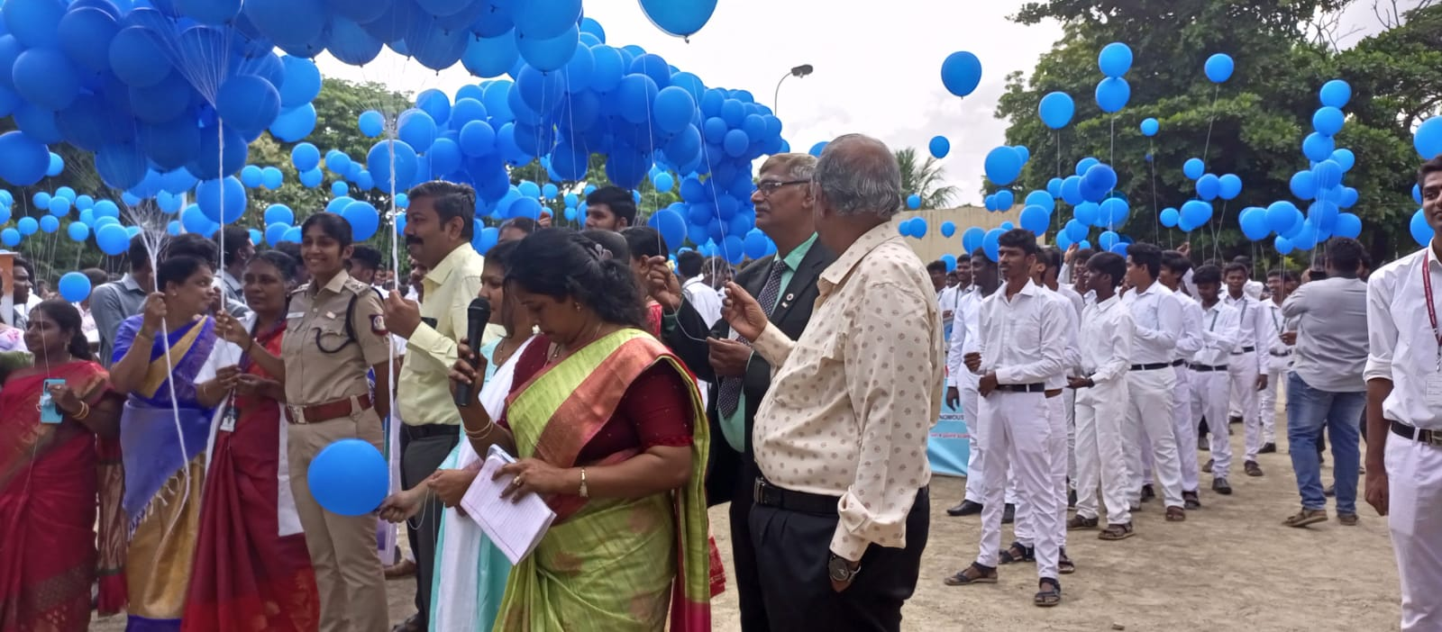

Clean India (Swachh Bharat) 2.0

On the date of 15/10/2022, “Clean India 2.0 was conducted by National service scheme of Jamal Mohamed College. The cleaning is held in front of Anna stadium (side of the road). Our NSS volunteers participated in the program and done their duty in a best manner. The program was completed in a good manner with the instruction of NSS leaders and NSS officers.
Number of NSS Volunteers Participated: 77 Date: 15/10/2022

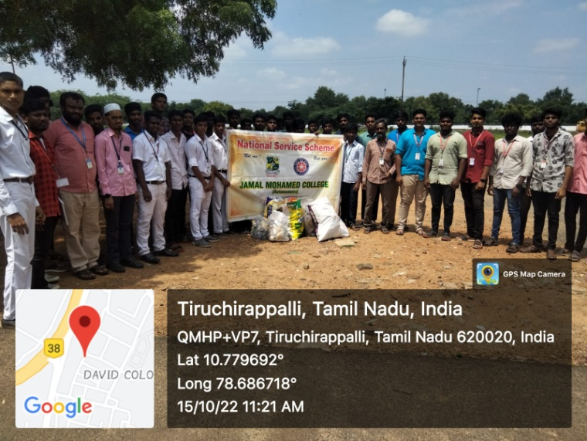 | 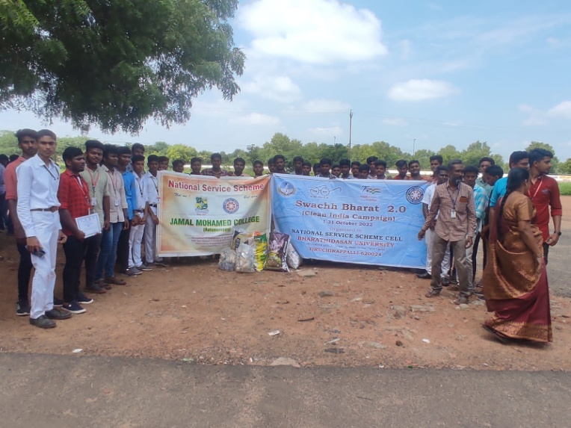

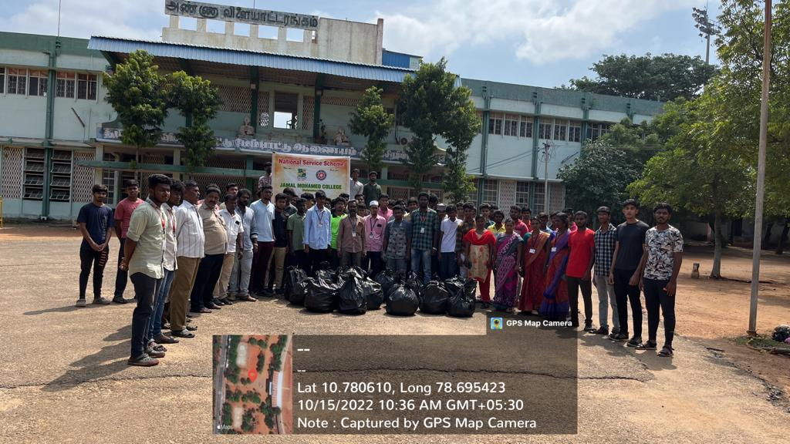 | 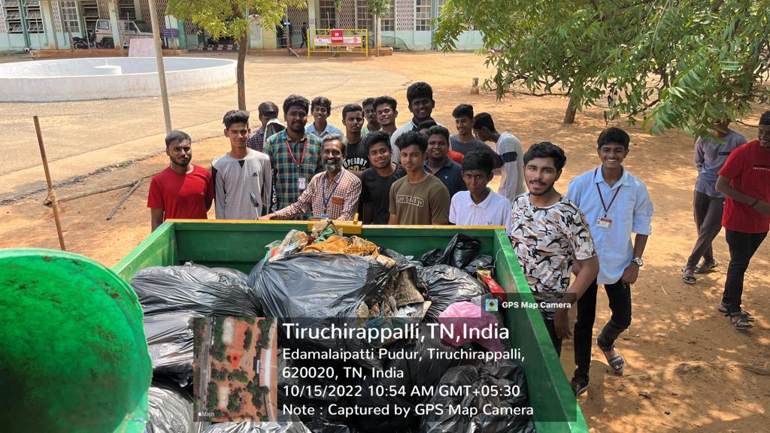
Youth awakening Rally

On the date of 15/10/2022, “On behalf of Former President Dr. A.P.J. Abdul Kalam’s Birthday Youth Awakening Rally was Organized by NSS Cell of Bharathidasan University and Police Department. NSS Coordinator of Bharathidasan University “Dr. Lakshmi Prabha” started the rally. The rally was started from Bharathidasan University Khajamalai Campus and finished at mannarpuram. Our college NSS volunteers participated in the rally. The program was completed in a good manner.
Number of NSS Volunteers Participated: 51 Date: 15/10/2022

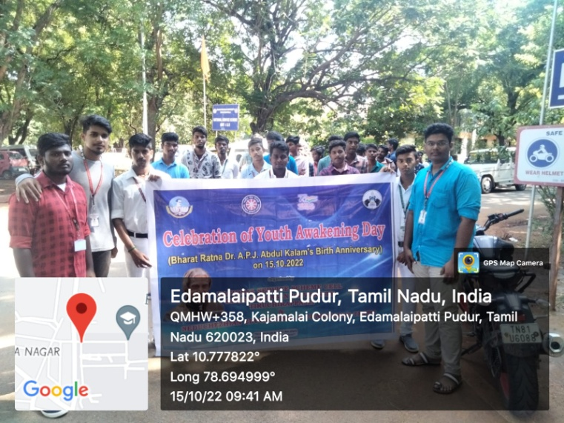 | 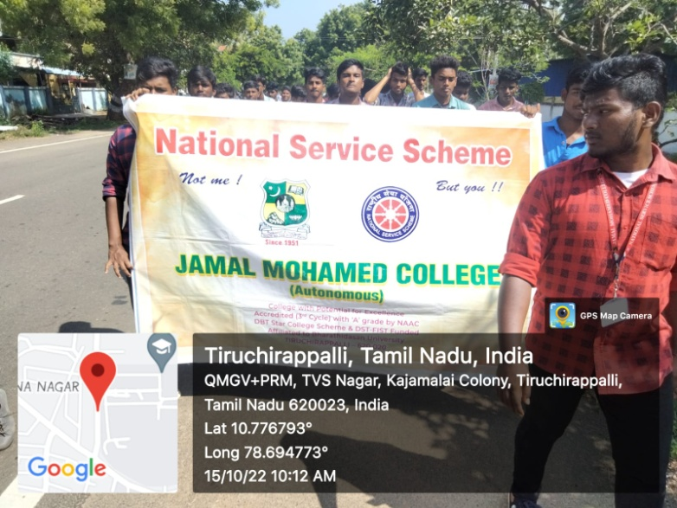
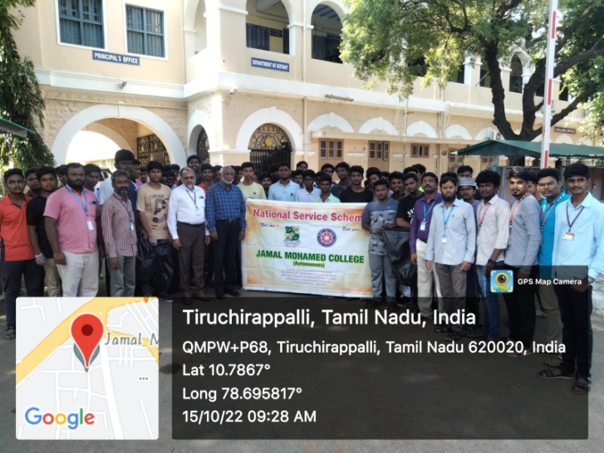 | 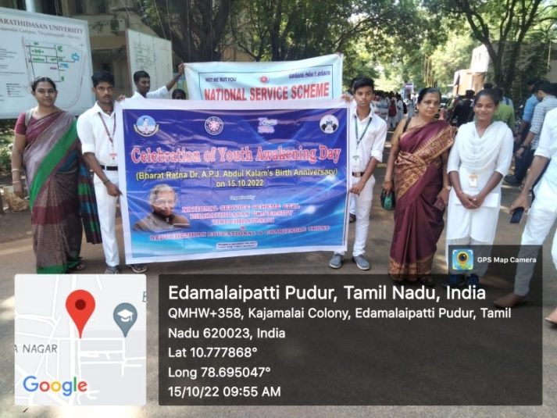

Eye camp

On the date of 19/10/2022, “Eye camp was conducted by Joseph Eye Hospital in Jamal Mohamed College. The Eye Camp was organized by National Service Scheme of our College. In this camp, free eye checkup was provided to our college faculties and students. They got benefited from this camp. The camp was organized and completed in a good manner by our volunteers with the guidance of NSS Leaders and Program Officers.
Number of NSS Volunteers Participated: 51 Date: 19/10/2022

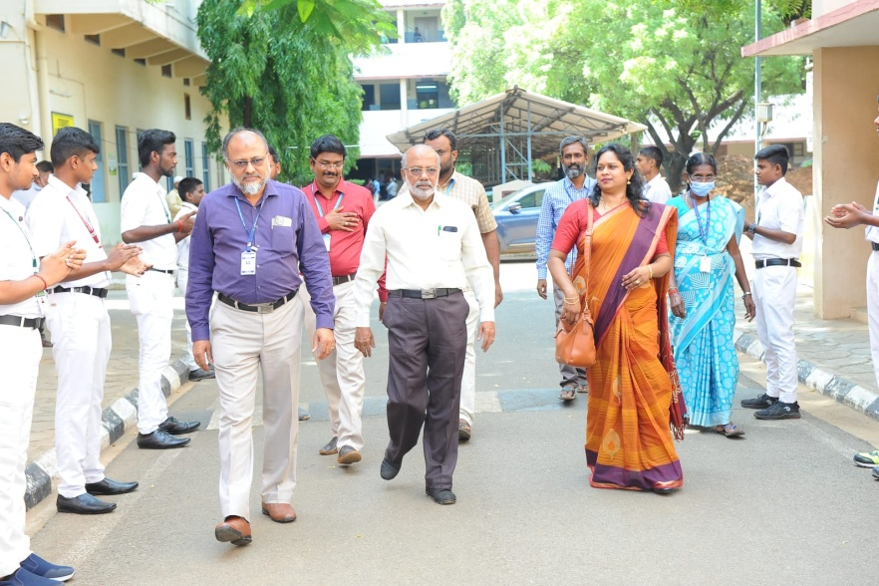 | 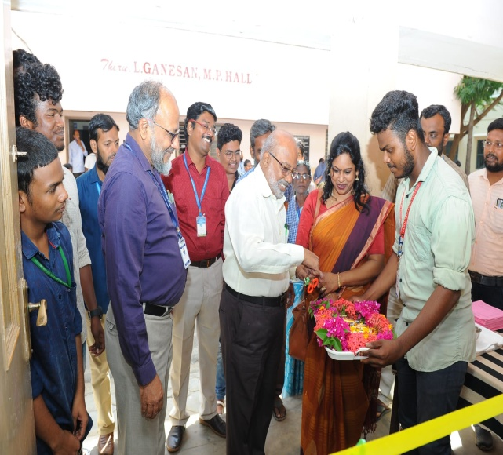
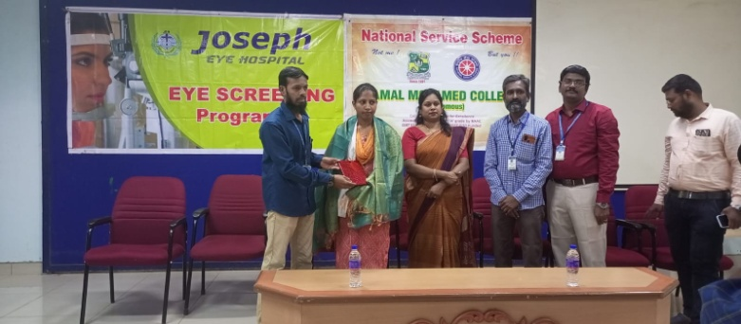 | 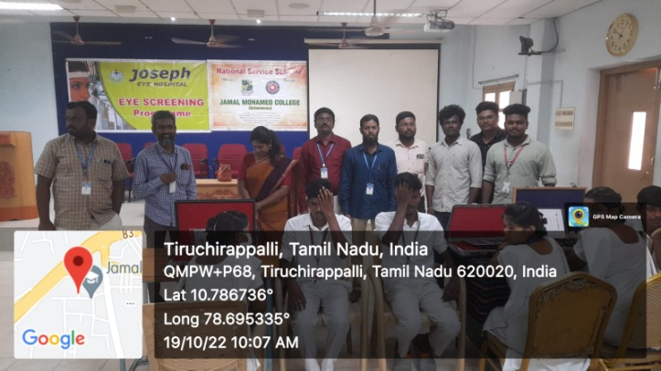
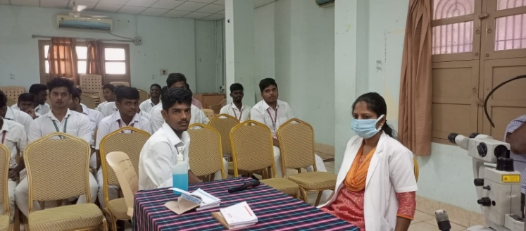 | 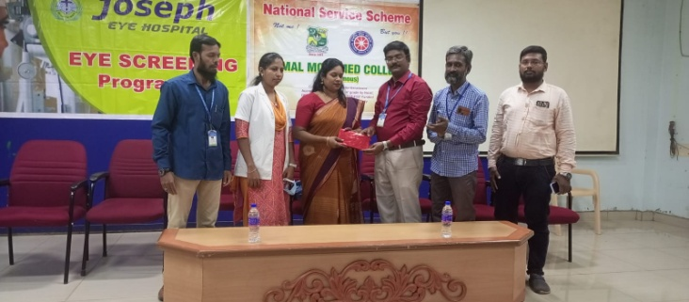

Diwali Awareness

On the date of 20/10/2022, Diwali Awareness Program was conducted by Joseph Eye Hospital. District fire Officer “Mrs. Ambika (chief Guest)” and NSS coordinator of Bharathidasan University “Dr. Lakshmi Prabha” (Guest of Honor) attended the program. In this program, our NSS volunteers witnessed safety drill awareness for fireworks done by Trichy Fire Station Officers. The Program was a great success with the guidance of NSS leaders and Program Officers. The program was completed in a good manner with the help of Our Volunteers.
Number of NSS Volunteers Participated: 125 Date: 20/10/2022

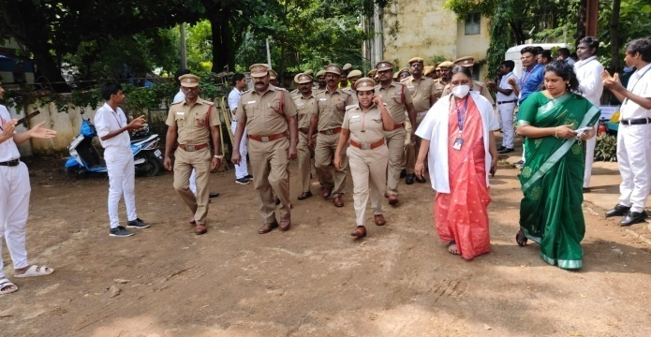 | 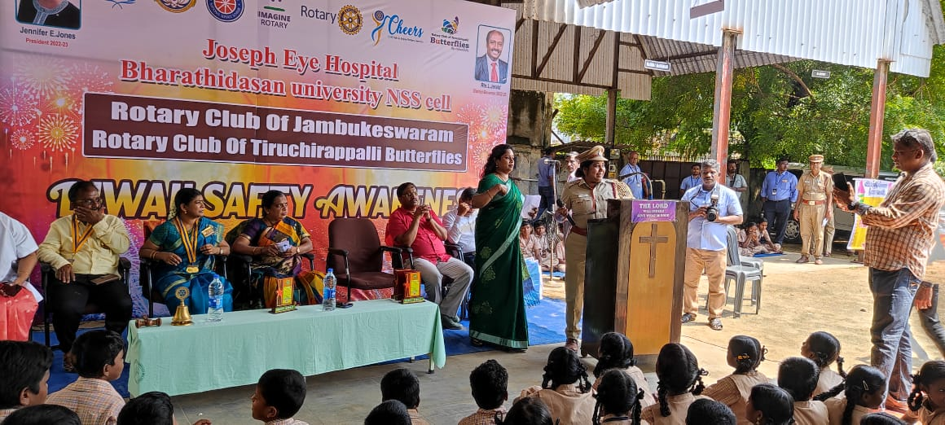
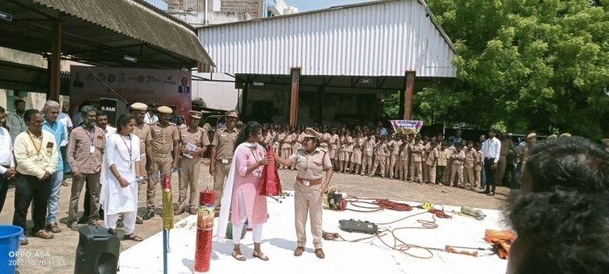 | 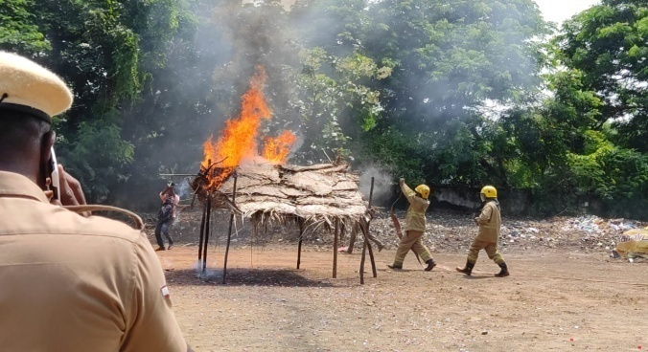
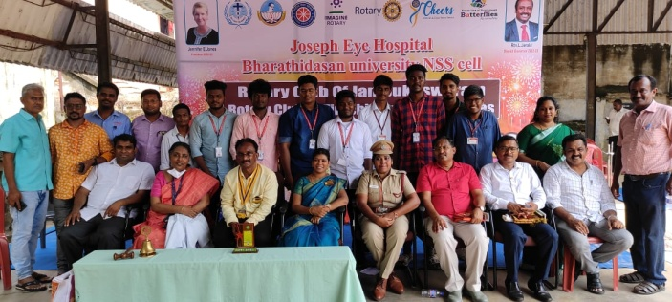 | 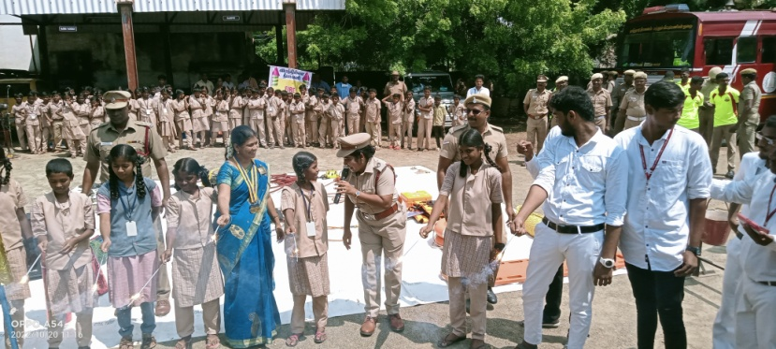
FIT INDIA RALLY 2.0

On the date of 31/10/2022, “Fit India Rally 2.0” was organized by NSS Cell of Bharathidasan University. The Rally was started by Vice Chancellor of Bharathidasan University Dr. M. Selvam. The rally takes place from BDU Khajamalai Campus to Anna Stadium Back Gate. Our NSS Volunteers Participated in the Rally 2.0 with the guidance of NSS leaders and NSS officers.
Number of NSS Volunteers Participated: 68 Date: 31/10/2022

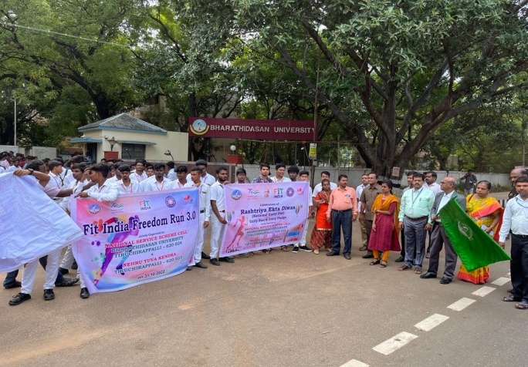 | 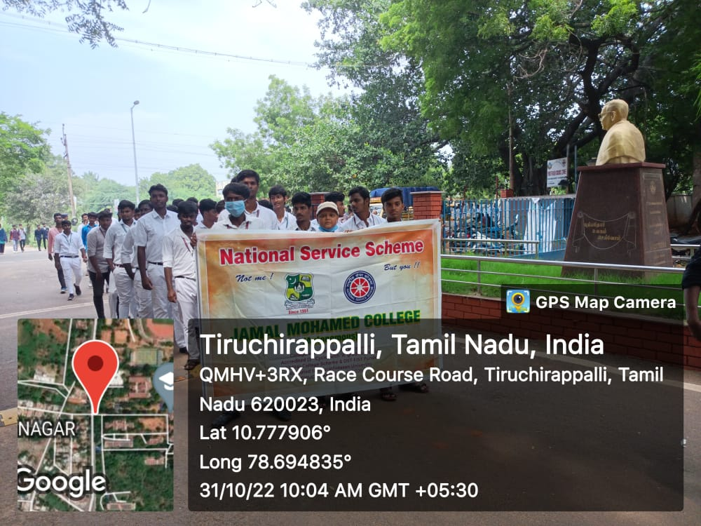
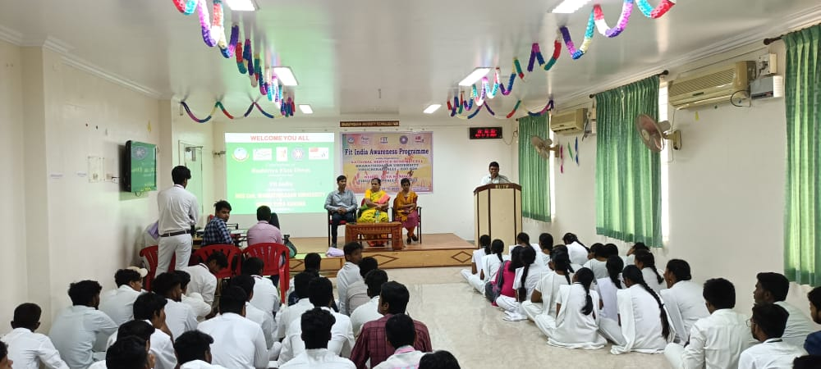 | 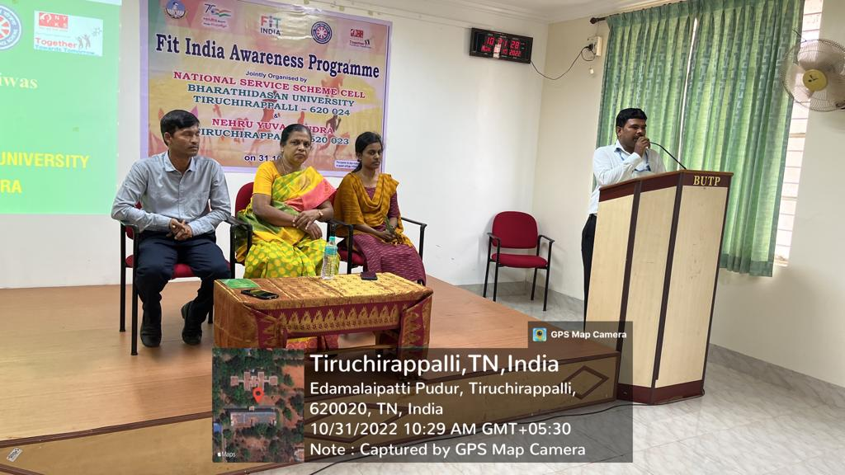

Unity Day Pledge

On the Date of 31/10/2022, Unity Day Pledge taking was conducted by National Service Scheme of Jamal Mohamed College. In this program, Our Volunteers and Program officers taken pledge about developing Unity and Co-ordination between students. The program was completed in a good manner with the instruction of NSS Leaders and Program Officers.

Number of NSS Volunteers Participated: 25 Date: 31/10/2022

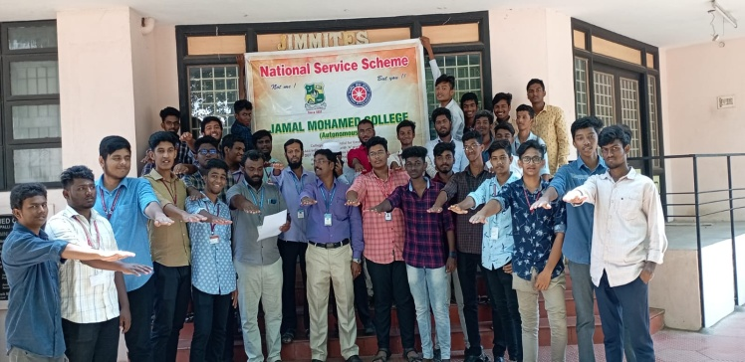

Orientation programme

On the Date of 01/11/2022, Orientation program was organized by National Service Scheme of Jamal Mohamed College. In this program, Associate Prof. of PG and Research Department of Chemistry, Dr. M. Syed Ali Padusha delivered his Valuable Speech to our NSS volunteers. After the Special Address, Cultural event was organized by our Volunteers in an energetic way.
After the cultural event the program was completed in a good manner.
Number of NSS Volunteers Participated: 220 Date: 01/11/2022

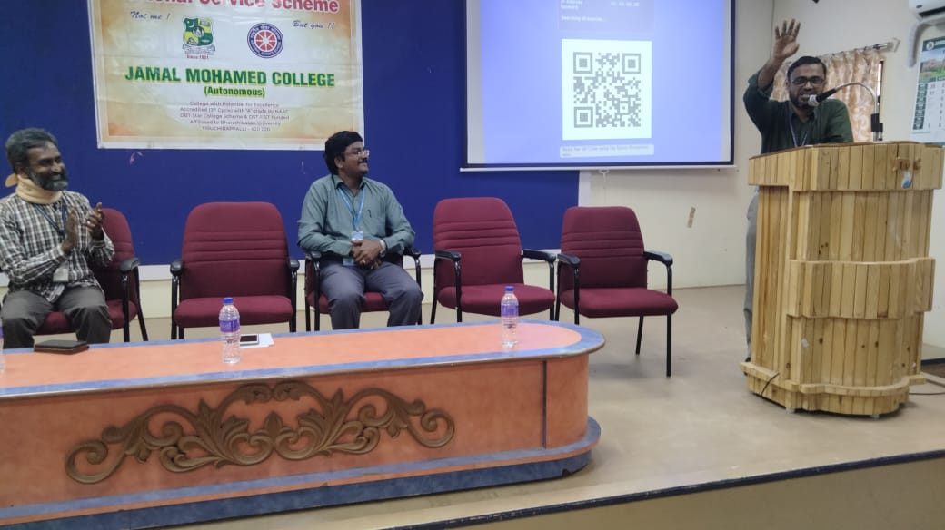 | 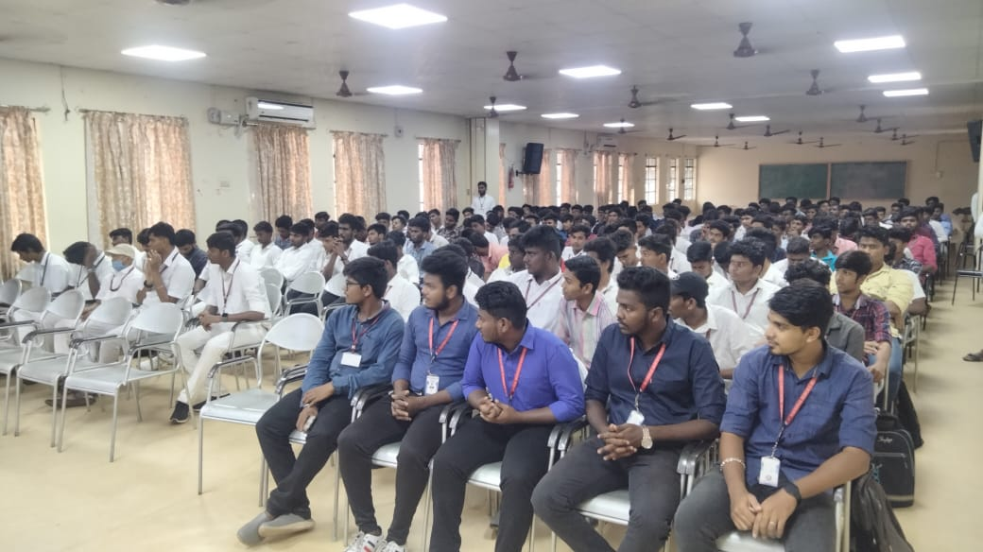
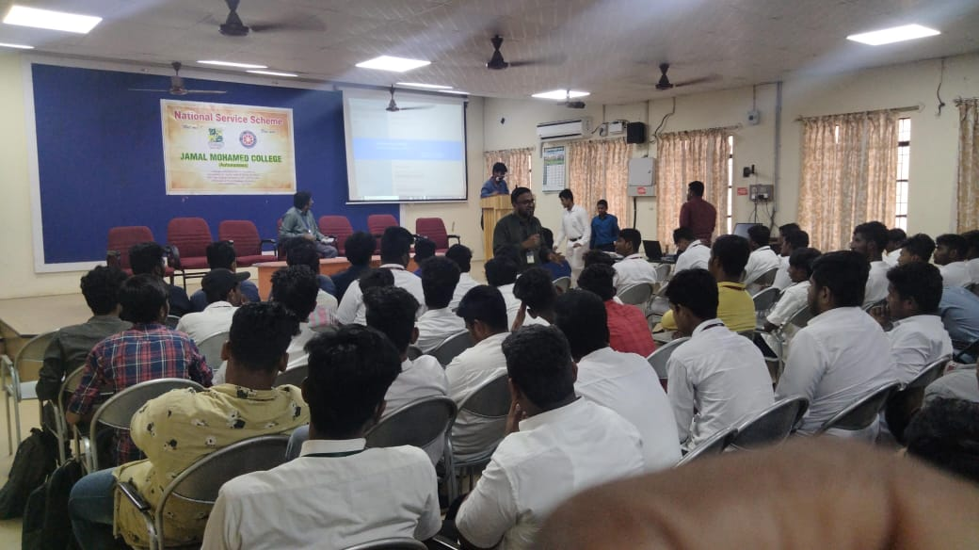 | 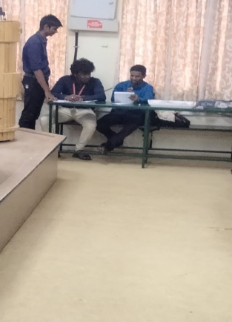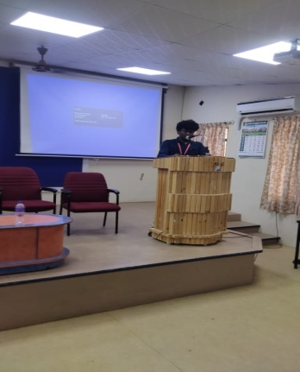

\
Student Induction Program

On the date of 07/11/2022 and 08/11/2022, Students Induction Program was conducted in Bharathidasan University for Fresh Integrated and PG students. Our NSS Volunteers participated in this program and Orientated the students by showing around the University Campus. The Program attained a great success with the guidance of NSS Leaders and Program Officers.
Number of NSS Volunteers Participated: 50 Date: 07/11/2022

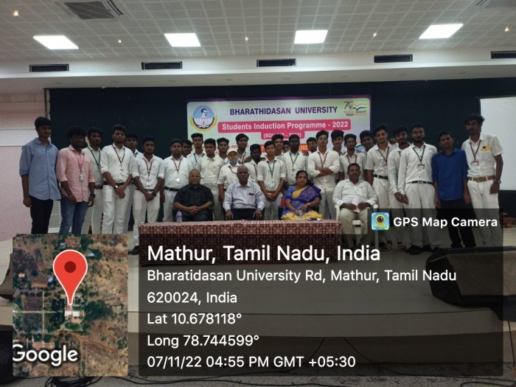 | 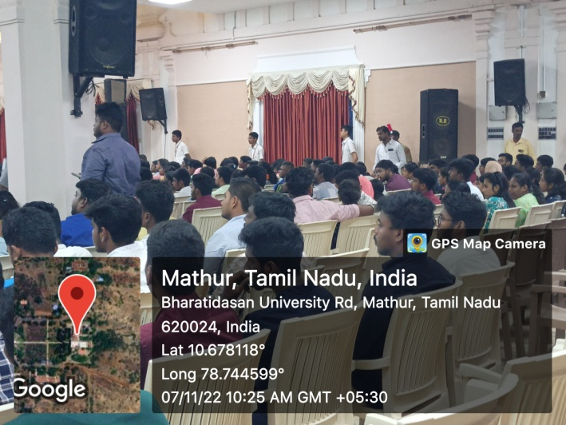
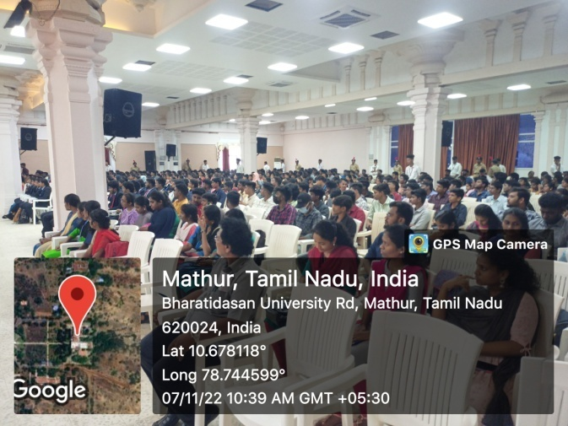 | 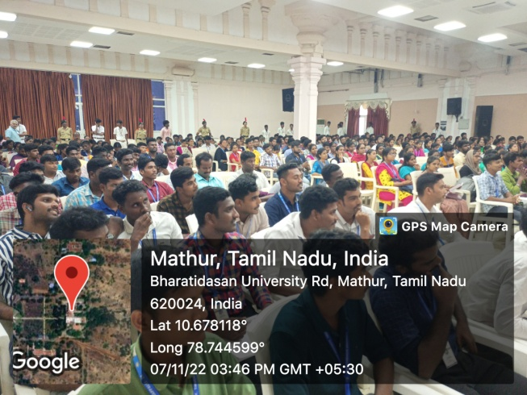
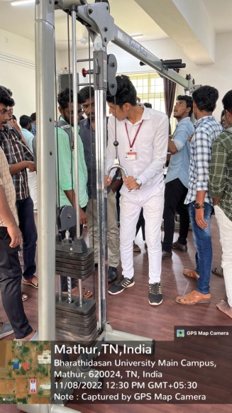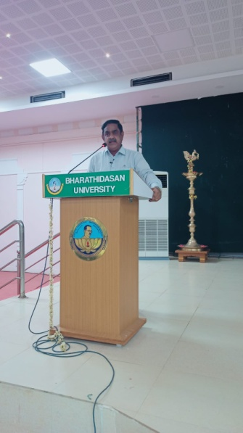 | 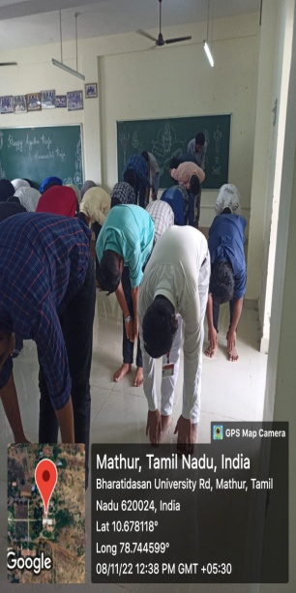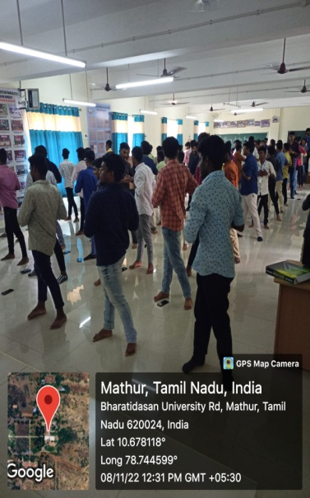
Blood Donation Camp

On the Date of 15/11/2022, Blood Donation camp was Organized at Jenny’s academy. In this Camp, some of our NSS volunteers participated and donated their blood.

Number of NSS Volunteers Participated: 04 Date: 15/11/2022

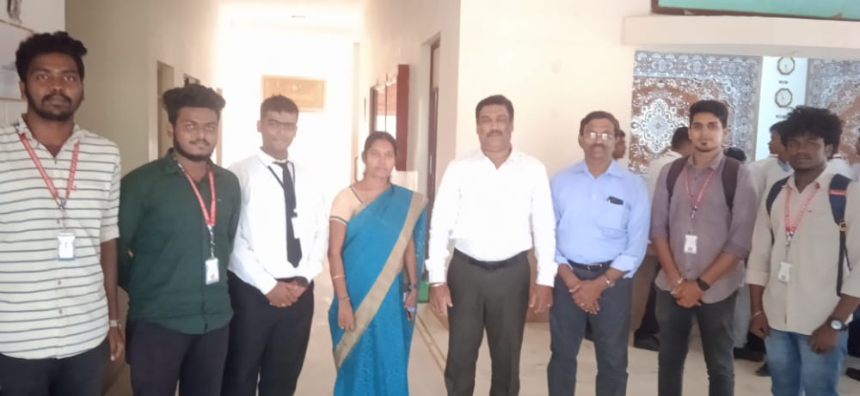 | 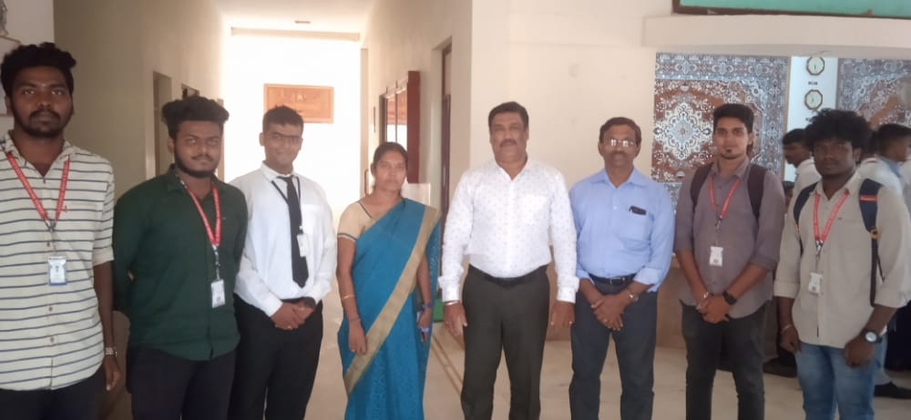

Placement cell program

On the Date of 14/12/2022, Placement Interview was conducted by Placement Cell of Jamal Mohamed College. HCL Company conducted the campus interview for Final Year UG and PG Students in our college. They recruited more than 20 candidates. Our NSS volunteers organized the program and completed it in a Good manner
.
Number of NSS Volunteers Participated: 6 Date: 14/12/2022

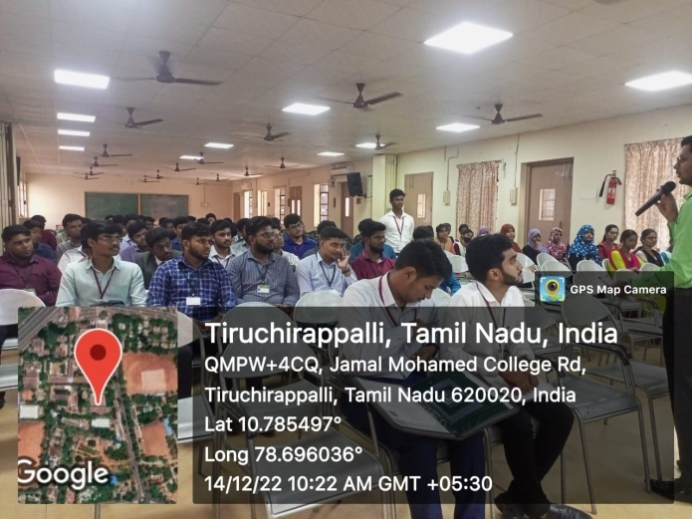 | 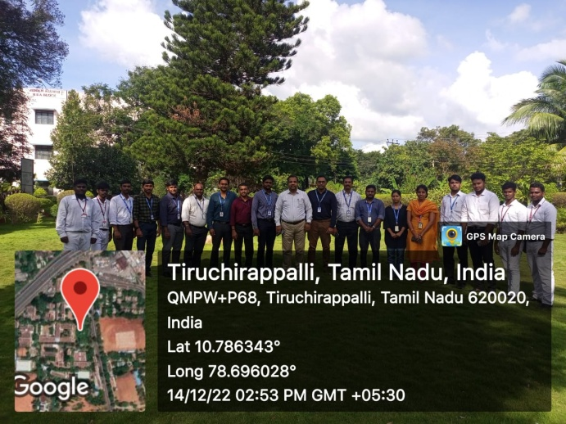
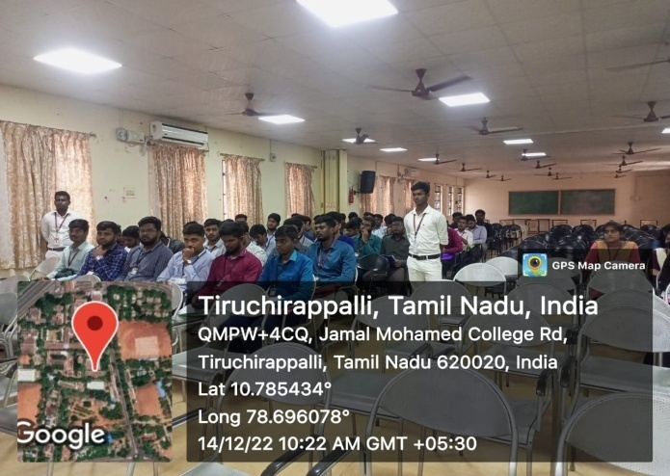 | 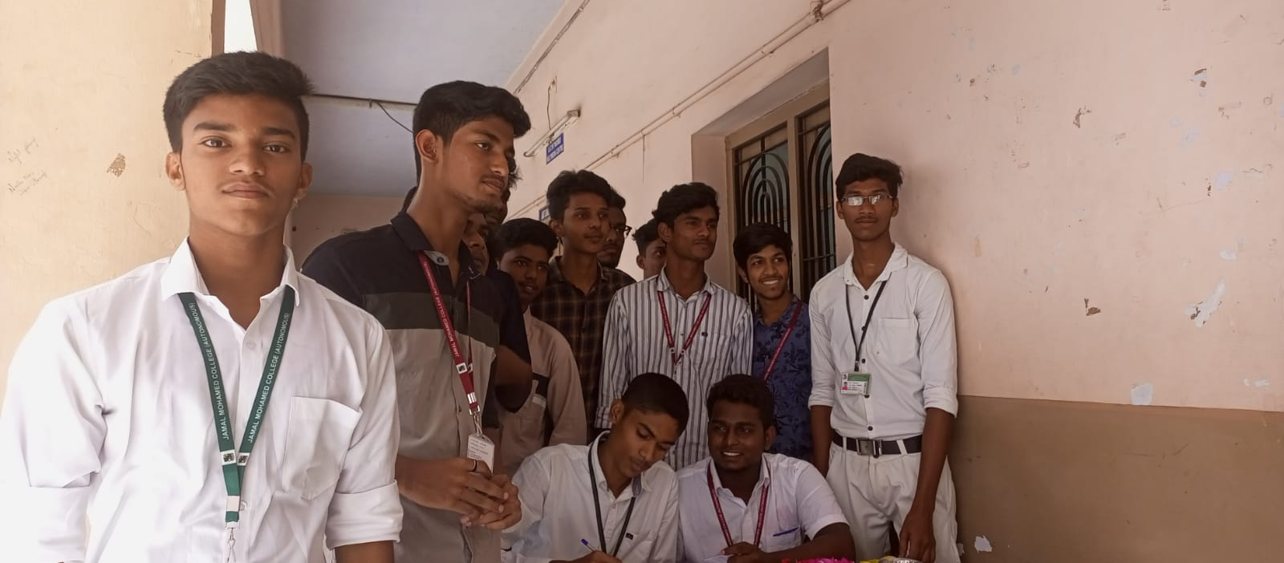

Constitution day program

On the Date of 20/12/2022, Opening Ceremony of Constitution Preamble Banner was conducted by Jamal Mohamed College National Service Scheme. In this program, our College Secretary, Joint secretary and Principal were attended the program. Our College Principal Dr. M. Ismail Mohideen gave introduction about our Indian Constitution and Our Secretary Dr. K. Khaja Nazeemudeen talked about the benefits of studying the constitution. The Constitution Preamble Banner was opened by our Secretary. The program completed in a good manner by our volunteers.

Number of NSS Volunteers Participated: 50 Date: 20/12/2022
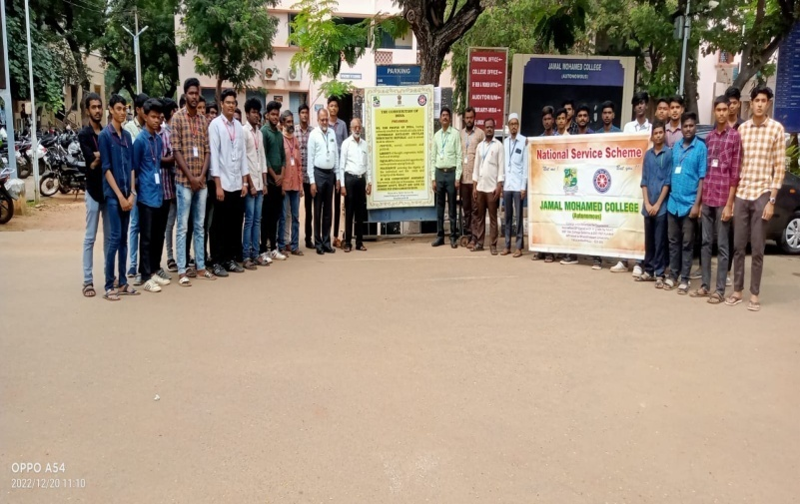 | 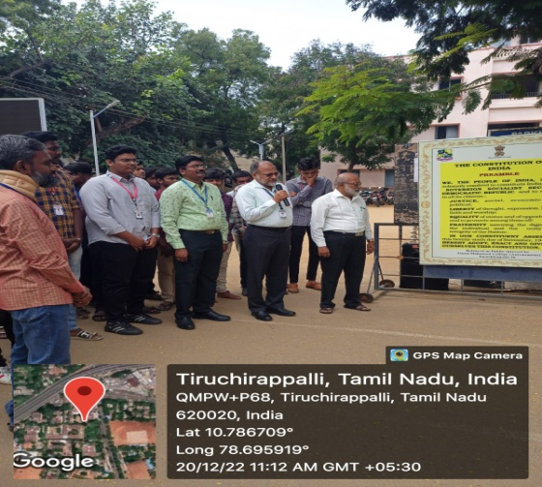
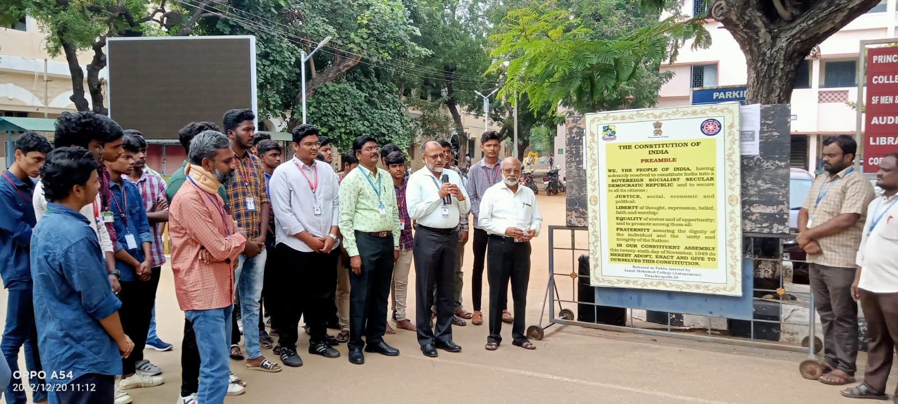 | 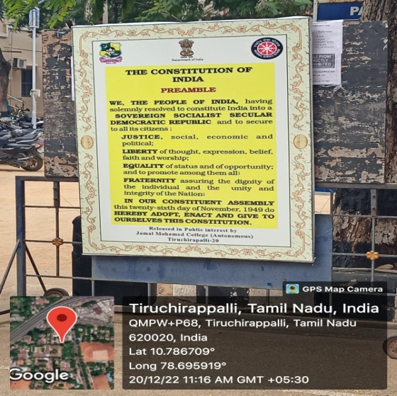
Placement Cell Program

On the Date of 21/12/2022, Placement Interview was conducted by Placement Cell of Jamal Mohamed College. VEE TECHNOLOGIES conducted the campus interview for Graduated Students of All Colleges. 30 Candidates were recruited by them. Our NSS Volunteers organized the program and completed it in a good manner.

Number of NSS Voulnteers Participated: 20 Date: 21/12/2022

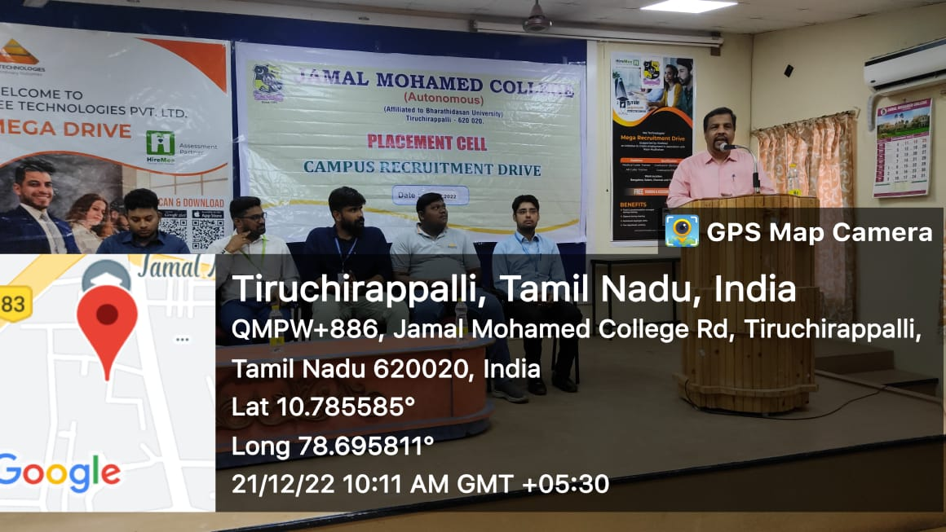 | 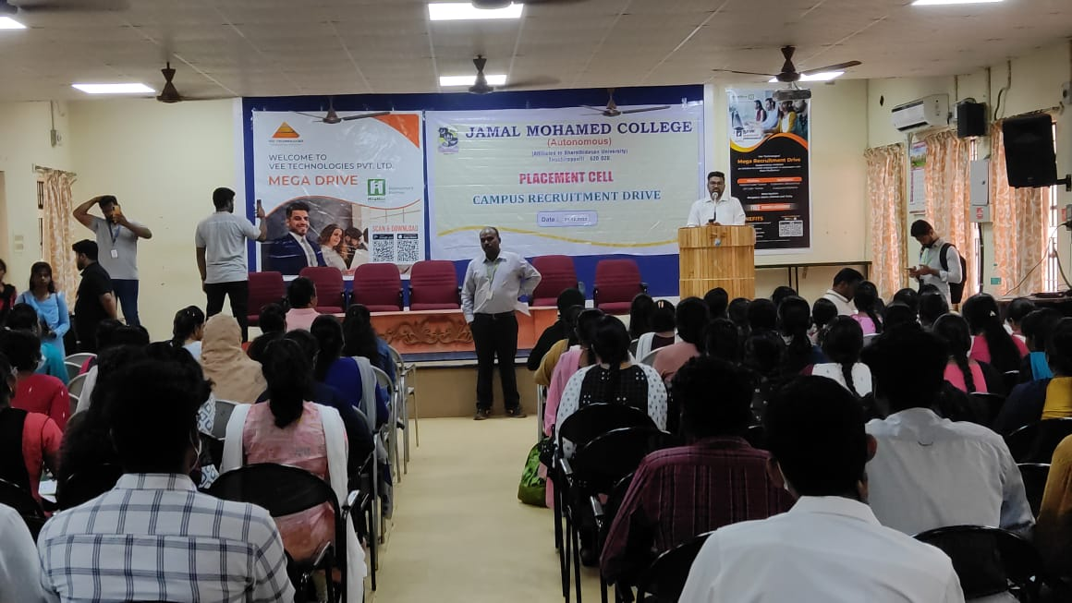
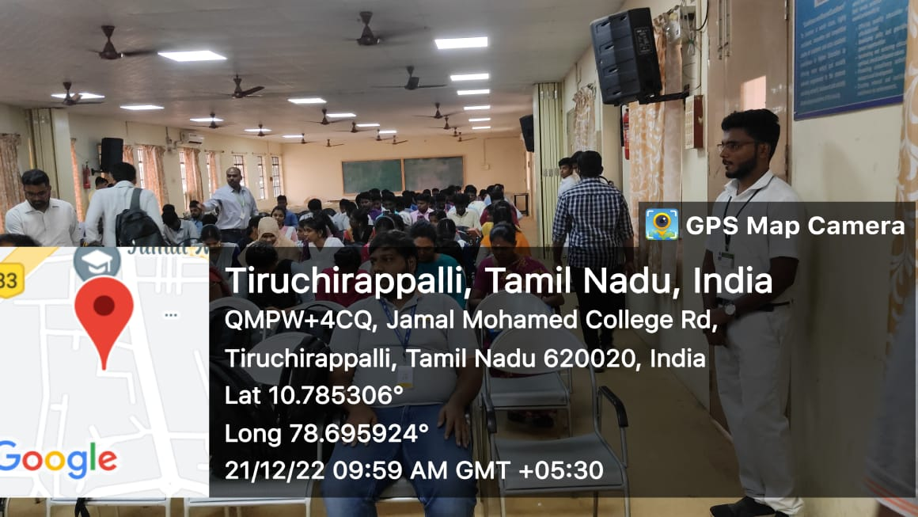 | 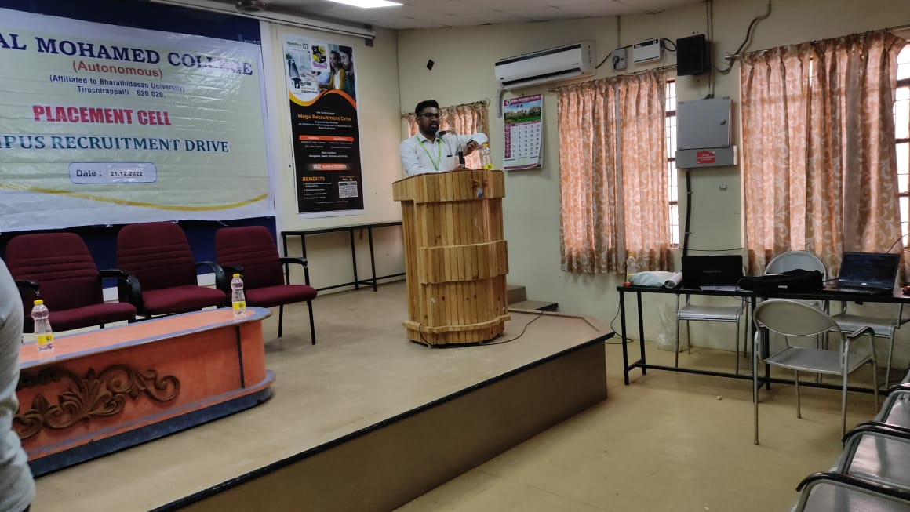

Awareness on constitution of India

On the Date of 27/12/2022, Awareness on Constitution of India was organized by National Service Scheme of Jamal Mohamed College. In this program, Our College Vice Principal Dr. Ibrahim gave his Special address to our NSS volunteers.
And Dr. Agustin asst. prof. of History Department gave his speech about Awareness on Constitution of India.
After this, The Refreshments were given and the Cultural Program was organized by our volunteers. By the guidance of NSS leaders and NSS officers, the program was completed successfully in a good manner.

Number of NSS Volunteers Participated: 70 Date: 27/12/2022
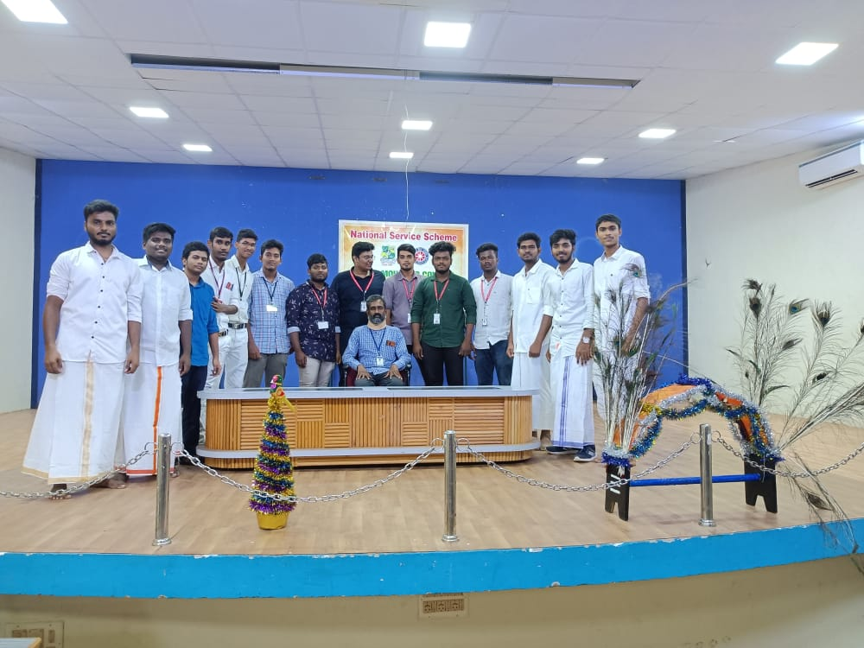 | 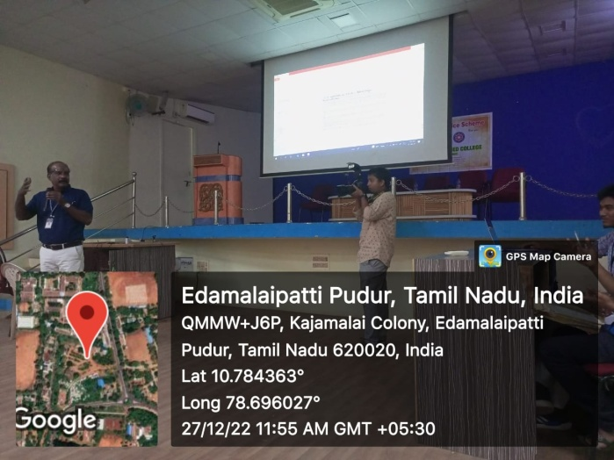
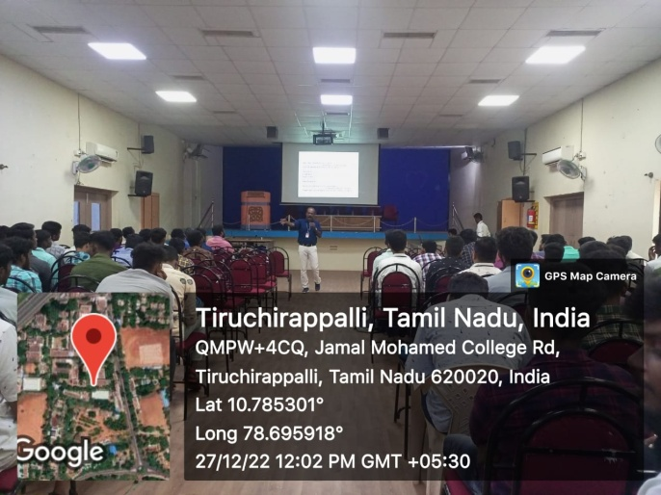 | 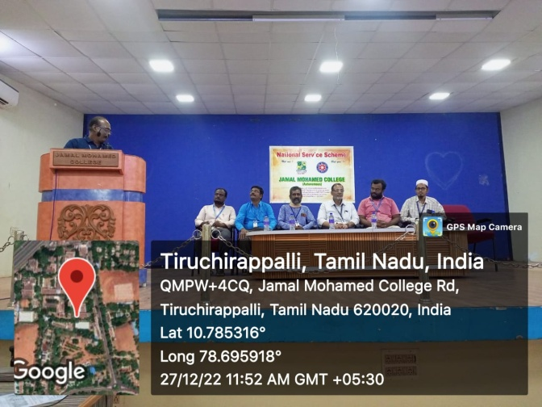

Help Desk program

On the Date of 09/01/2023 – 11/01/2023, Help Desk program was conducted by JAMAL MOHAMED COLLEGE & NAL ULLANGAL TRUST. In this program our NSS volunteers went to M.G.M. Govt. Hospital to made a help desk and guided the patients by showing their ward correctly. The Program was Inaugurated by Our College Principal, Management Committee and Hospital Dean Dr. Nehru.zz
After refreshment the program was completed in a good manner with the instruction of NSS leaders and program officers.
Number of NSS Volunteers Participated: 35 Date: 09/01/2023
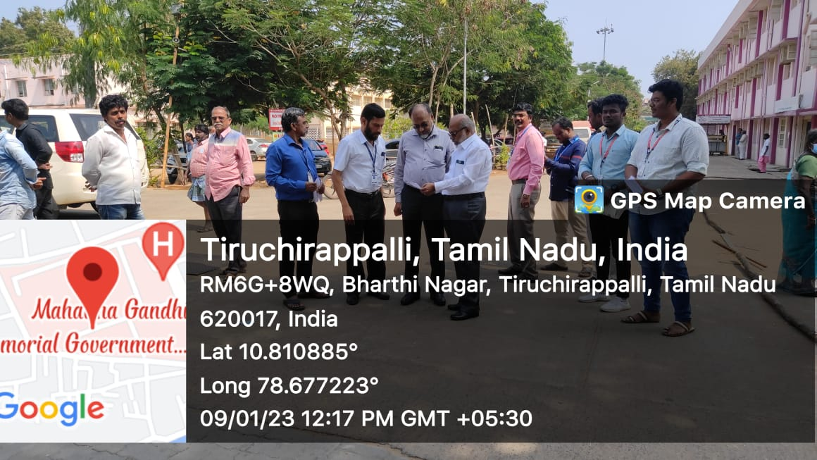 | 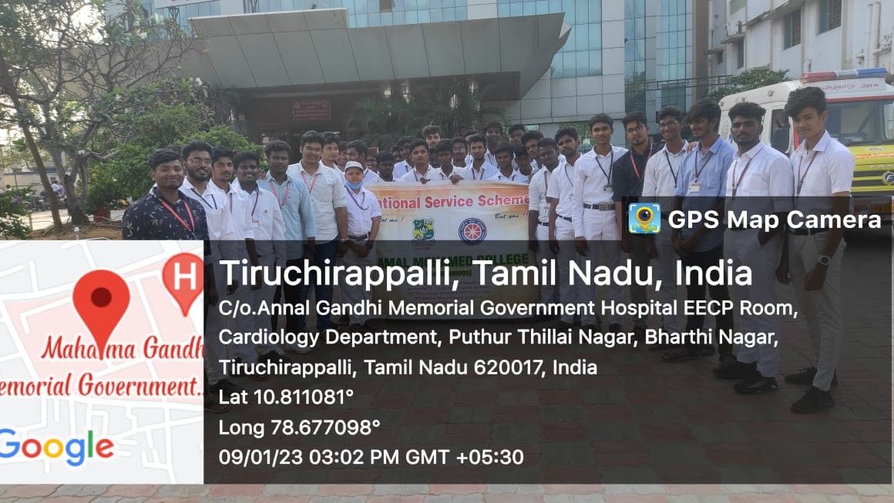
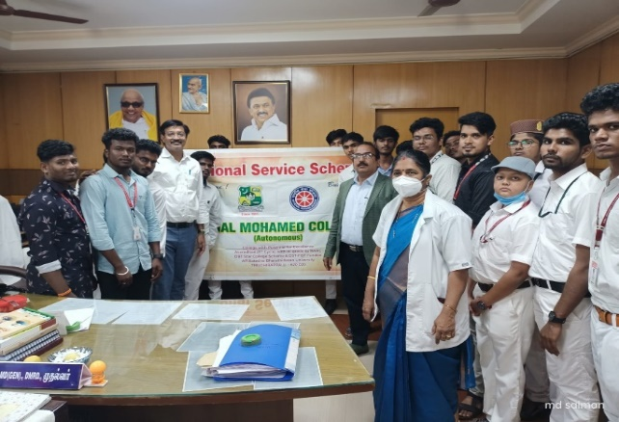

Pongal Celebration at Navalpattu

On the Date of 13/01/2023, Pongal Celebration Program was organized by Jamal Mohamed College National Service Scheme at Navalpattu. In that Program, our volunteers conducted small competitions like Running Race, Frog Race, Kho Kho etc., to Elementary School Students. At last Our Program Officers and Leaders distributed prizes to Students. The Program was completed in a good manner with the instruction of NSS Leaders and Program Officers

Number of NSS Volunteers Participated: 25 Date: 13/01/2023
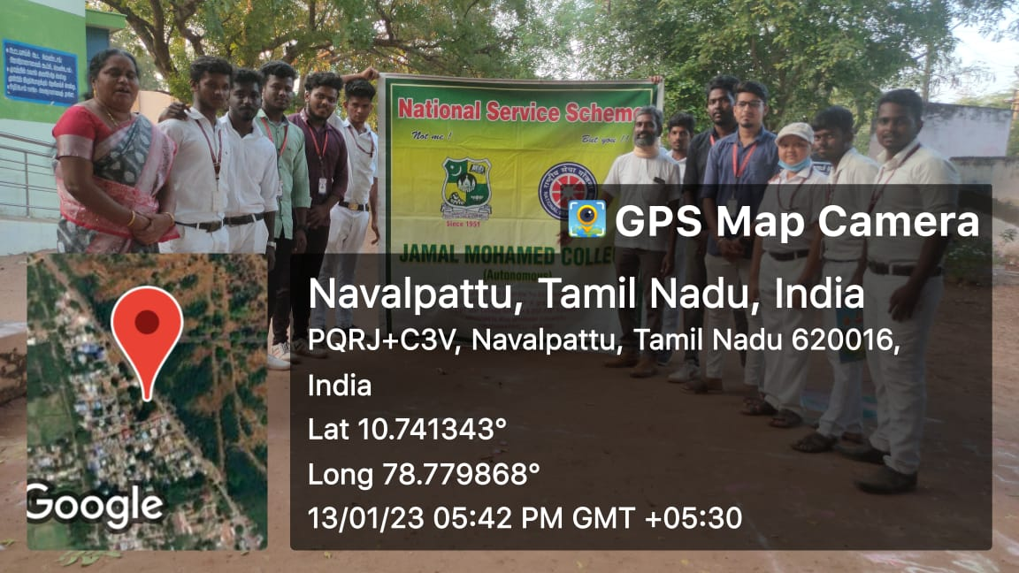
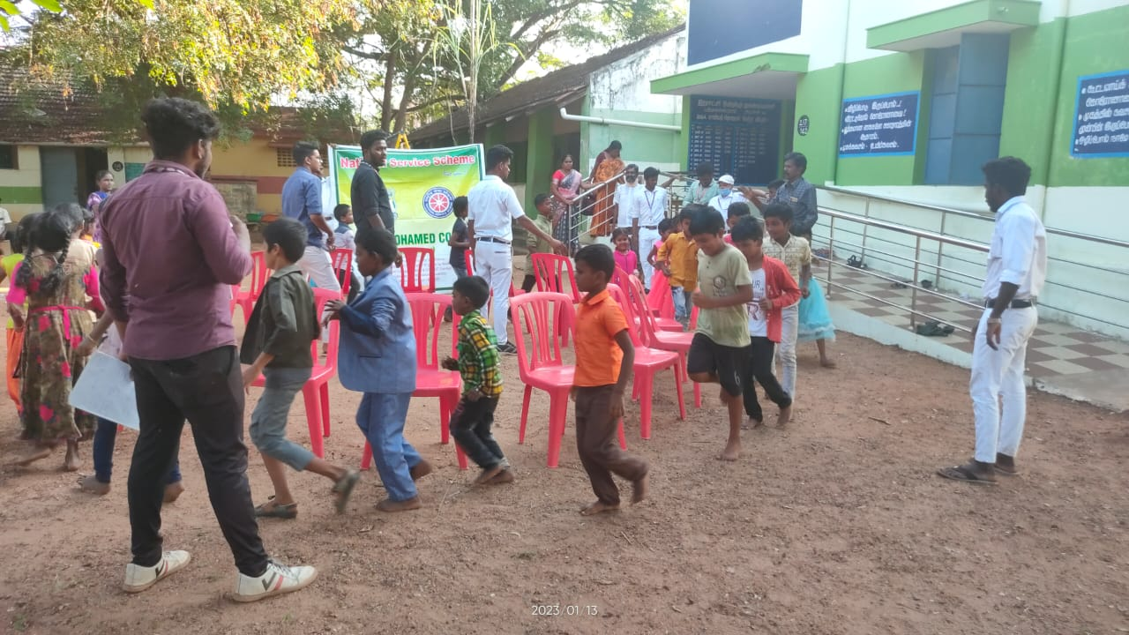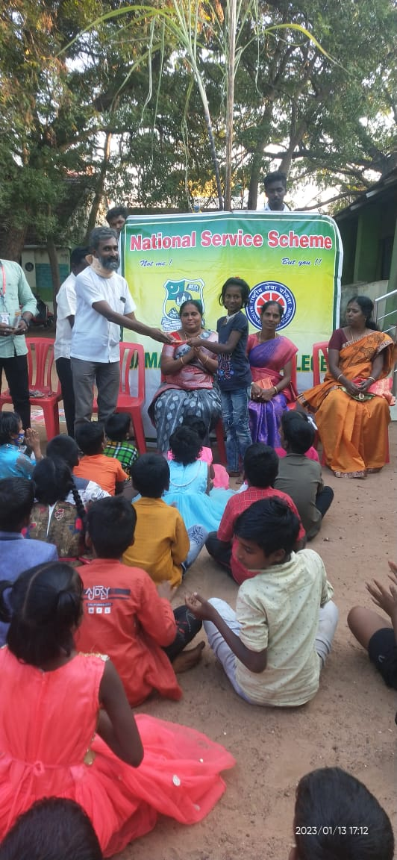

Road Safety Awareness Street Play

On the Date of 13/01/2023, Road safety Awareness Street play was conducted by Jamal Mohamed College National Service scheme and Tiruchirappalli Traffic Police department. The program was Commenced by Commissioner of Police Sathyapriya IPS in Mannarpuram. Our NSS volunteers performed the Road Safety Awareness street play in front of the dignitaries. After the Program, the Dignitaries appreciated the Participated NSS Volunteers. After this, the volunteers also Performed in TVS Tolgate. We Performed these Plays during Peak Hours. Because it is easy to Spread Awareness between the General Public.
After refreshment the program was completed in a good manner with the instruction of NSS leaders and program officers.

Number of NSS Volunteers Participated: 55 Date: 13/01/2023
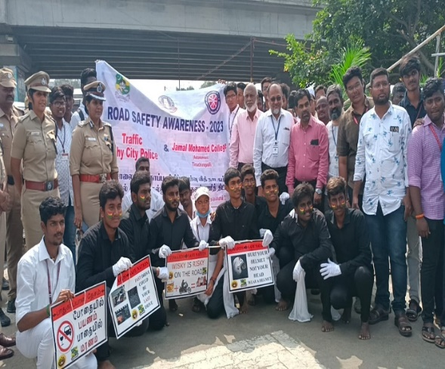 | 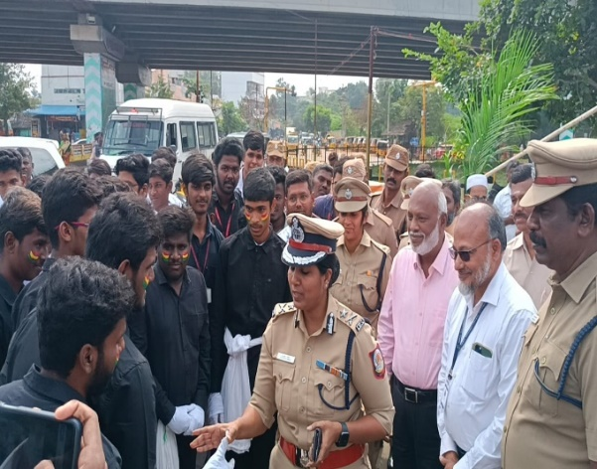
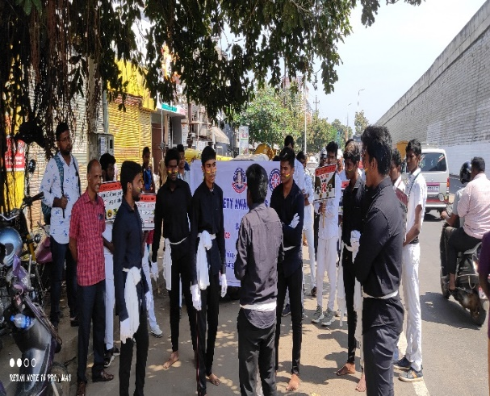 | 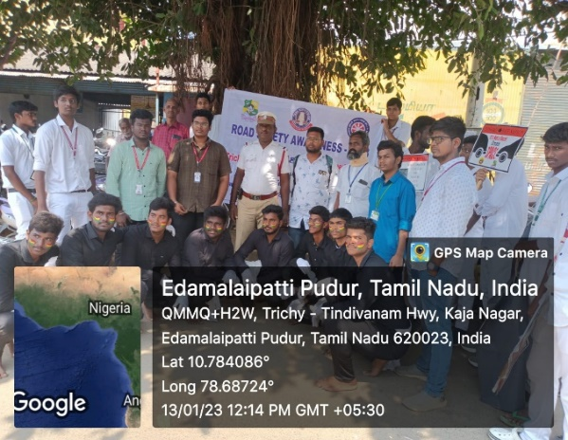

Road Safety Awareness Street Play

On the Date of 14/01/2023, Road safety Awareness Street play was conducted by Jamal Mohamed College National Service scheme and Tiruchirappalli Traffic Police department at Chatram Bus stand and Main Guard Gate. In this street play our volunteers gave meaningful message about Road Safety to the public.
After refreshment the program was completed in a good manner with the instruction of NSS leaders and program officers.
Number of NSS Volunteers Participated: 15 Date: 14/01/2023
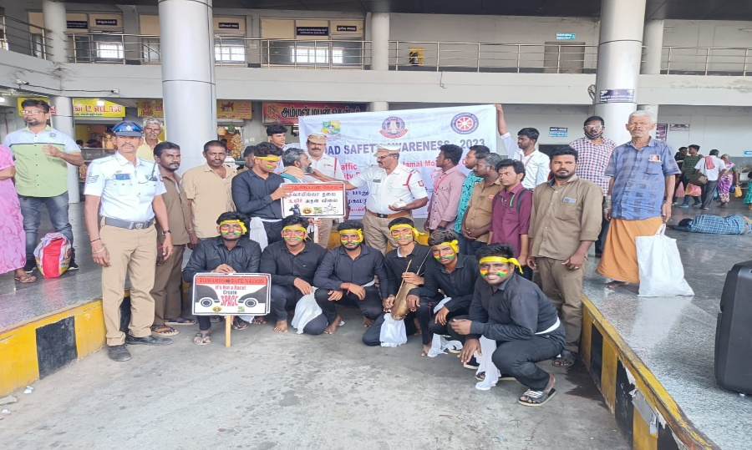
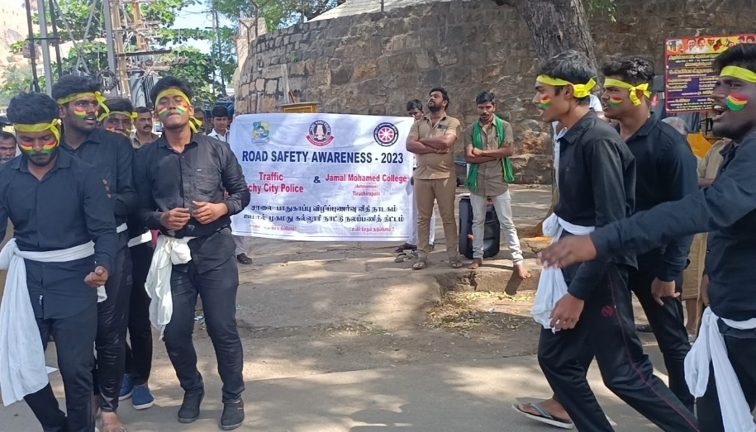

Vagai Sooda Vaa

On the Date of 19/01/2023, The Program Vagai Sooda Vaa was inaugurated by our Trichy District Collector Mr. Pradeep Kumar, which was organized King Maker IAS academy. In this Program, He interacted with our College students and shared his thoughts and advices about Clearing Civil Service Examination and Getting a Government Job. After refreshment the program was completed in a good manner with the instruction of NSS leaders and program officers.
Number of NSS Volunteers Participated: 25 Date: 19/01/2023
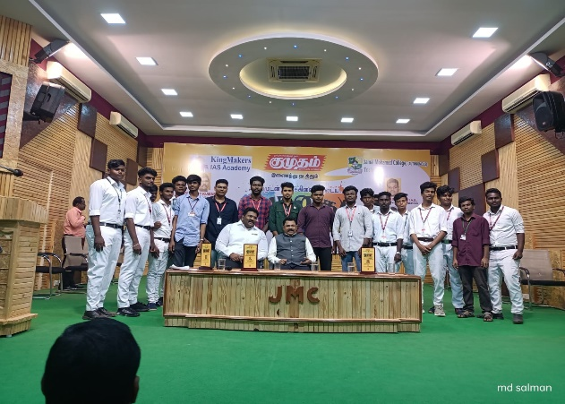 | 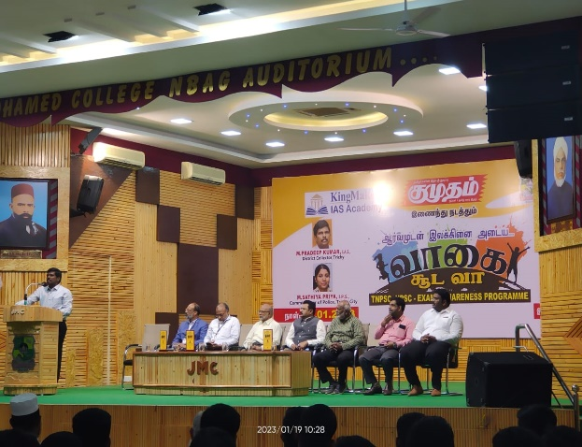
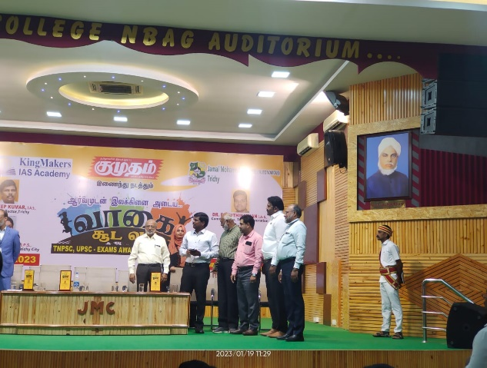

Science Fair

On the Date of 22/01/2023, The Science fair was held at NBAG Auditorium of Jamal Mohamed College. School Students of Different districts came there to participate in the Science Fair and all of them presented their experiments in front of the Judges. All of the participants did their best. At 4pm, Principal and Secretary distributed the prizes to the participants. The Program was conducted and done in a good manner with the instructions of NSS Program Officers and Leaders.
Number of NSS Volunteers Participated: 25 Date: 22/01/2023
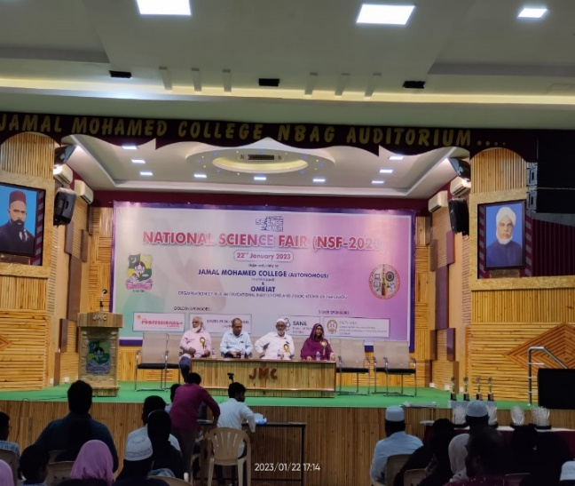 | 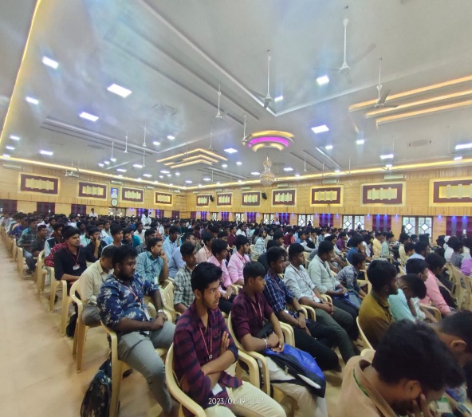

Placement Cell Program

On the Date of 24/01/2023, Placement Cell Orientation was conducted by Placement Cell of Jamal Mohamed College for First Year Students. In that program, Dr. A. Umar Farook delivered speech about ‘Lets Lead a Balanced Life’. And Dr. N. Mujafarkani given speech about ‘Goal Setting’. Our NSS volunteers organized the program and completed it in a Good manner
.
Number of NSS Volunteers Participated: 06 Date: 24/01/2023
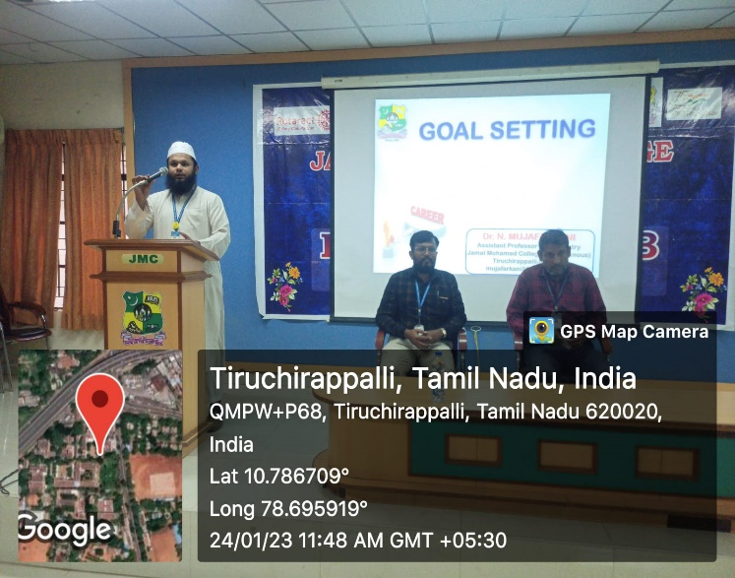 | 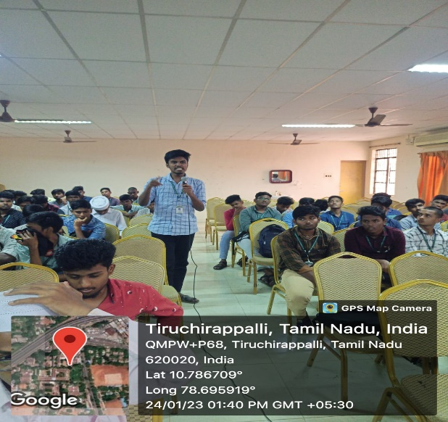
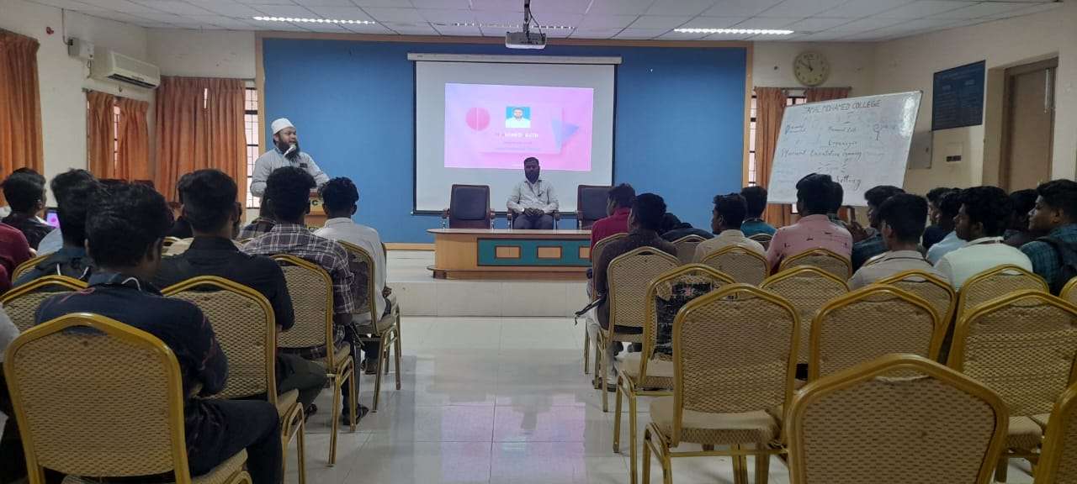 | 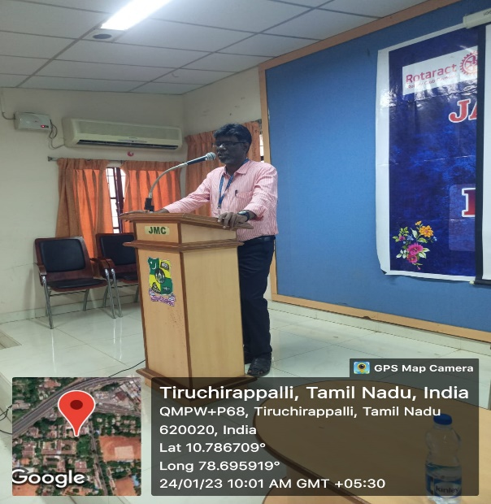

Voters Day Pledge

On the Date of 25/01/2022, Voters Day Pledge taking was conducted by National Service Scheme of Jamal Mohamed College. In this program, Our Volunteers and Program officers taken pledge about Right of Voters and Voting Awareness. The program was completed in a good manner with the instruction of NSS Leaders and Program Officers.

Number of NSS Volunteers Participated: 25 Date: 25/01/2023

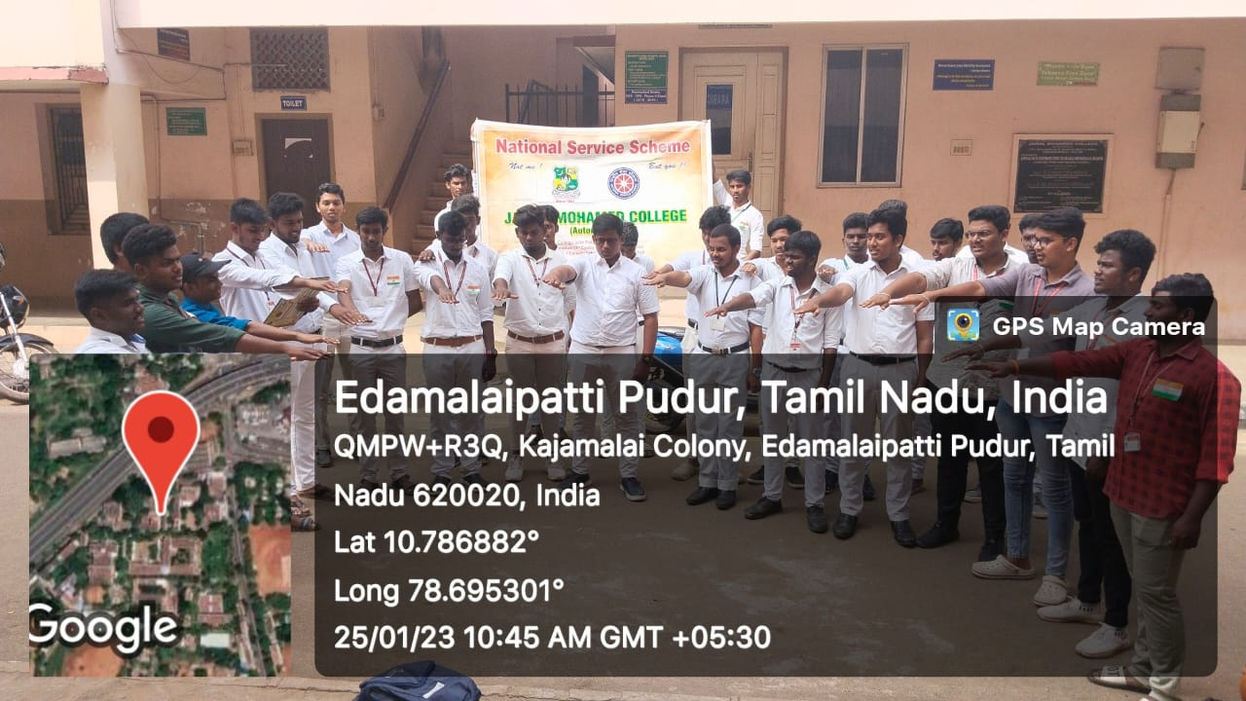

Republic Day

On the date 26/01/2022, 74th Republic day was celebrated at Bharathidasan University. Our NSS Volunteers participated in the welcoming of the guest and Flag Hoisting Ceremony Republic Day. DR. M. SELVAM Vice-Chancellor of Bharathidasan University presided over the program. Mrs. A. LAKSHMI PRABHA NSS Coordinator of Bharathidasan University, NSS Staffs and our college Program officer has guided our NSS Volunteers to make the program grand success.
Number of NSS Volunteers Participated: 45 Date: 26/01/2023

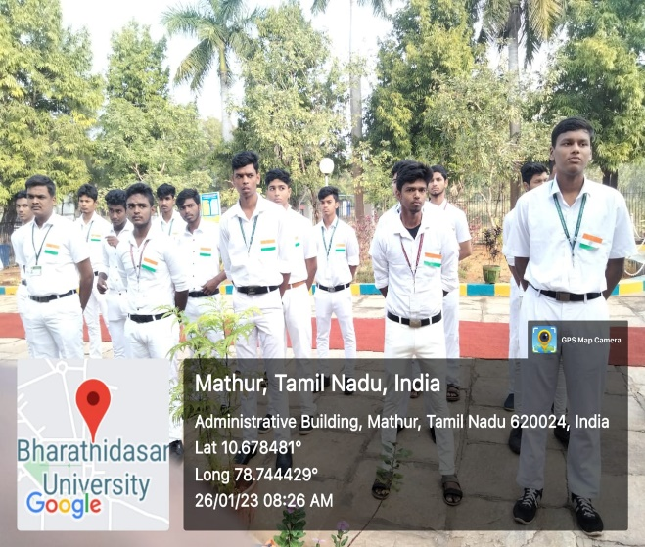 | 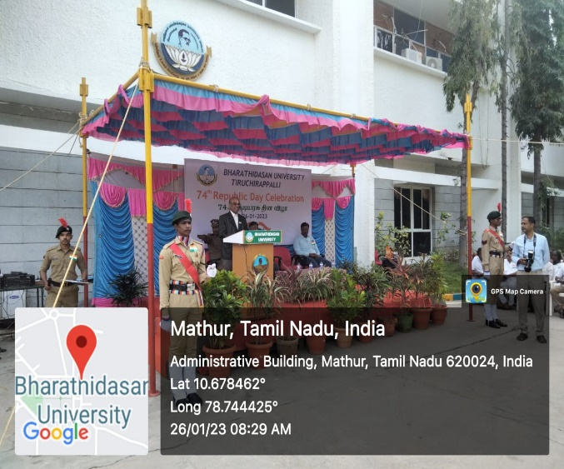
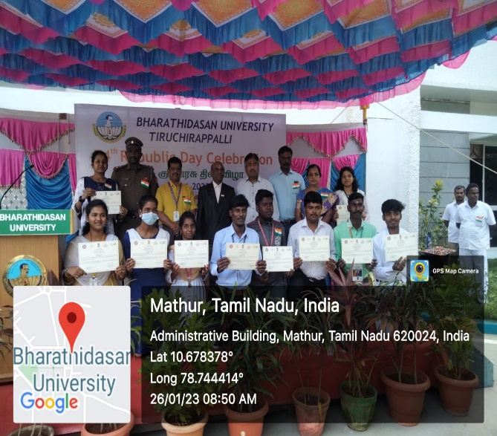 | 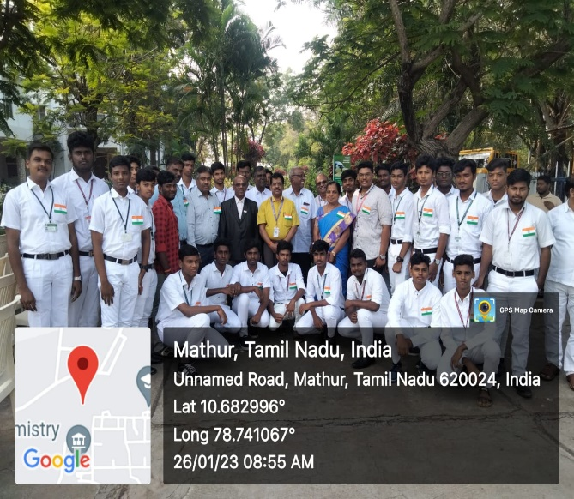
Republic Day

On the date 26/01/2023, 74th Republic day was celebrated at Jamal Mohamed College. Our College Principal addressed the speech about Indian Republic and our College Secretary Hoisted the tricolor National flag and distributed the sweets. Our college Program officers and NSS Volunteers has participated in the program. The Program was completed in a good manner by our volunteers.
Number of NSS Volunteers Participated: 25 Date: 26/01/2023
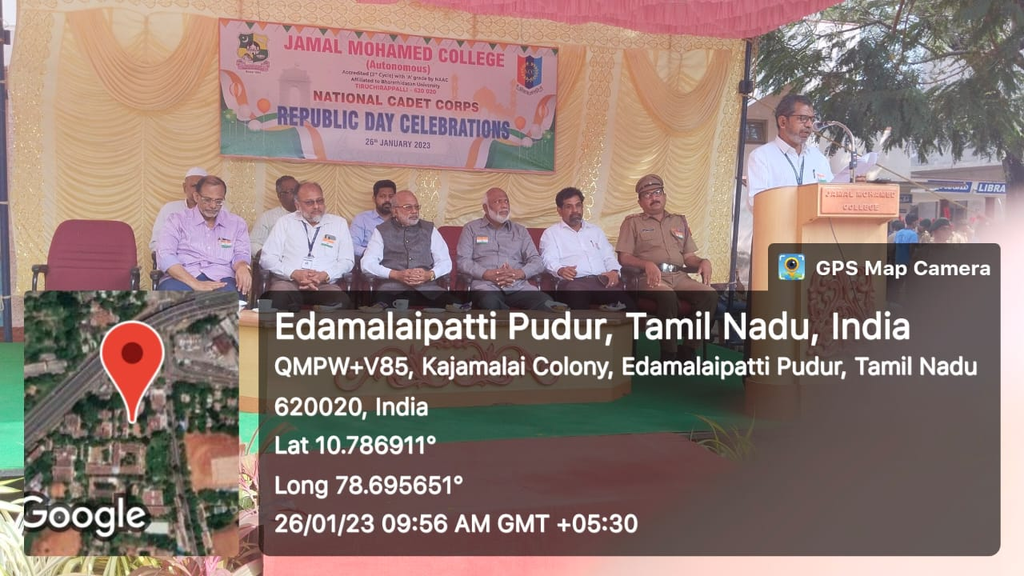 | 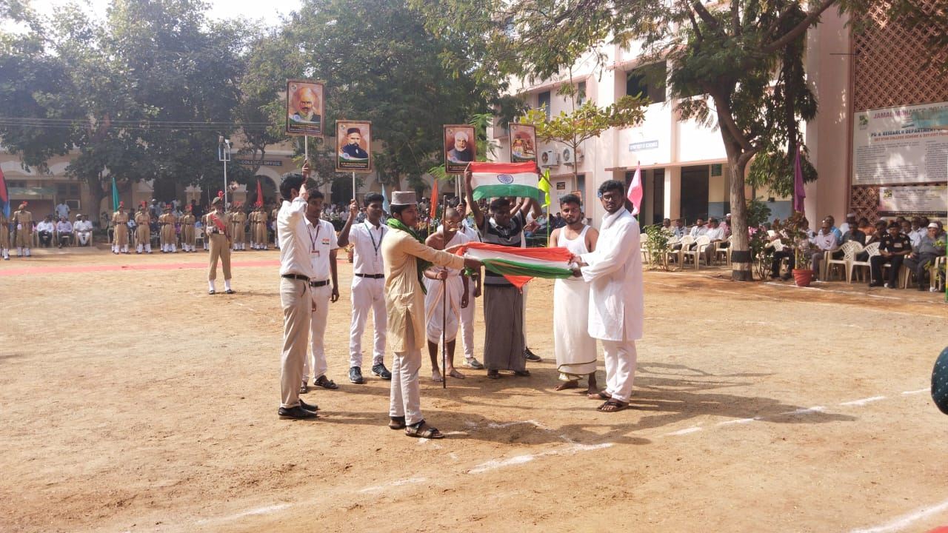
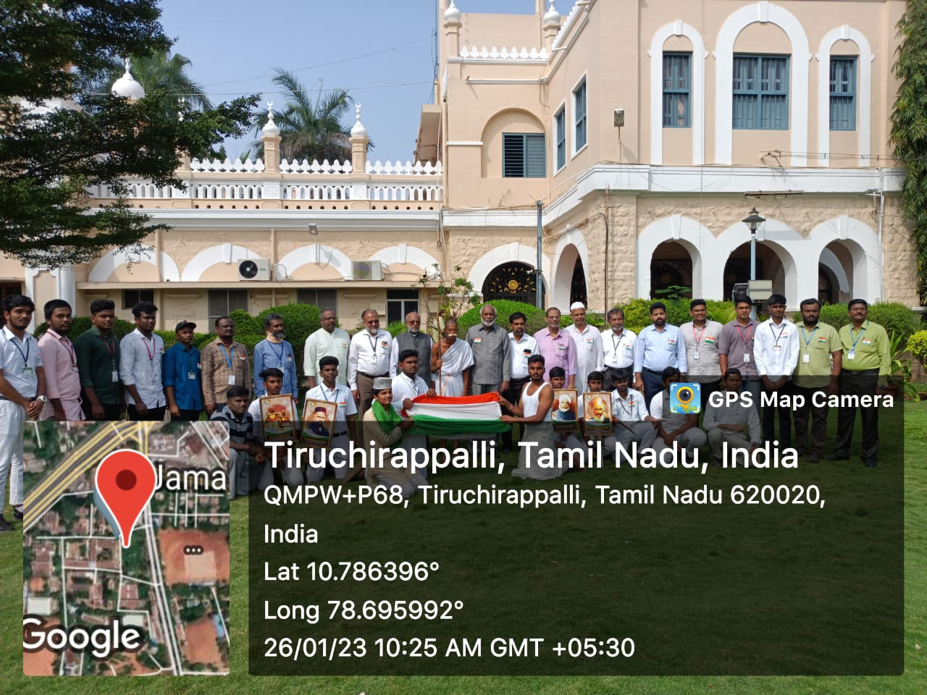

Eye Awareness Street Play

On the Date of 28/01/2022, Eye Safety Awareness Street play was conducted by Jamal Mohamed College National Service Scheme and Joseph Eye Hospital. The Program was commenced by Commissioner of Police Mrs. Sathyapriya IPS in KK Nagar. In this street play our volunteers gave meaningful message about Eye safety to the public.
After refreshment the program was completed by good manner with the instruction of NSS leaders and program officers
Number of NSS Volunteers Participated: 25 Date: 13/01/2023

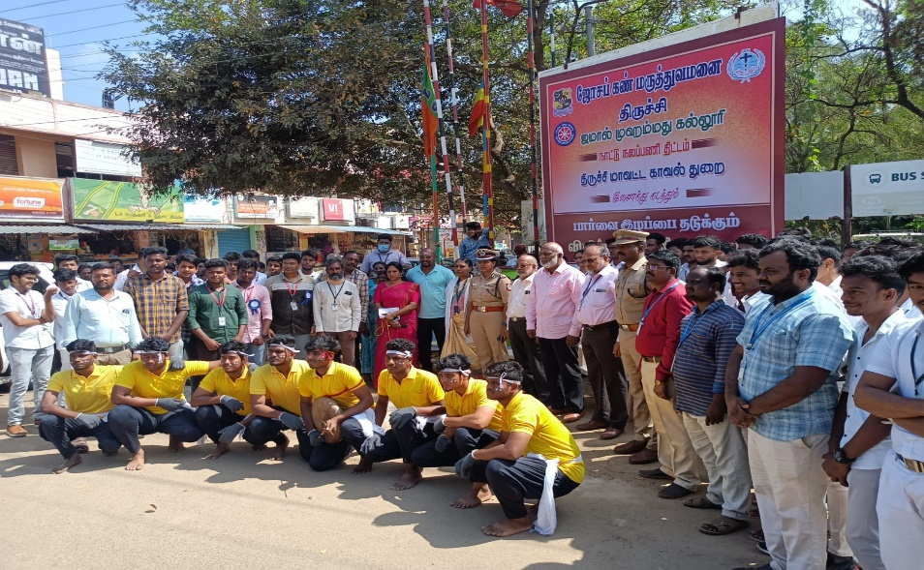

Indian Social Science Congress Program

On the Date of 27/01/2023 to 31/01/2023, The Indian Social Science Congress Program was organized by Bharathidasan University. It was a National Level Conference and Visitors from different states attended the program. Our Volunteers guided them and some of them stayed with them in their allotted venue. In the evening times, the cultural program was organized in various colleges like Bishop Heber, Cauvery College for Women, National College and Jamal Mohamed College. The Performances were energetic and the days ended with a dinner and all of them returned to their respective venue. The valediction program takes place at the last day. Our Volunteers guided them and provided them lunch. In the afternoon, the all of the visitors vacated their allotted rooms and went to their native places. The Program was completed in a good manner with the instructions of NSS leaders and Program Officers.

Number of NSS Volunteers Participated: 130 Date: 31/01/2023
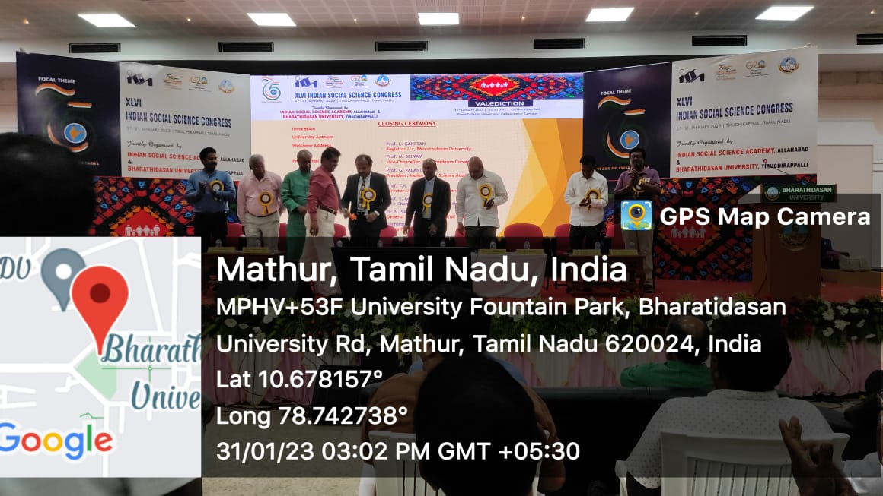 | 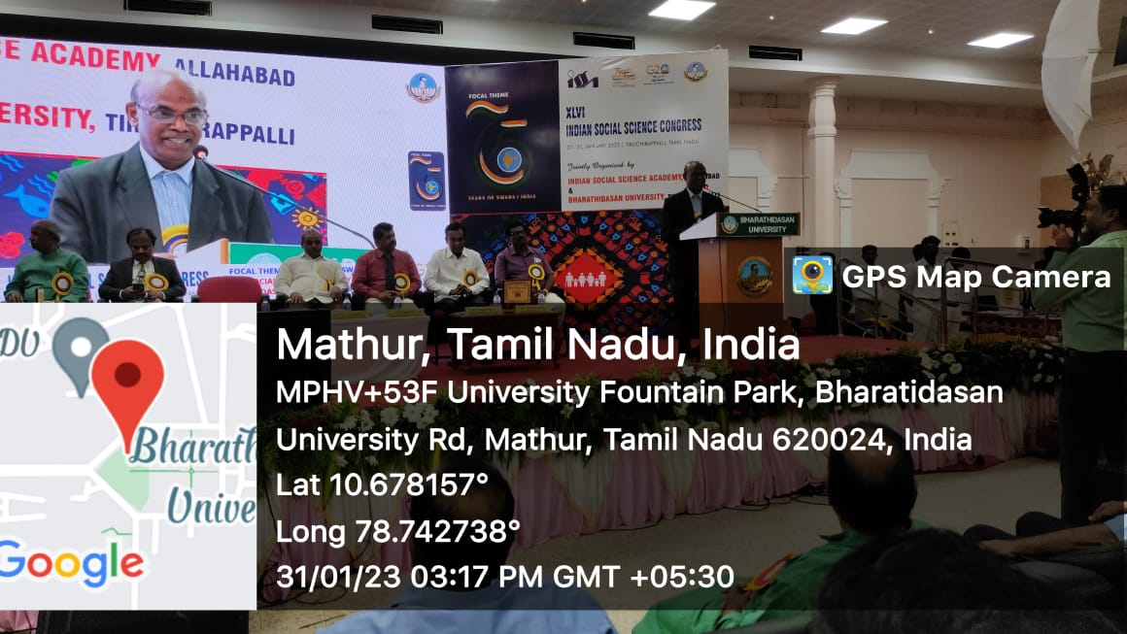

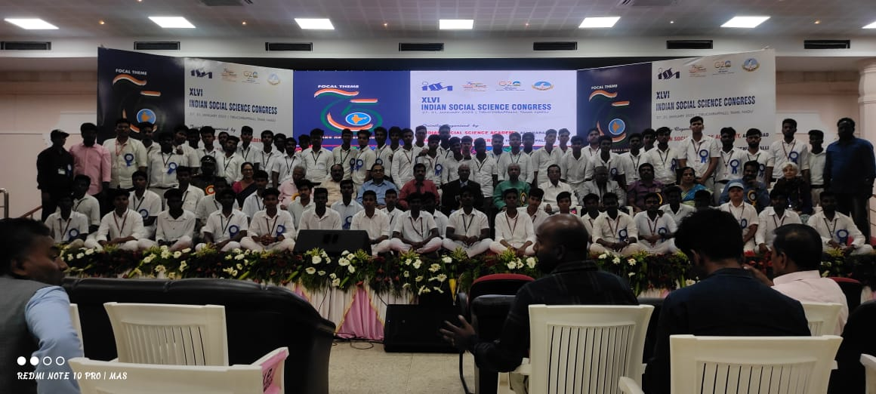
Anti-Terrorism Day Pledge

On the Date of 01/02/2023, Anti-Terrorism Day Pledge taking was conducted by National Service Scheme of Jamal Mohamed College. In this program, Our Volunteers and Program officers taken pledge about Anti-Terrorism. The program was completed in a good manner with the instruction of NSS Leaders and Program Officers.

Number of NSS Volunteers Participated: 25 Date: 25/01/2023

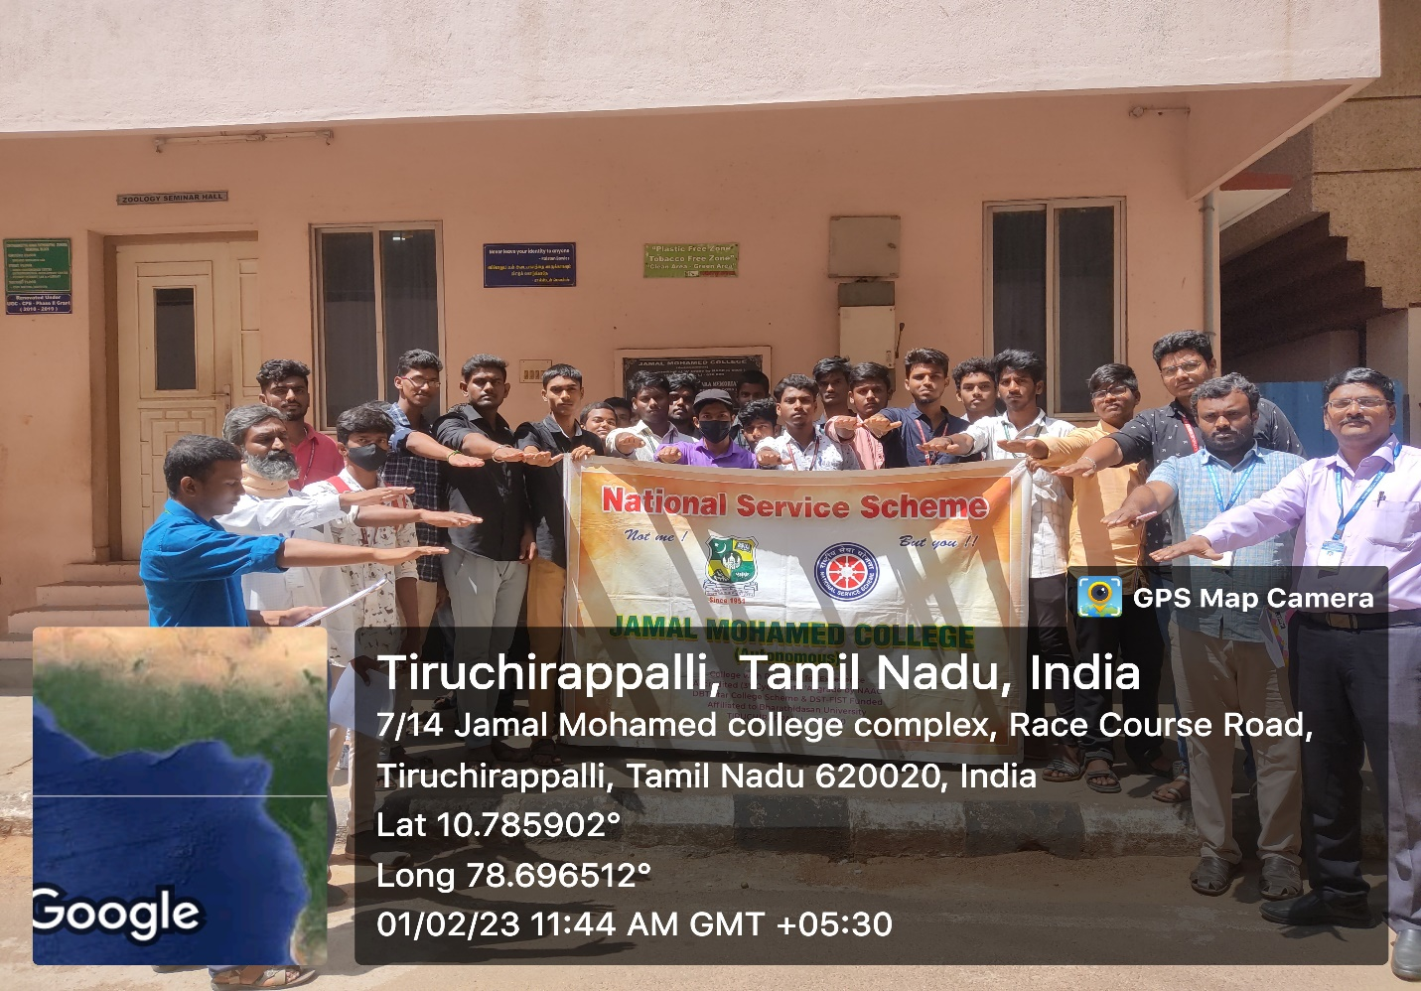

Eye Safety Awareness Street Play

On the Date of 01/02/2022, Eye Safety Awareness Street play was conducted by Jamal Mohamed College National Service Scheme and Joseph Eye Hospital. On this Day, Our Volunteers did street play at many places like Mannarpuram, TVS Tolgate, Central Bus Stand and Govt. Exhibition. In this street play our volunteers gave meaningful message about Eye safety to the public.
After refreshment the program was completed by good manner with the instruction of NSS leaders and program officers
Number of NSS Volunteers Participated: 15 Date: 01/02/2023
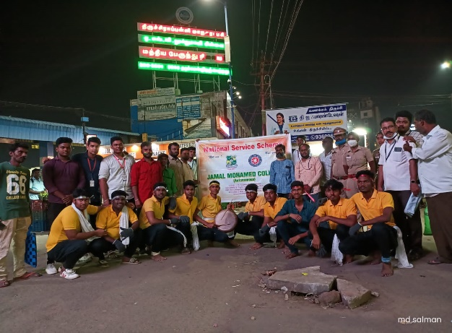 | 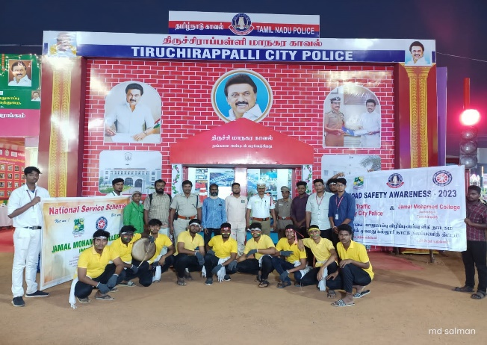
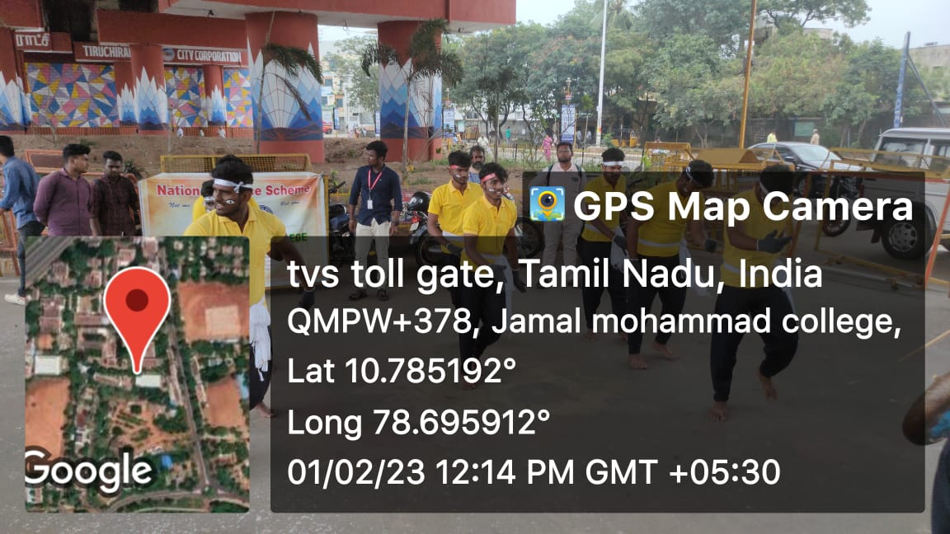 | 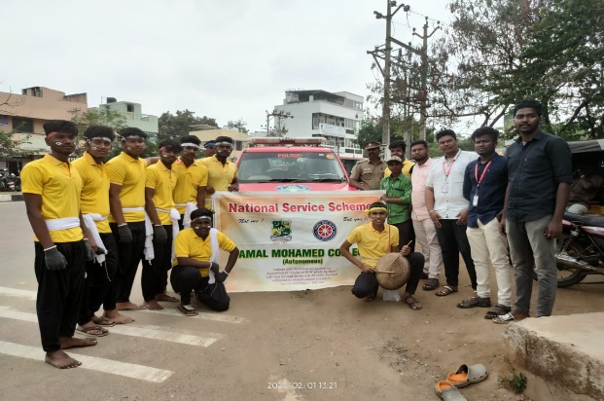

Eye Safety Awareness Street Play

On the Date of 06/02/2022, Eye Safety Awareness Street play was conducted by Jamal Mohamed College National Service Scheme and Joseph Eye Hospital. On this Day, Our Volunteers did street play at many places like Chatram Bus Stand and Main Guard Gate. In this street play our volunteers gave meaningful message about Eye safety to the public.
After refreshment the program was completed by good manner with the instruction of NSS leaders and program officers

Number of NSS Volunteers Participated: 12 Date: 06/02/2023
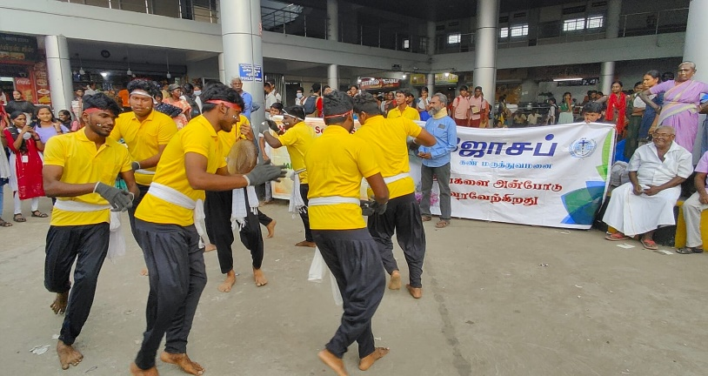 | 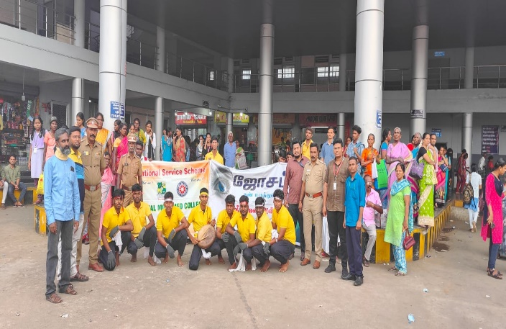

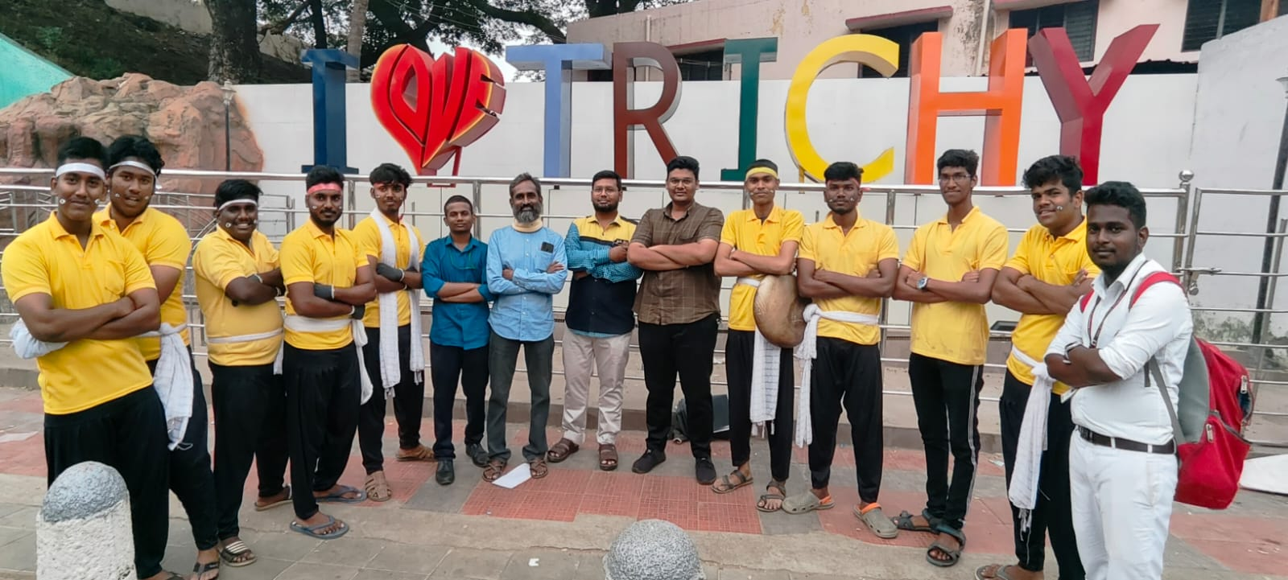

Placement cell Program

On the Date of 06/02/2023, Placement Interview was conducted by Placement Cell of Jamal Mohamed College. Nice Education conducted the campus interview for Final Year UG and PG Students in our college. They recruited more than 50 candidates. Our NSS volunteers organized the program and completed it in a Good manner.
Number of NSS Volunteers Participated: 6 Date: 06/02/2023

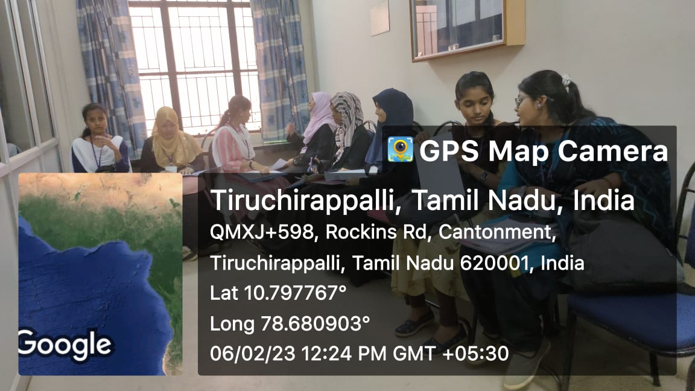 | 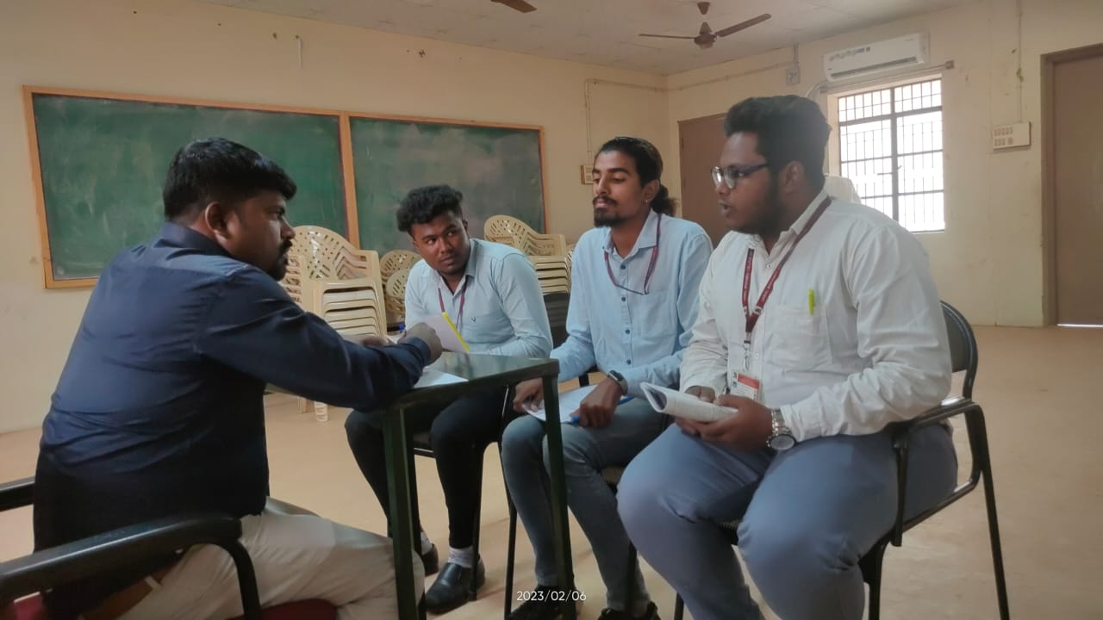
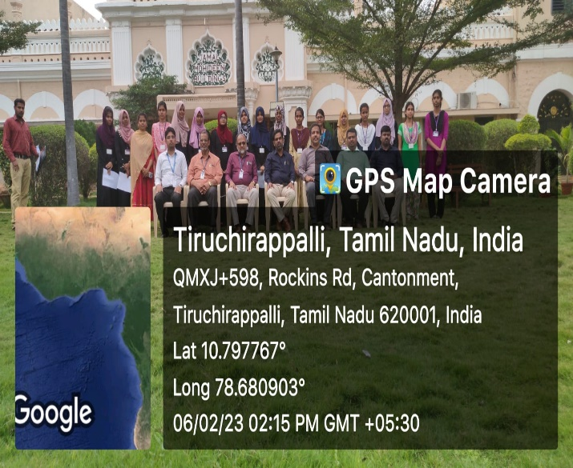 | 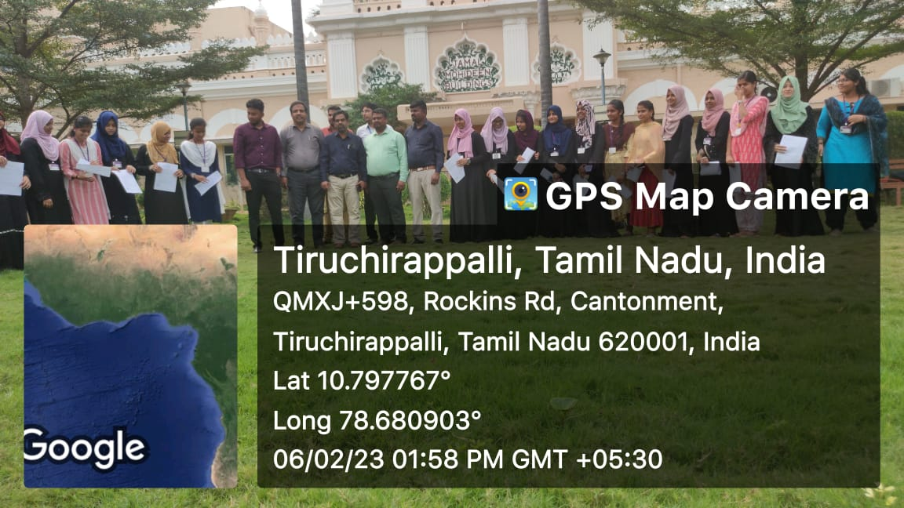
Eye Safety Awareness Street Play

On the Date of 07/02/2022, Eye Safety Awareness Street play was conducted by Jamal Mohamed College National Service Scheme and Joseph Eye Hospital. On this Day, Our Volunteers did street play at Trichy Railway Junction and Joseph Eye Hospital. In this street play our volunteers gave meaningful message about Eye safety to the public.
After refreshment the program was completed by good manner with the instruction of NSS leaders and program officers
Number of NSS Volunteers Participated: 15 Date: 07/02/2023
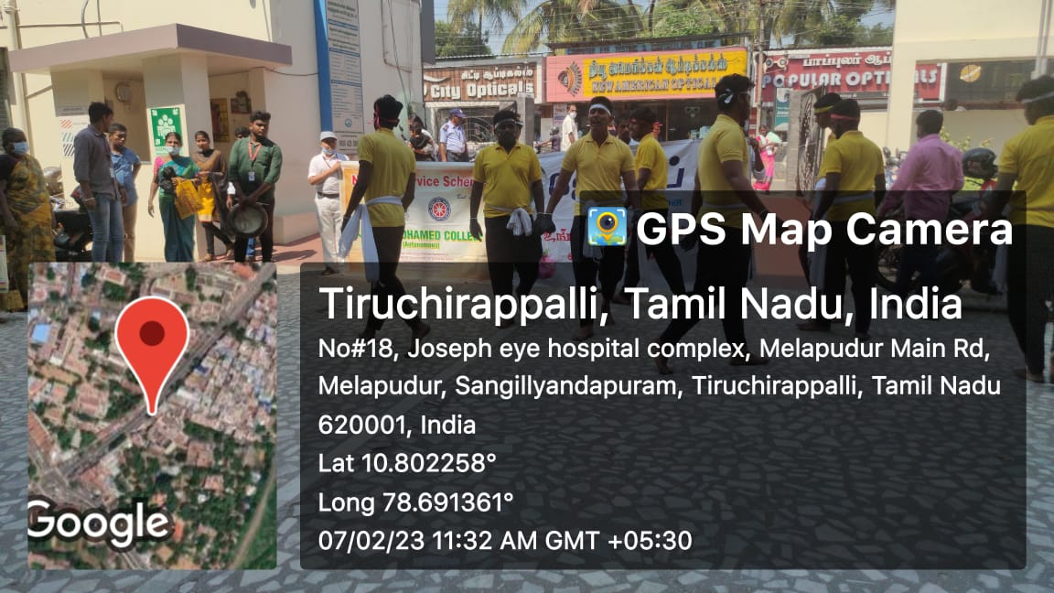 | 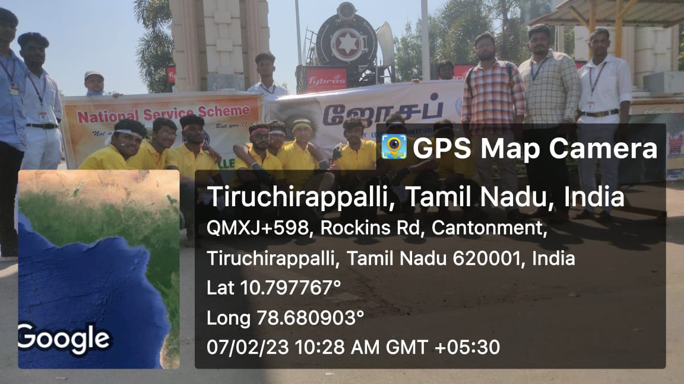
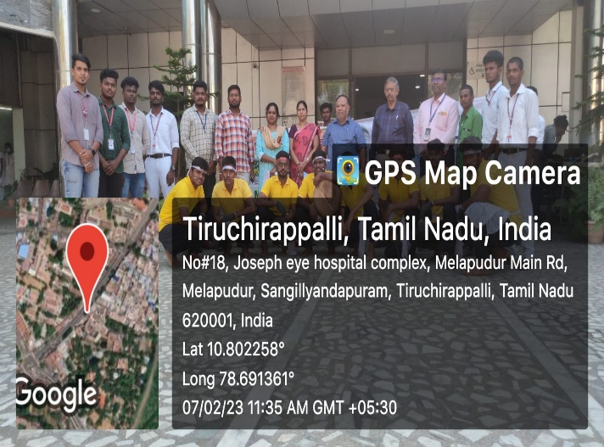 | 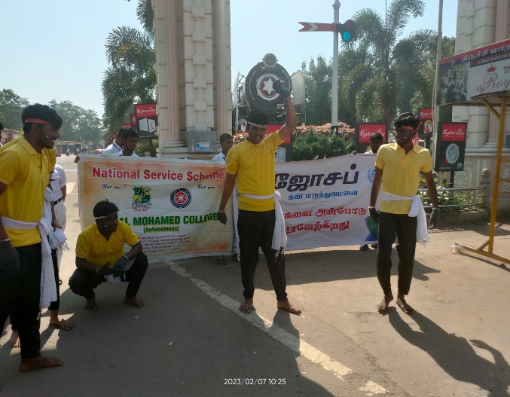

Helmet Awareness Rally

On the Date of 08/02/2023, Helmet Awareness Rally was Organized by Jamal Mohamed College and Tiruchirappalli Police department. The Rally was started by police commissioner Sathyapriya IPS in front of Gate No.4 of JMC and it covered nearly 5 kilometers. In this Rally our volunteers participated and created awareness about NO HELMET NO BIKE.
After refreshment the program was completed in a good manner with the instruction of NSS leaders and program officers.
Number of NSS Volunteers Participated: 35 Date: 13/01/2023
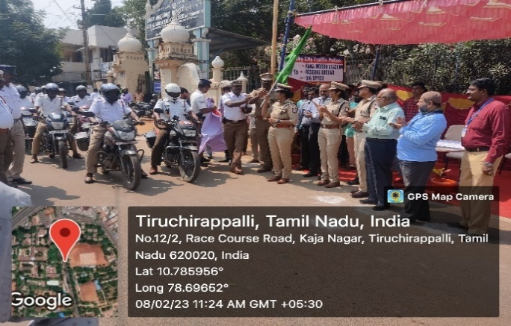 | 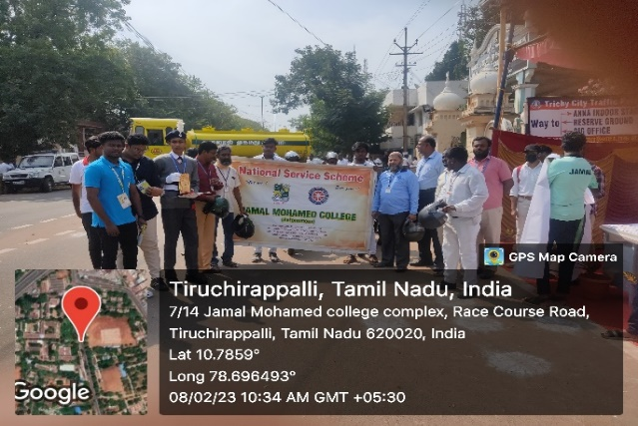
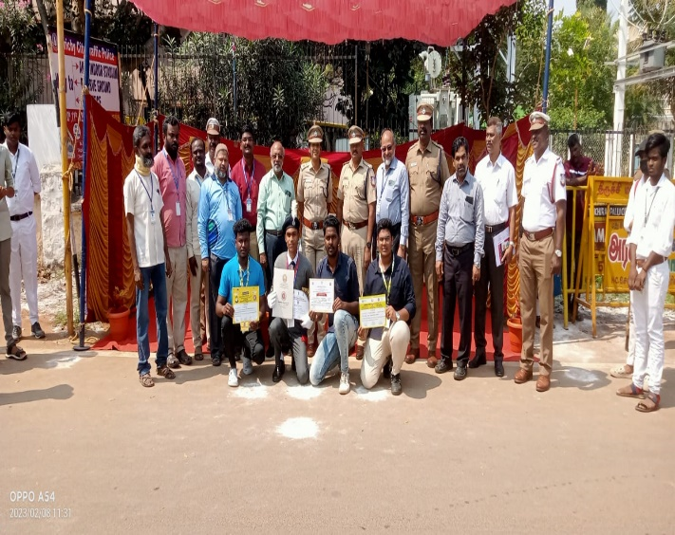 | 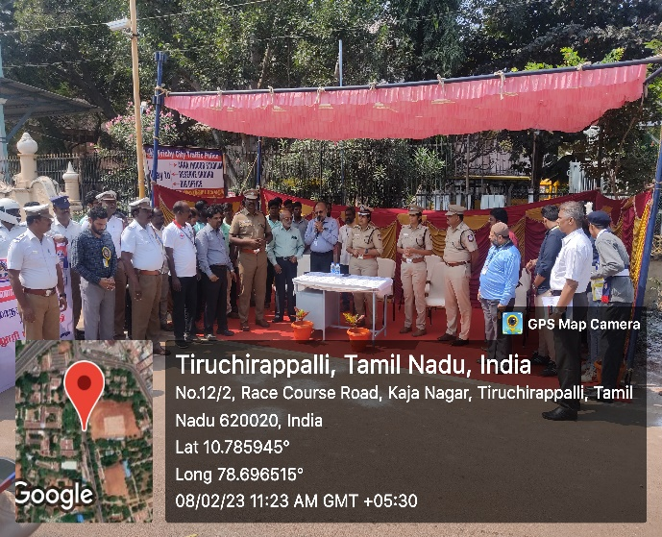
Placement cell program

On the Date of 09/02/2023, placement Interview was conducted by Placement Cell of Jamal Mohamed College. Omega Health Care conducted the campus interview for Final Year UG and PG Students in our college. They recruited the candidates according to their qualifications and English Fluency. Our NSS volunteers organized the program and completed it in a Good manner.
Number of NSS Volunteers Participated: 6 Date: 09/02/2023

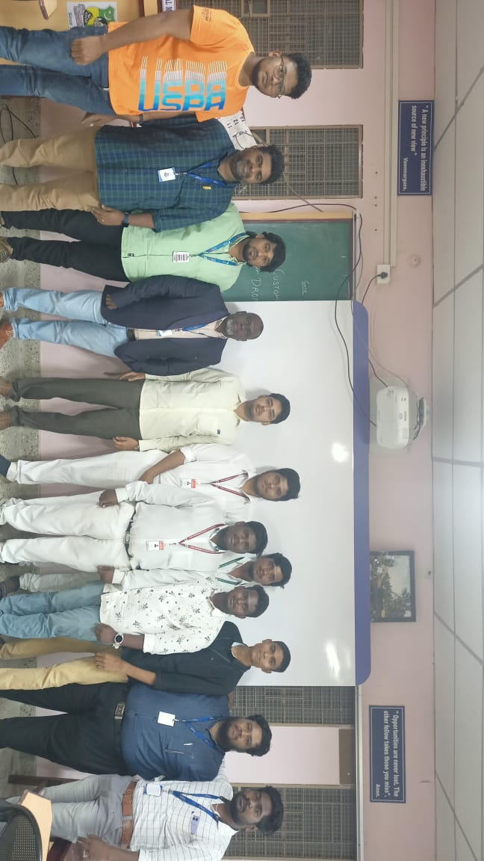

Eye Awareness Street Play

On the Date of 10/02/2023, Eye Safety Awareness Street play was conducted by Jamal Mohamed College National Service Scheme and Joseph Eye Hospital at Collector Office. Our Volunteers did street play in front of Our District Collector Mr. Pradeep Kumar. Our volunteers gave meaningful message about Eye safety to the public. He appreciated our volunteers and gave certificate to the volunteers and program officers.
After refreshment the program was completed by good manner with the instruction of NSS leaders and program officers
Number of NSS Volunteers Participated: 15 Date: 10/01/2023
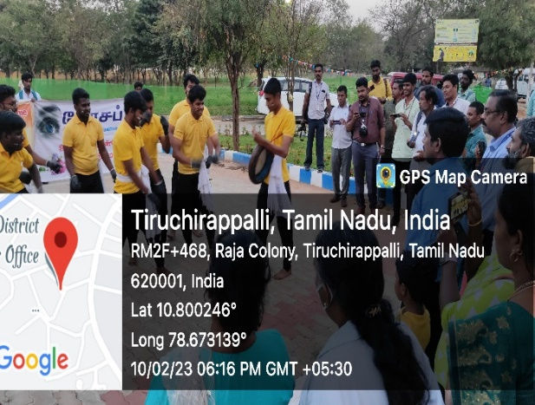 | 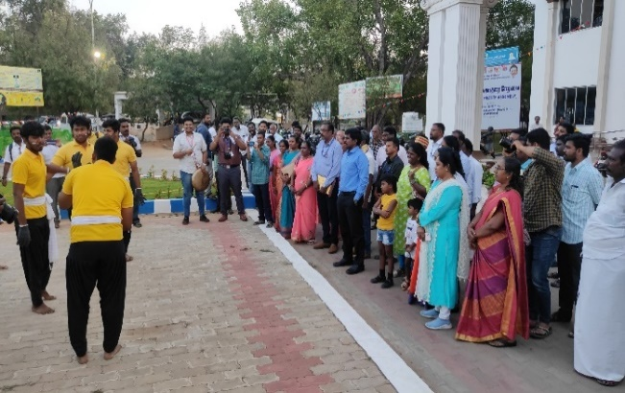
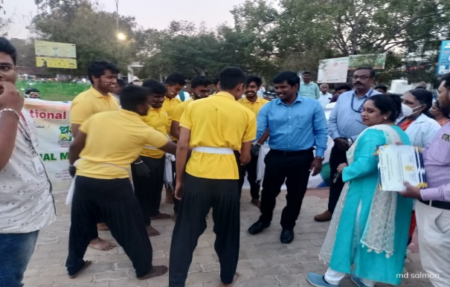 | 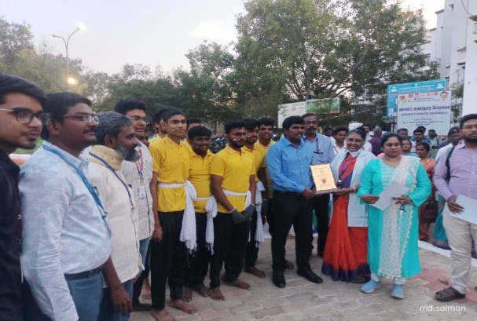

Pulwama Attack Pledge

On the Date of 14/02/2023, Pulwama Attack Pledge taking was conducted by National Service Scheme of Jamal Mohamed College. In this program, Our Volunteers and Program officers taken pledge on behalf of the Terrorist attack at Pulwama that costs 40 lives of our CRPF Soldiers. We have taken this pledge to respect the soldiers who lost their life for us. The program was completed in a good manner with the instruction of NSS Leaders and Program Officers.
Number of NSS Volunteers Participated: 25 Date: 14/02/2023

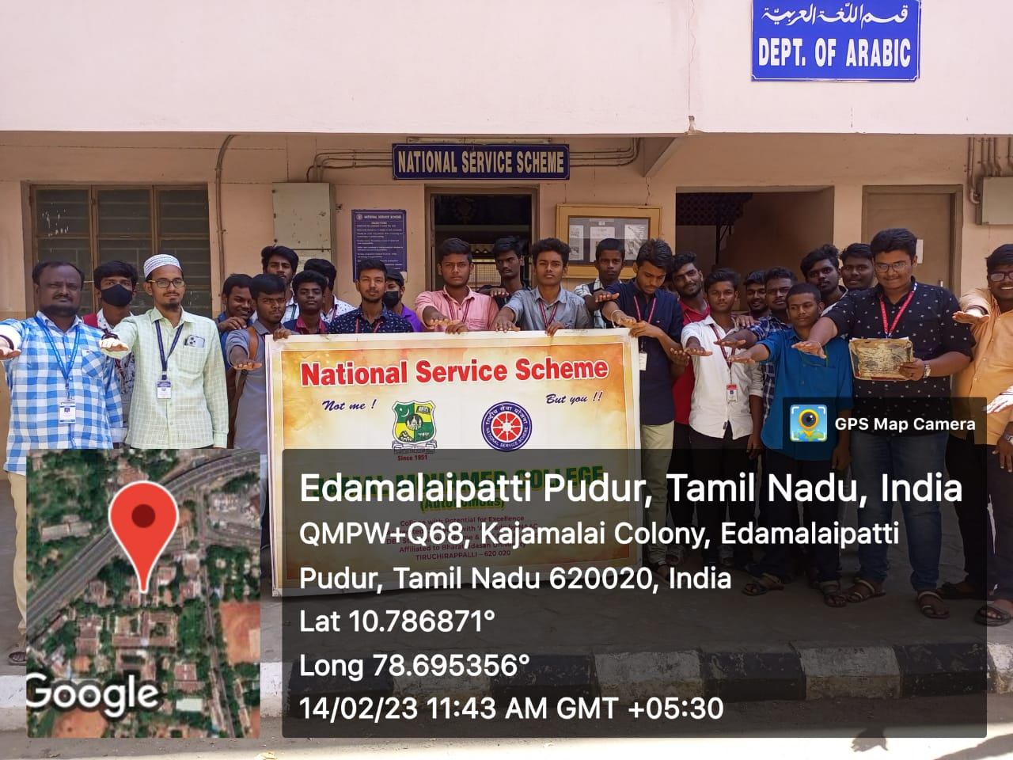

Deworming programme

On the date of 21/02/2023.Deworming Program was conducted by NSS of Jamal Mohamed College. In this program, deworming tablets are distributed by NSS volunteers to the students of Jamal Mohamed College. Our program Officers and NSS leaders instructed to the NSS Volunteers to successfully completed the program to good manner.
Number of NSS Volunteers Participated: 10 Date: 21/02/2023

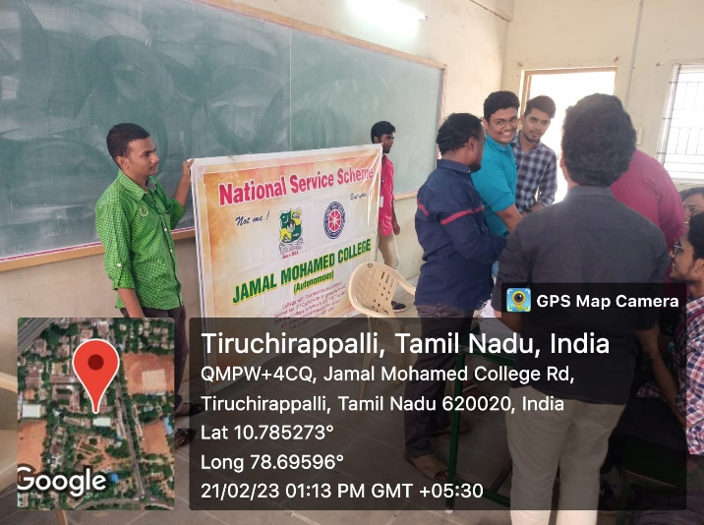 | 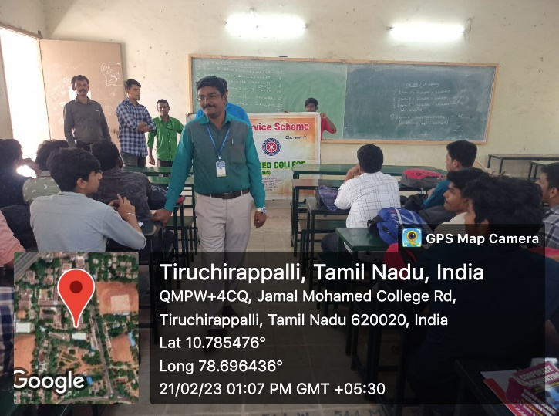
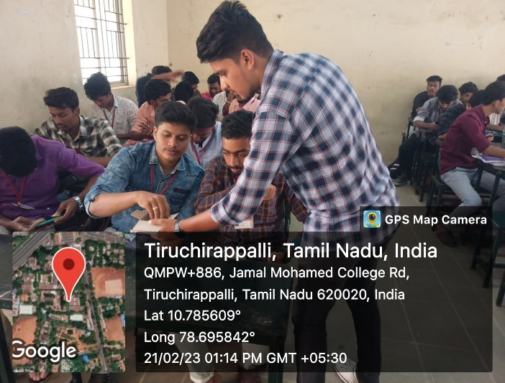 | 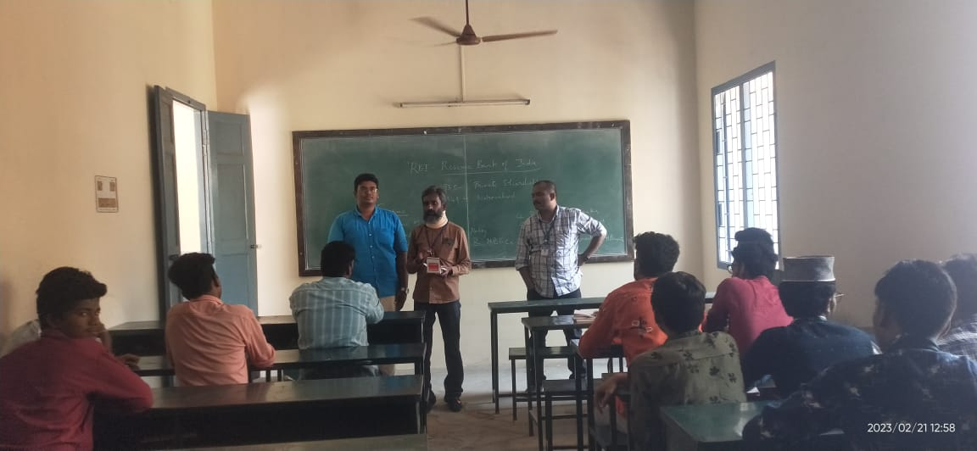

Placement Cell Program

On the Date of 24/02/2023, Placement Cell Program was conducted by Placement Cell of Jamal Mohamed College. SRG conducted the campus interview for Final Year UG and PG Students in our college. They recruited the candidates according to their qualifications. Our NSS volunteers organized the program and completed it in a Good manner.
Number of NSS Volunteers Participated: 6 Date: 24/02/2023
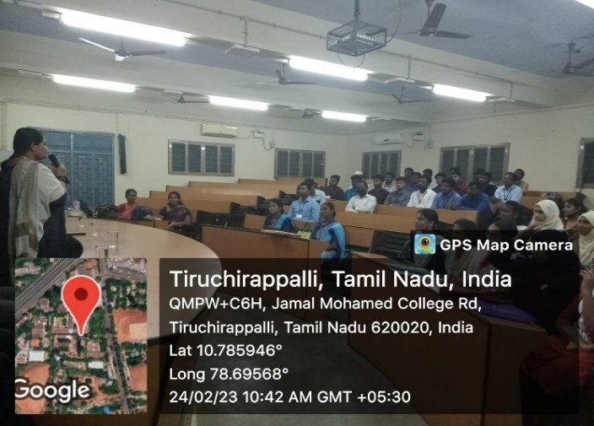 | 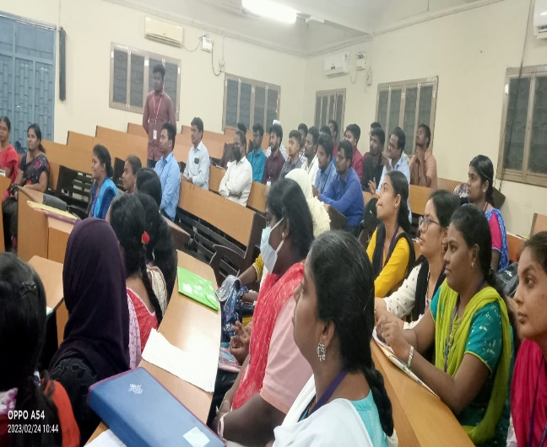
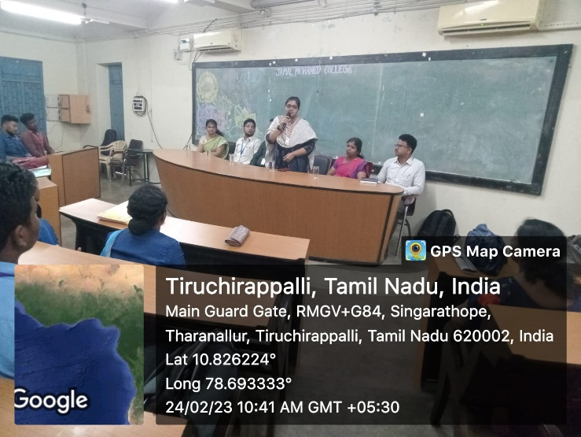 | 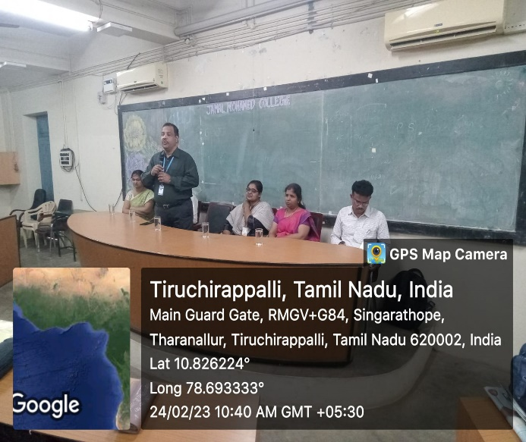

Naan Mudhalvan Program

On the Date of 25/02/2023, Naan Mudhalvan Program was organized by National Service Scheme of Jamal Mohamed College. In this Program, Our College Principal, Secretary and Treasurer gave their valuable speech to the Government School Students about importance of Higher Education. After refreshments our NSS Volunteers showed them our college campus. After this Our Volunteers Provided lunch for the School Students. The Program was done in a good manner with the instruction of NSS Leaders and Program Officers.
Number of NSS Volunteers Participated: 30 Date: 13/01/2023
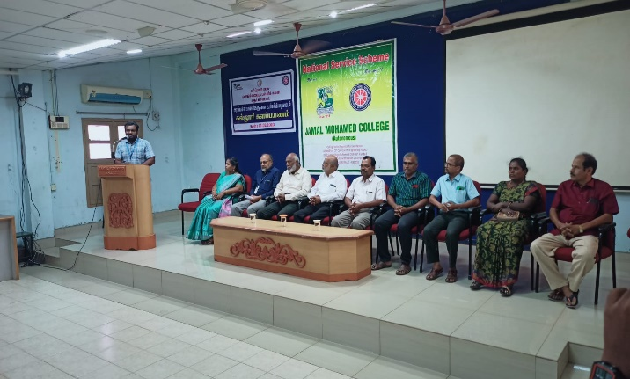 | 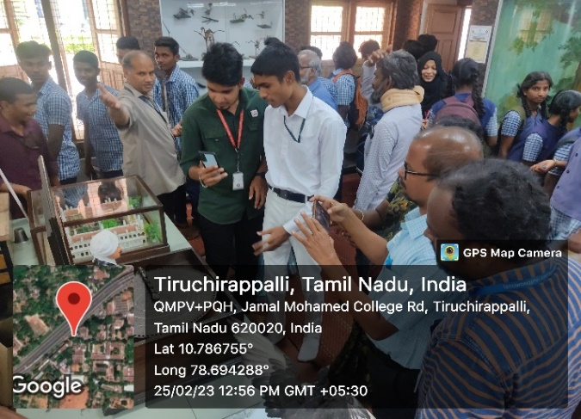
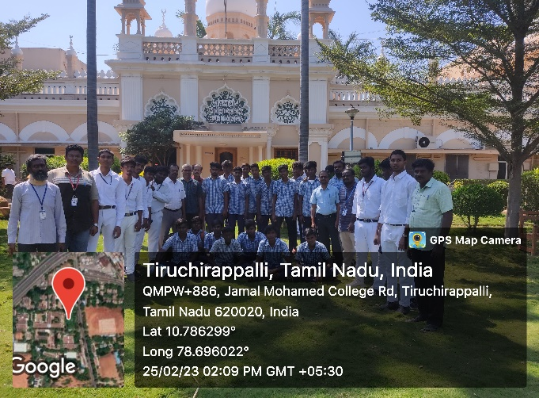 | 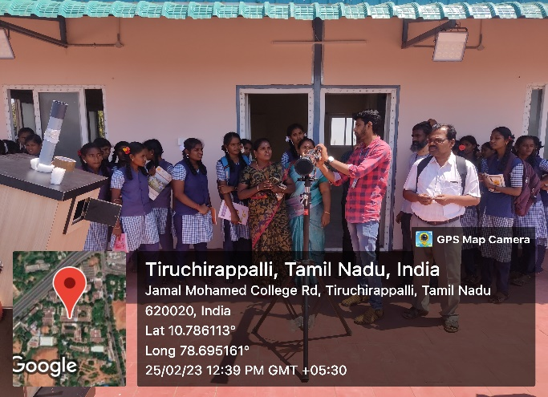

District Level Neighborhood Youth Parliament

On the date of 25/02/2023, District Level Neighborhood Youth parliament was conducted by Nehru Yuva Kendra and Bharathidasan University at Cauvery College for Women, Trichy. There a seminar was conducted about Youth Empowerment for all the college NSS students of Trichy. After the seminar the refreshment was given and the program ended with a beautiful cultural dances. The program was completed in a good manner with the instruction of NSS Leaders and Program officers.
Number of NSS Volunteers Participated: 40 Date: 25/02/2023

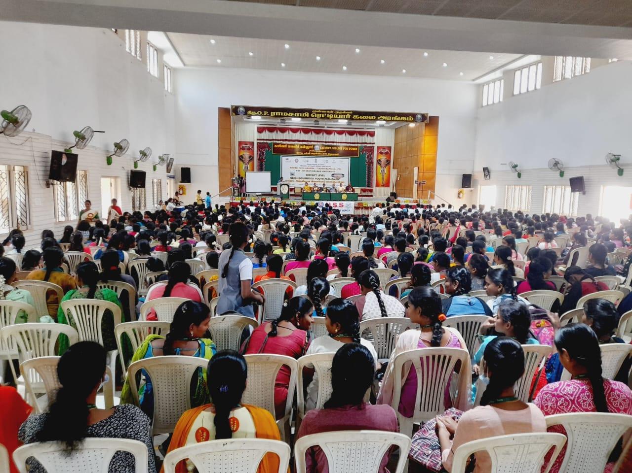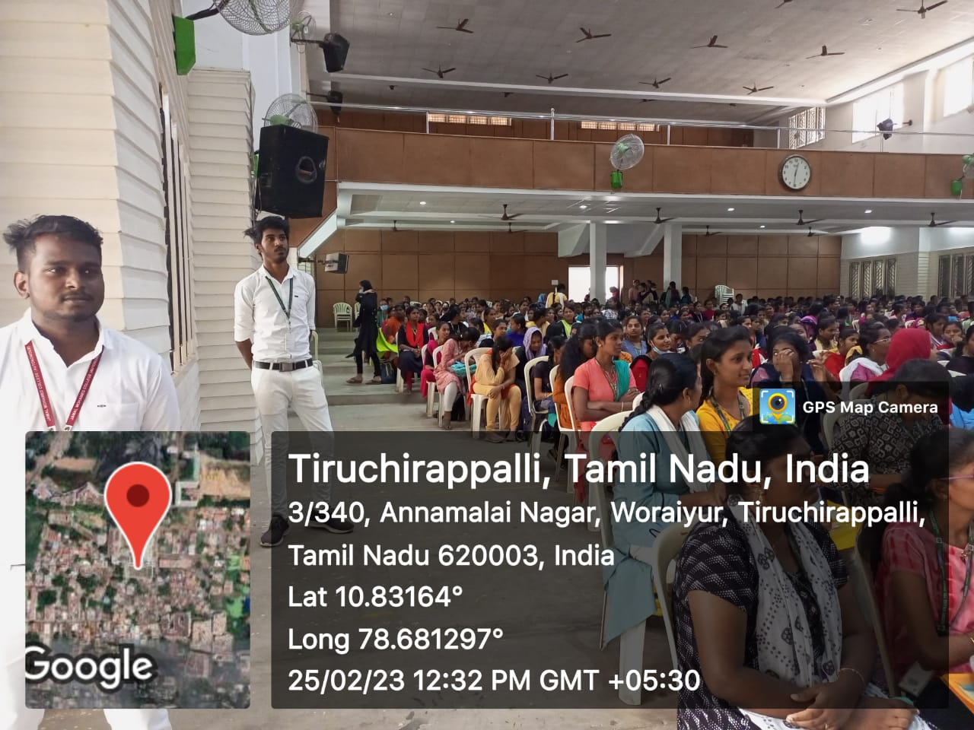

Naan Mudhalvan Program

On the Date of 27/02/2023, Naan Mudhalvan Program was organized by National Service Scheme of Jamal Mohamed College. In this Program, Our College Principal, Secretary and Treasurer gave their valuable speech to the Government School Students about importance of Higher Education. Lot of Dignitaries from different Schools Joined with them. After refreshments our NSS Volunteers showed them our college campus. After this Our Volunteers Provided lunch for the School Students. The Program was done in a good manner with the instruction of NSS Leaders and Program Officers.
Number of NSS Volunteers Participated: 40 Date: 27/02/2023
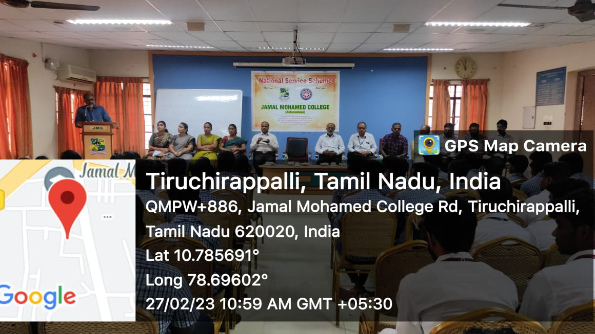 | 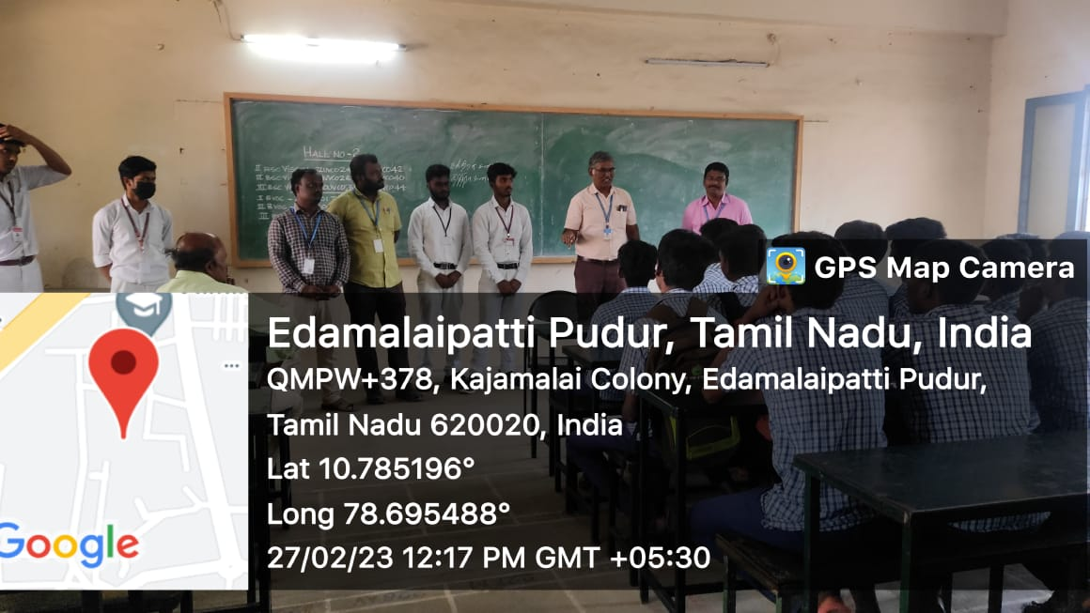
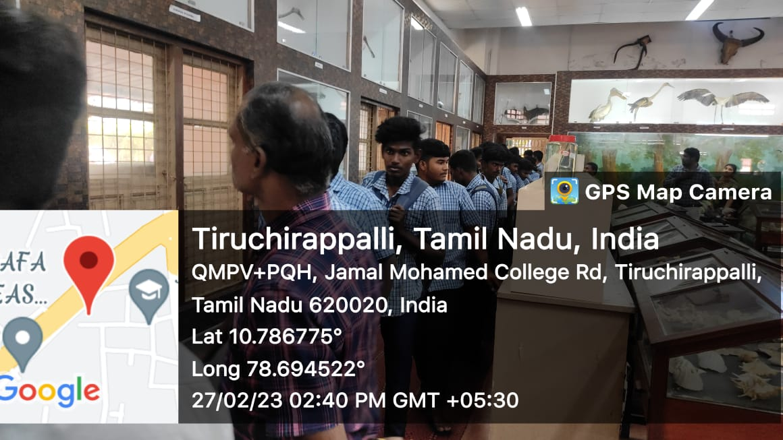 | 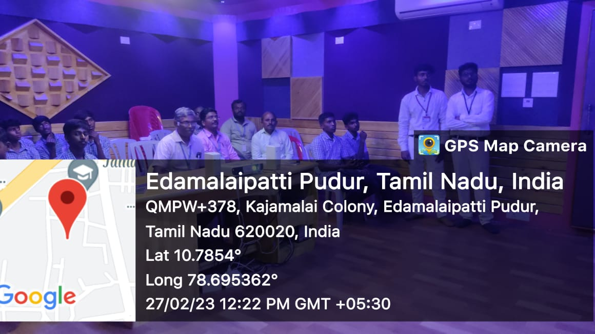

Placement Cell Program

On the Date of 28/02/2023, Placement Interview was conducted by Placement Cell of Jamal Mohamed College. Vijay Group of Institutions conducted the campus interview for Final Year UG and PG Students in our college. They recruited the candidates according to their qualifications and English fluency. Our NSS volunteers organized the program and completed it in a Good manner.
Number of NSS Volunteers Participated: 14 Date: 28/02/2023
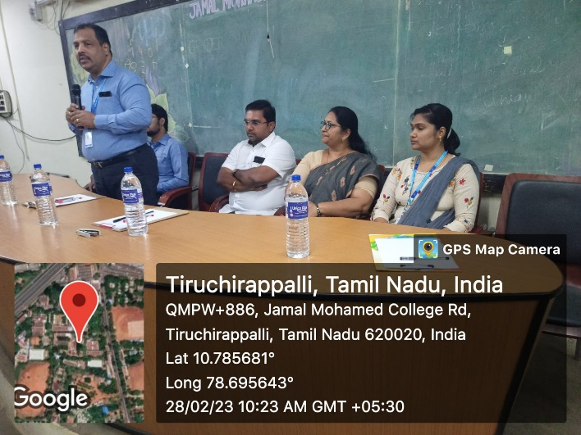 | 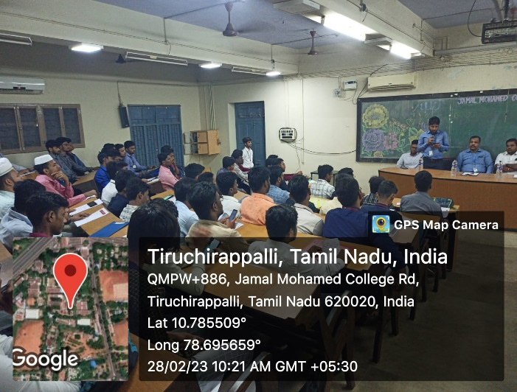
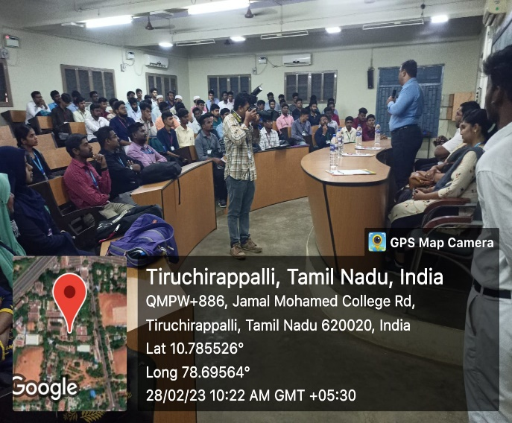 | 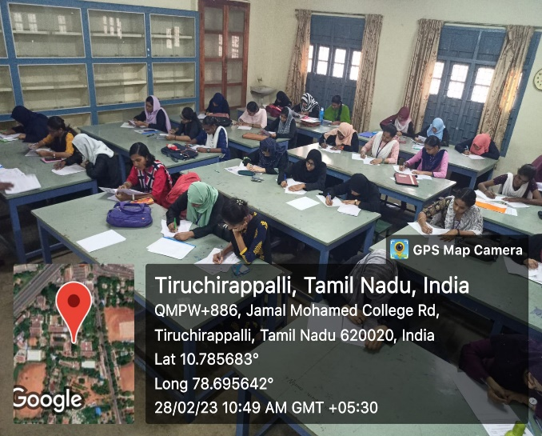

Placement Cell Program

On the Date of 03/03/2023, Placement Interview was conducted by Placement Cell of Jamal Mohamed College. VR Della conducted the campus interview for Final Year UG and PG Students in our college. They recruited the candidates according to their qualifications. Our NSS volunteers organized the program and completed it in a Good manner.
Number of NSS Volunteers Participated: 12 Date: 03/03/2023
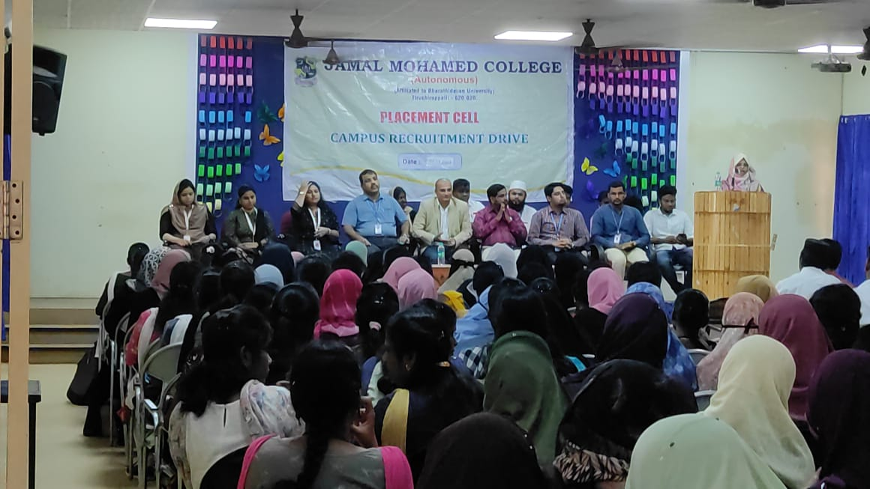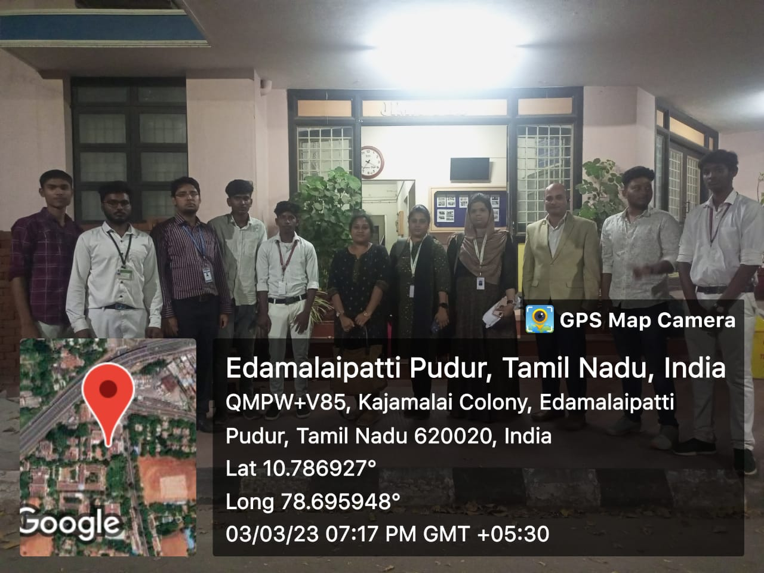

Placement Cell Program

On the Date of 06/03/2023, Placement Interview was conducted by Placement Cell of Jamal Mohamed College. Verve Manque Global Airport Services, Bangalore conducted the campus interview for Final Year UG and PG Students in our college. They recruited the candidates according to their qualifications. Our NSS volunteers organized the program and completed it in a Good manner.
Number of NSS Volunteers Participated: 12 Date: 06/03/2023

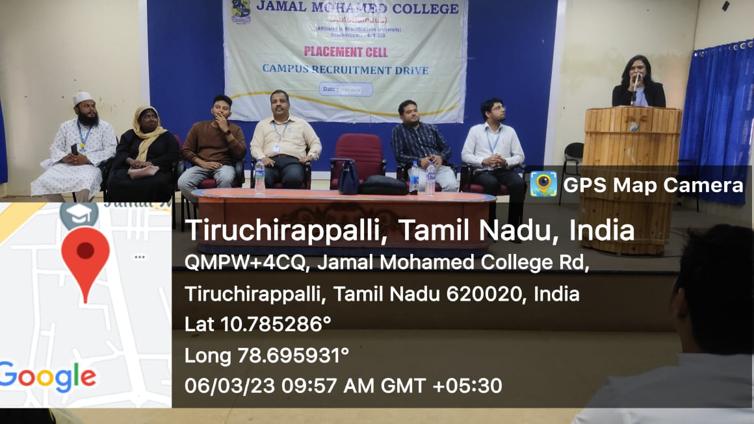
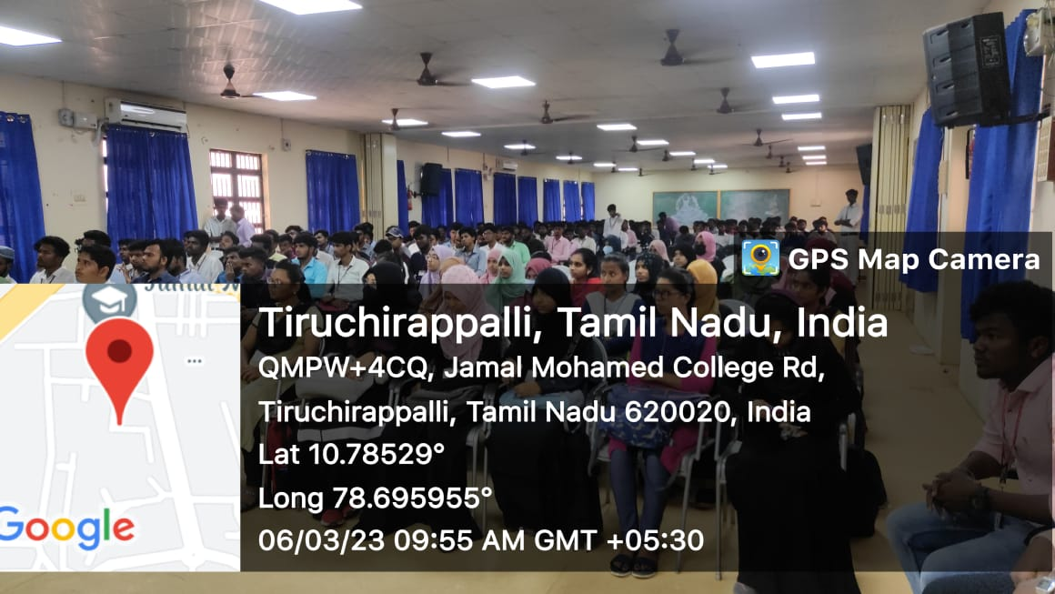

Meeladhu Vizha

On the Date of 07/03/2023, Meeladhu Vizha was organized by National Service Scheme of Jamal Mohamed College in NBAG Auditorium. Before this Program, Our NSS Volunteers distributed Sweets to Students and Staffs of All Departments. In this Program, Our Principal, Secretary and Correspondent, Joint Secretary, Treasurer and Vice Principal felicitated the program. Dr. K. Abdul Samad (Chief Guest) Delivered the Special Address and Distributed Prizes to the Winners of Moral Education and Deeniyath Education Exam. Our NSS Volunteers Provided refreshment to the Faculty Members. The Program was completed in a good manner.
Number of NSS Volunteers Participated: 30 Date: 07/03/2023
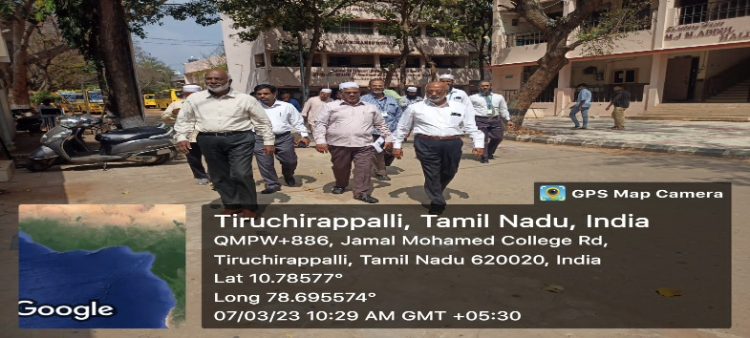 | 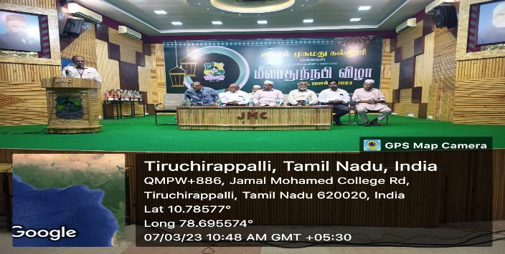

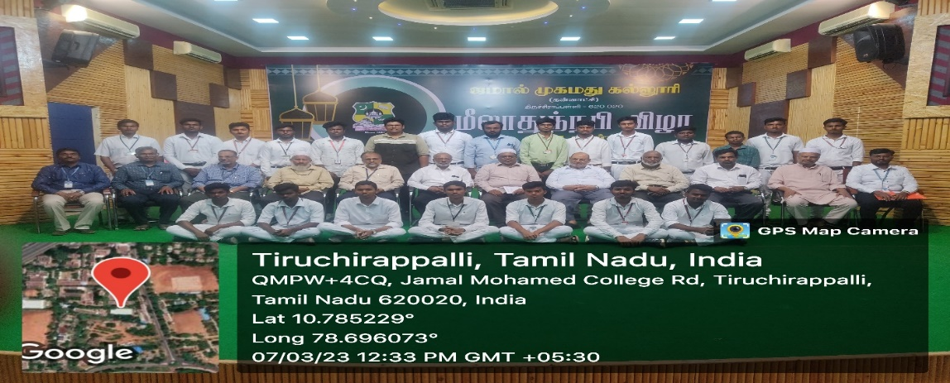

Women’s Day Celebration at BDU

On the Date of 10/03/2023, Women’s Day Celebration was organized by NSS Cell of Bharathidasan University at Convocation Hall. In this program, Dr. M. Selvam, Vice Chancellor of BDU and Dr. A. Lakshmi Prabha, NSS Coordinator of BDU felicitated the Program. Special Address was given by Dr. K. Tamilisai Soundararajan, Governor of Telangana about Women’s Empowerment.
Our NSS Volunteers arranged the lunch for the participants and did their work in a best manner.

Number of NSS Volunteers Participated: 50 Date: 10/03/2023

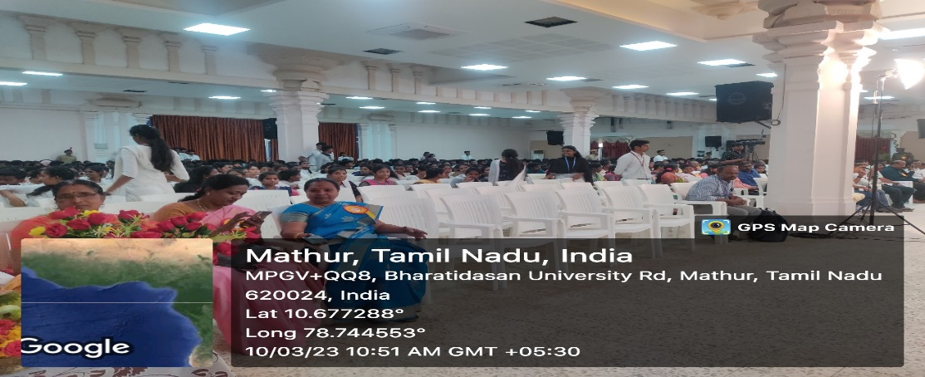
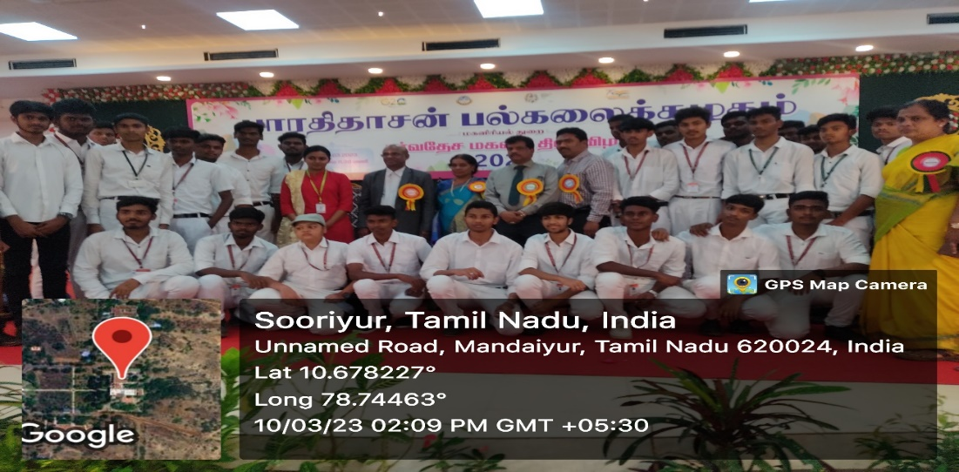
Cleaning Program at BDU

On the Date of 10/03/2023, Cleaning Program was done by our Volunteers at Bharathidasan University. In this Program, Our NSS Volunteers cleaned the NSS and RRC Store Room and arranged the things in a good manner. The Program was completed in a best way.

Number of NSS Volunteers Participated: 10 Date: 10/03/2023

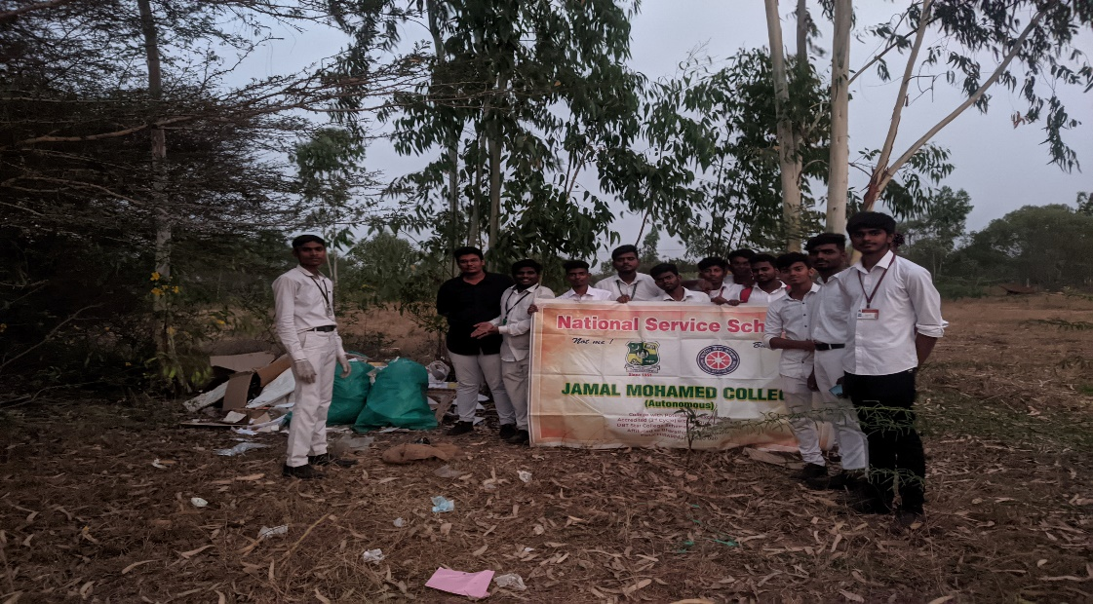
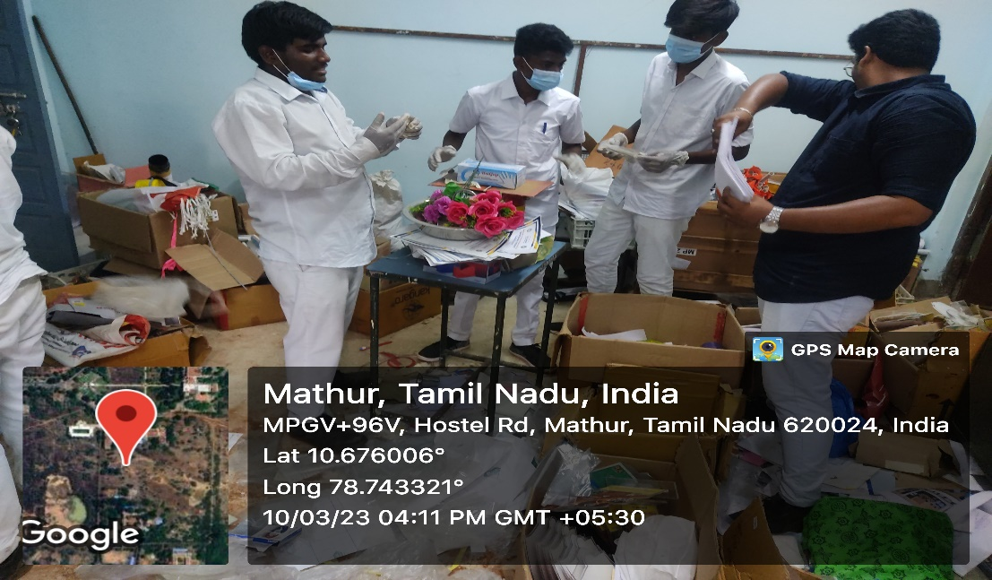

International Women’s Day at JEH

On the Date of 14/03/2023, International Women’s Day program was organized by Joseph Eye Hospital and NSS Cell of Bharathidasan University. In this Program, NSS Coordinator of Bharathidasan University Dr. A. Lakshmi Prabha and Deputy Director of Joseph Eye Hospital Dr. Prathiba felicitated the program. Dr. Lakshmi Prabha distributed best women award to 33 highly valued women on behalf of International Women’s Day. Our Volunteers participated in this program and done their work neatly.

Number of NSS Volunteers Participated: 30 Date: 14/03/2023
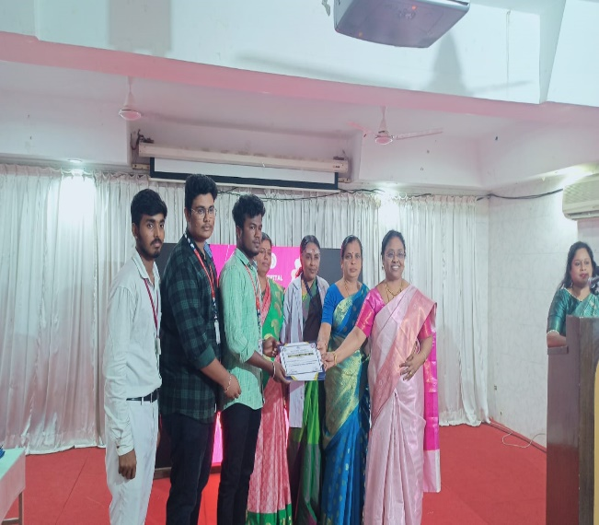 | 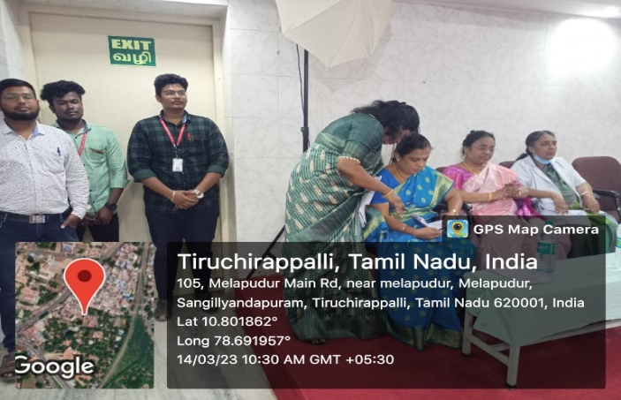
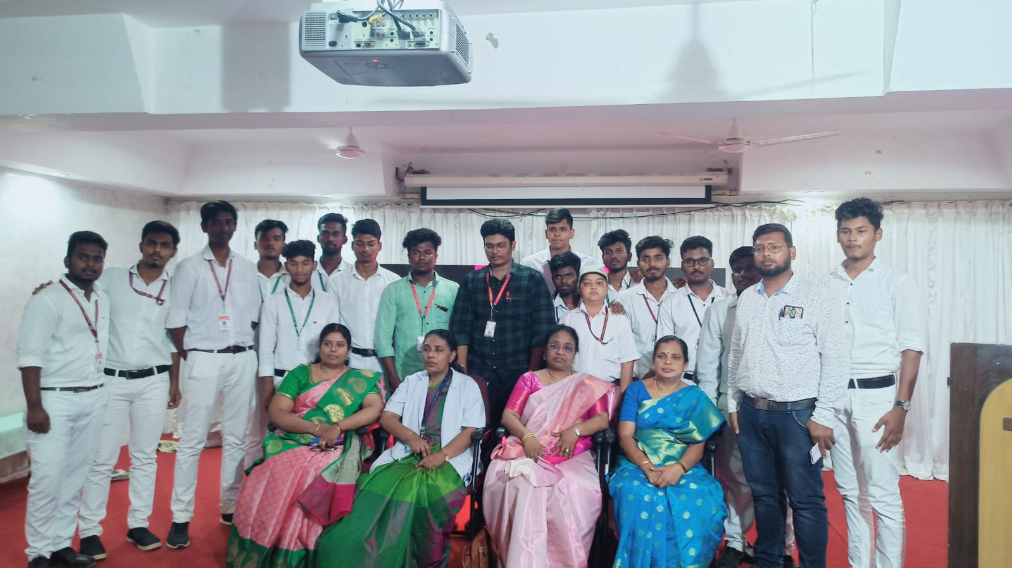
Pannattu Karutharangam

On the Date of 14/03/2023, Pannattu Karutharangam was organized by Tamil Department of Jamal Mohamed College in NBAG Auditorium. In this Program, Our NSS Volunteers neatly arranged the stage and reception. Our Prinicipal and Secretary were felicitated the program. Municipal Administration Minister Thiru K.N. Nehru and Minister for Minority Welfare and Non Resident Tamils Welfare Thiru Gingee K.S. Masthan were attended the program and gave special address. After this, Our NSS volunteers provided refreshment to the Faculty Members. The Program was completed in a good manner.

Number of NSS Volunteers Participated: 30 Date: 14/03/2023

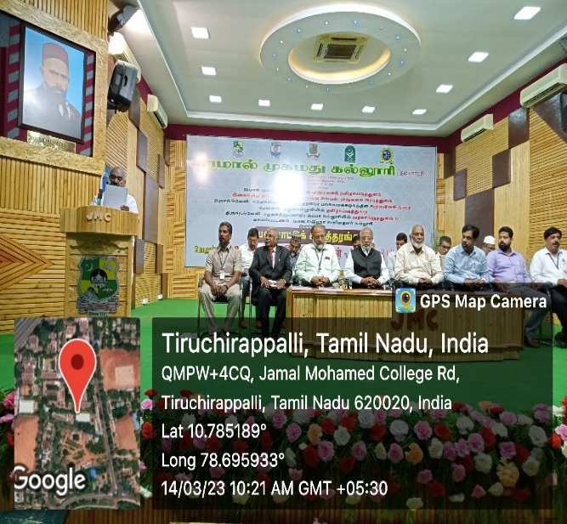 | 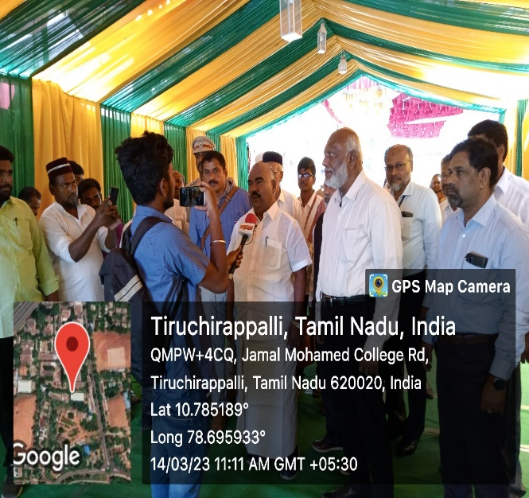

College Day Celebration

On the Date of 15/03/2023, College Day was celebrated in Jamal Mohamed College and our NSS Volunteers organized the program. In this Program, Our Principal presented the Annual Report of our college. Secretary and Correspondent, Joint Secretary, Treasurer and Vice Principal felicitated the program. Dr. A. Ramachandran, Anna University, Chennai (Chief Guest) delivered the Special Address and Distributed Prizes to the alumni University Rank Holders. Fine Arts team of our college performed their cultural talents in front of the dignitaries. The Program was completed in a good manner.

Number of NSS Volunteers Participated: 30 Date: 15/03/2023

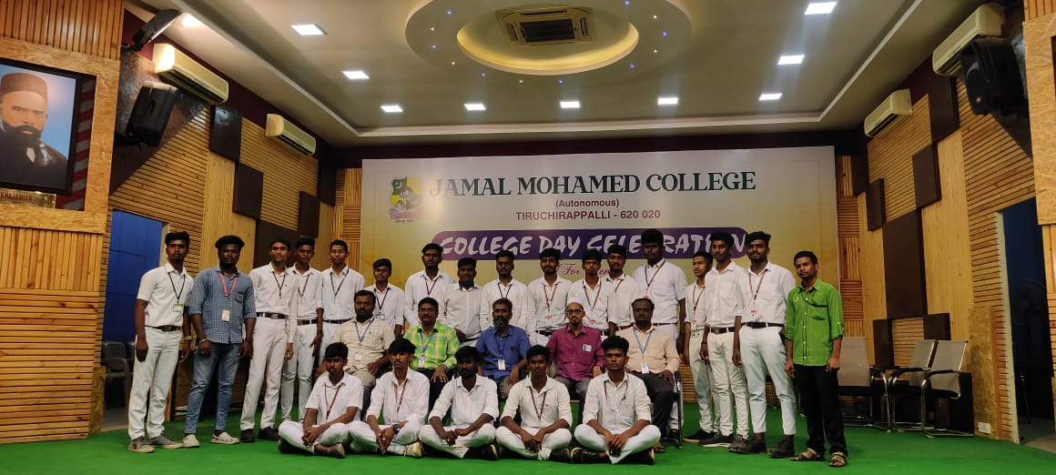 | 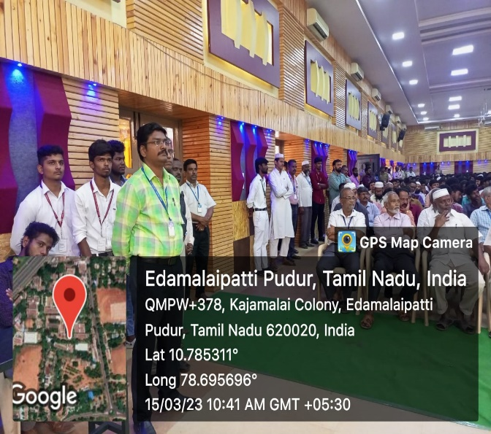

Placement Cell Program

On the Date of 15/03/2023, Placement Cell Program was conducted by Placement Cell of Jamal Mohamed College. Tata Consultancy Services (TCS) conducted the campus interview for Final Year UG and PG Students of all colleges. More than 1000 candidates were attended the campus interview. They recruited the candidates according to their qualifications. Our NSS volunteers organized the program and completed it in a Good manner.

Number of NSS Volunteers Participated: 12 Date: 15/03/2023

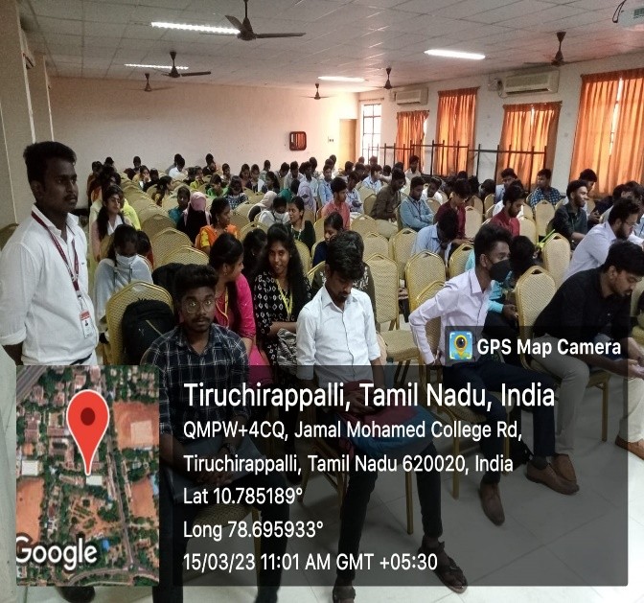 | 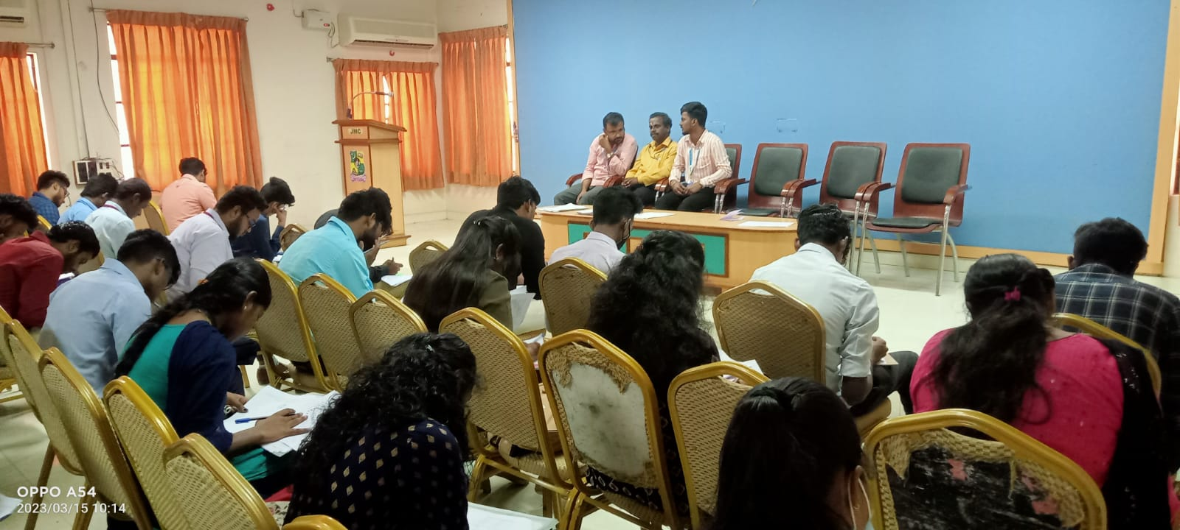

Maperum Tamil Kanavu at BDU

On the Date of 16/03/2023, Maperum Tamil Kanavu was organized by NSS Cell of Bharathidasan University and Tamil Department of BDU at Convocation Hall. In this program, Dr. M. Selvam, Vice Chancellor of BDU felicitated the Program. Special Address was given by District Collector Mr. Pradeep Kumar and MLA (Trichy East) Inigo Iruthayaraj. Our NSS Volunteers arranged the lunch for the participants and did their work in a best manner.

Number of NSS Volunteers Participated: 50 Date: 16/03/2023

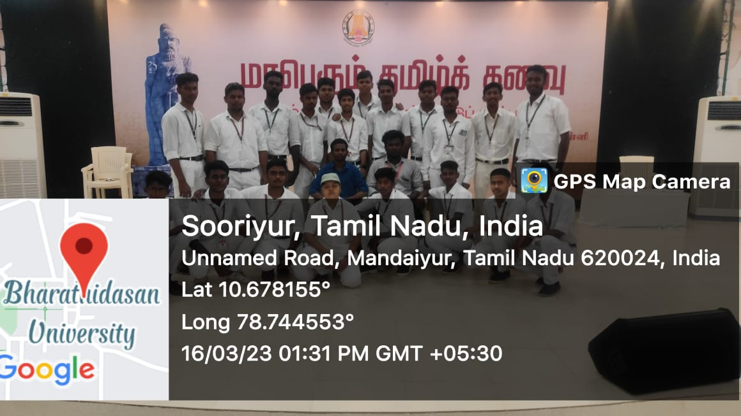

Masjid Cleaning Program

On the Date of 16/03/2023, Masjid Cleaning Program was organized by NSS Cell of Jamal Mohamed College. In this program, Our NSS Volunteers Cleaned our College Masjid on behalf Ramadan Month. Our Volunteers cleaned the surroundings in a good manner with the respective tools. After Refreshments, the program was completed in a best way.

Number of NSS Volunteers Participated: 30 Date: 16/03/2023

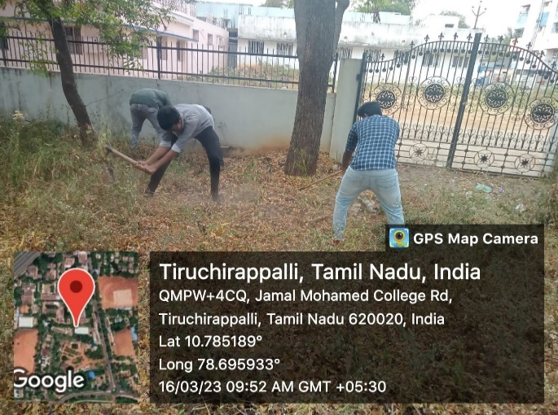 | 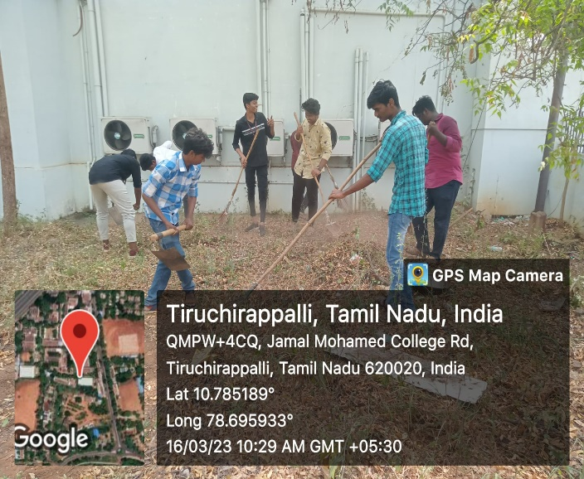
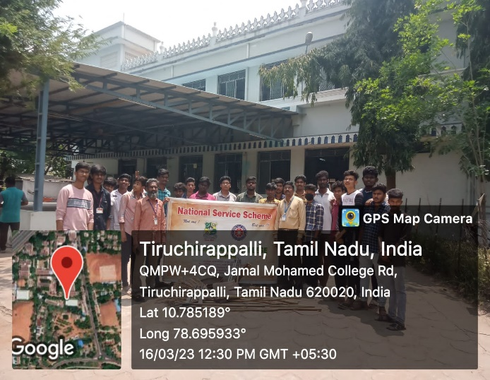 | 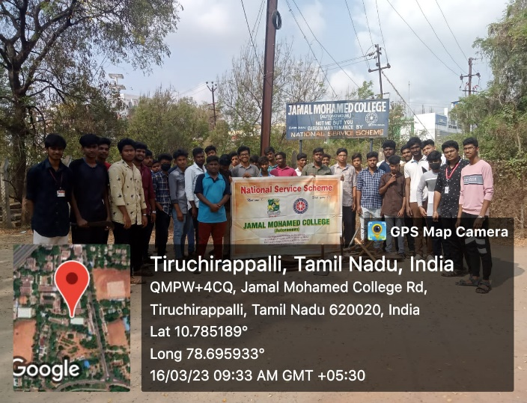

Food Distribution Program

On the Date of 17/03/2023, Food Distribution Program was organized by NSS Cell of Jamal Mohamed College. In this program, Our NSS Volunteers distributed Food Parcels to people those who needed it. The program was completed in a best way.

Number of NSS Volunteers Participated: 03 Date: 17/03/2023
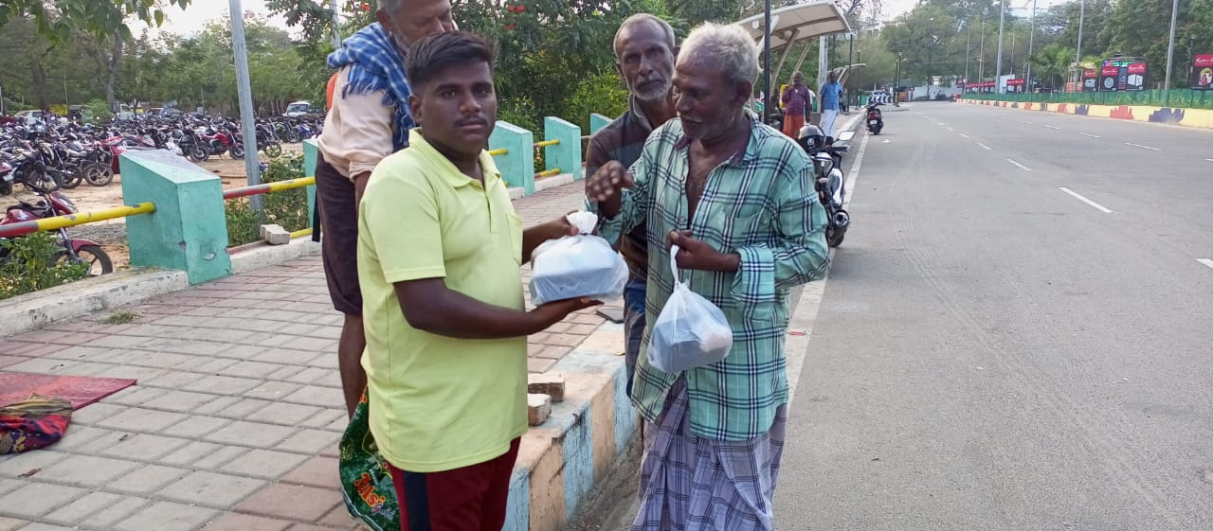 | 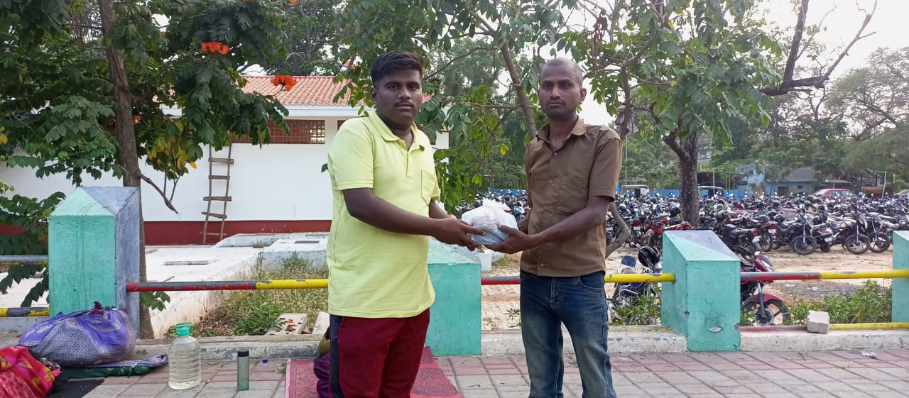
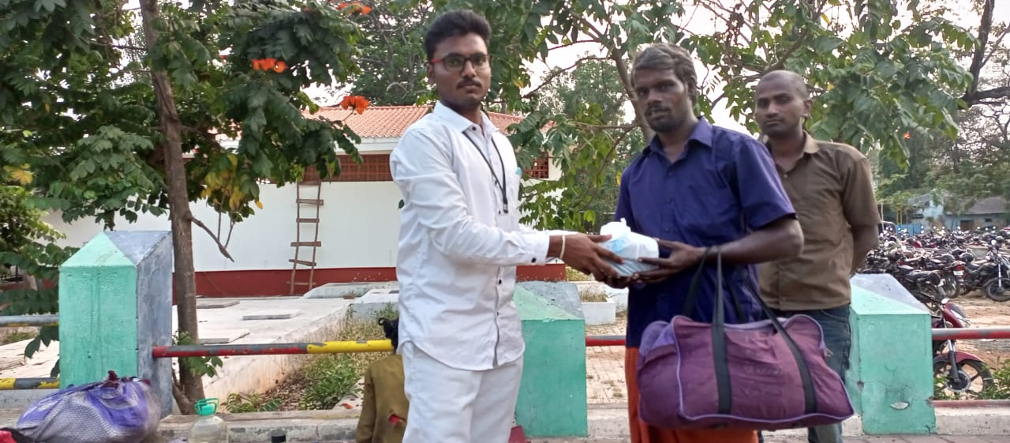 | 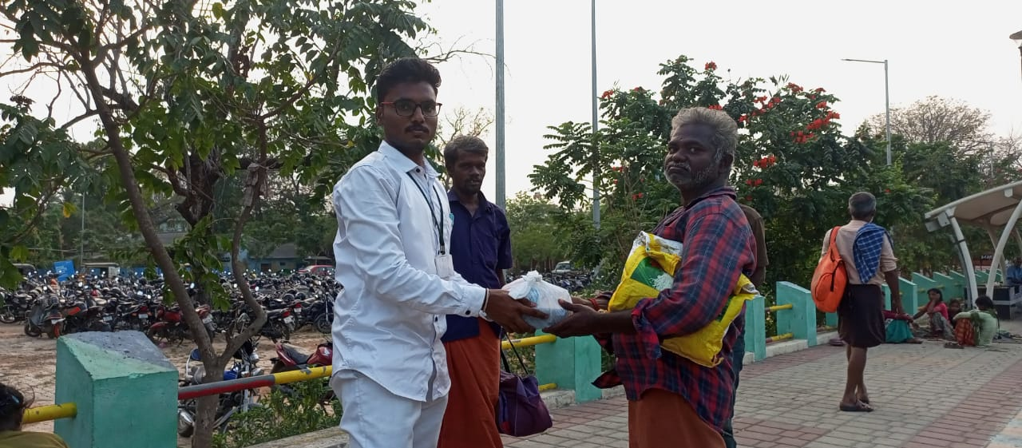
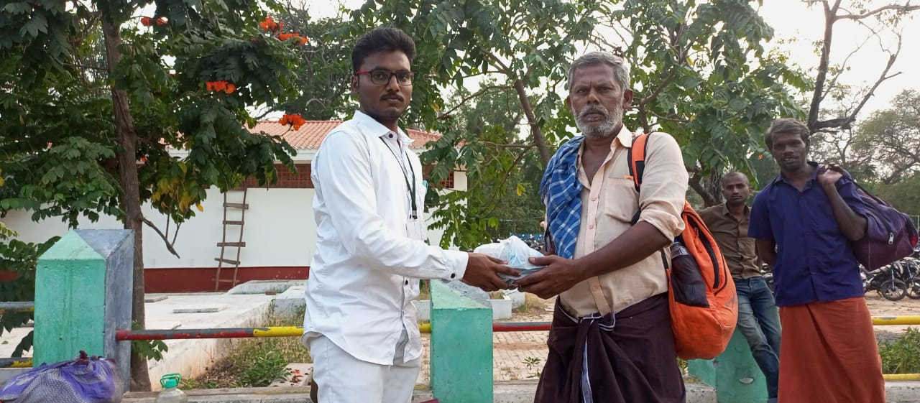 | 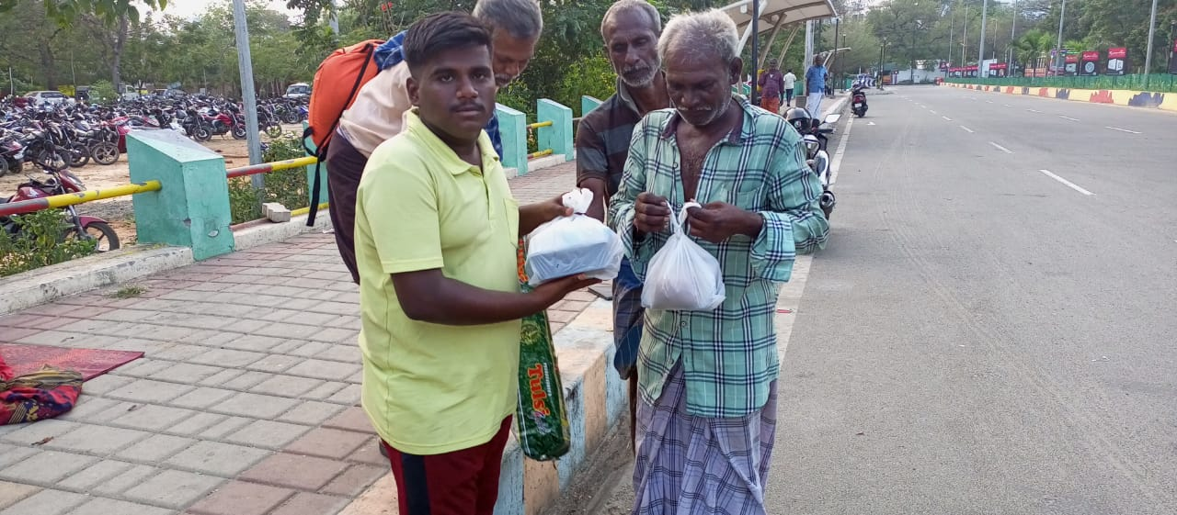
Social Service Rally

On the Date of 20/03/2023, Social Service Rally was organized by Syndicate Members in Bharathidasan University Khajamalai Campus. This rally covers nearly 4-5km. but due to unexpected rain the rally was finished shortly. In this rally, Our NSS Volunteers Participated and did their duty in a good manner with the instruction of NSS Program Officers.

Number of NSS Volunteers Participated: 30 Date: 20/03/2023

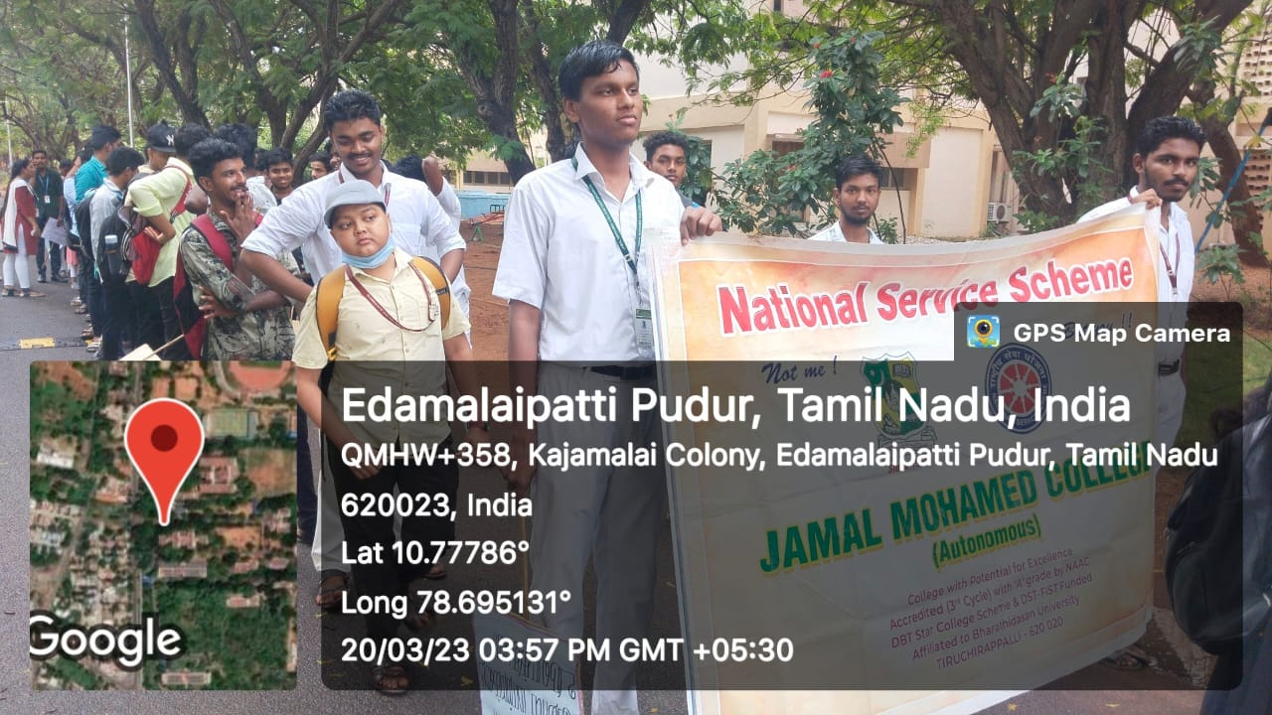
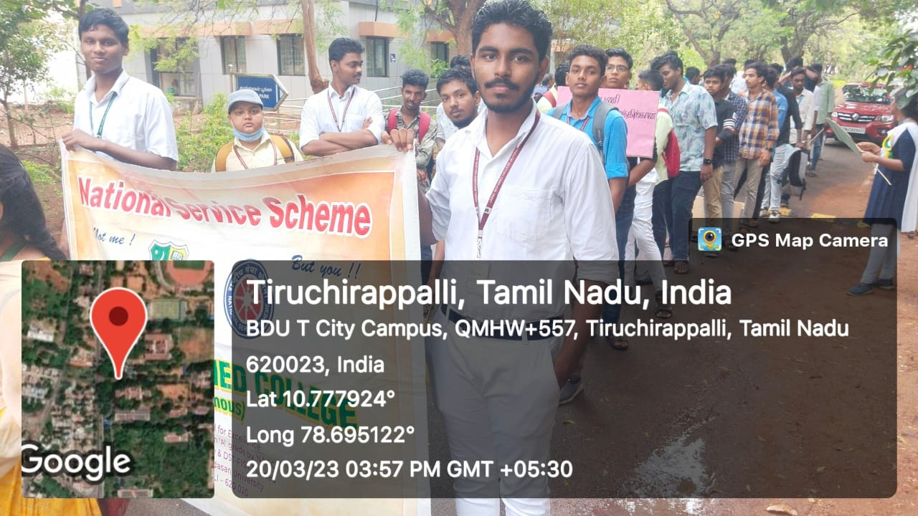

Chamfest 2023

On the Date of 21/03/2023, Chamfest was organized by NSS Cell of St. Joseph’s College. It was a state level inter collegiate competition. Our NSS Volunteers Bagged 5 prices in the events like Quiz, Documentary, Marching Band, Debate and Street play. And also we lifted the overall runner up trophy. The program was completed in a good manner with the instruction of NSS Seniors.

Number of NSS Volunteers Participated: 25 Date: 21/03/2023

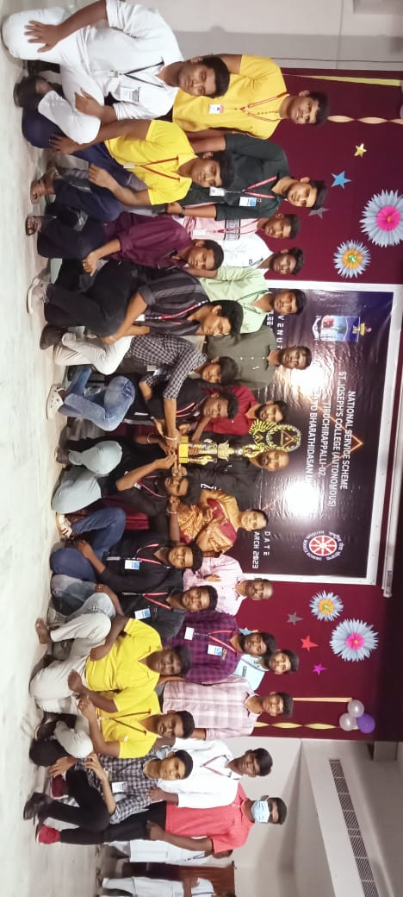

Yuva Samvad

On the Date of 23/03/2023, Yuva Samvad Program was organized by NSS Cell of Bharathidasan University at Srimad Andavan Arts & College, Trichy. In this program, the participants had to express their visions and dreams about the given topics in front of judges. Youth’s Dialogue on behalf of Nation’s growth is the overall theme. 5 of our NSS Volunteers participated and gave their pleasant speech in front of the Judges. At last, the program was completed and attained a great success.

Number of NSS Volunteers Participated: 10 Date: 23/03/2023

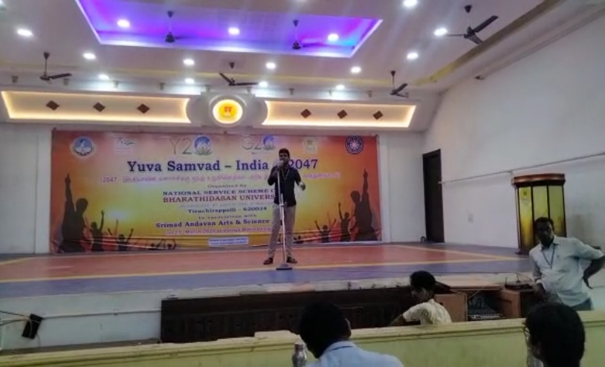 | 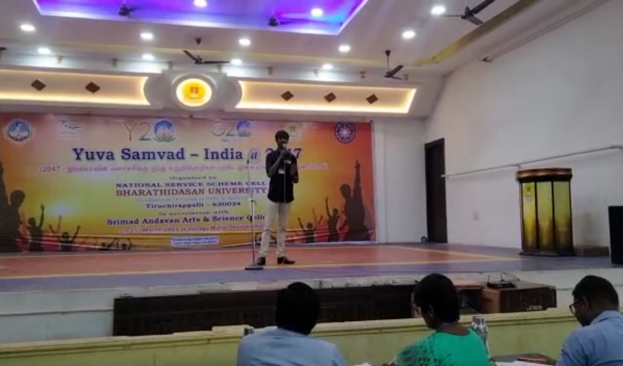

University Award Presentation Ceremony

On the Date of 27/03/2023, University Award Presentation Ceremony was organized by NSS Cell of Bharathidasan University. In this program, University Level NSS Awards for the Year 2019-20, 2020-21, 2021-22 was distributed to the winners. Dr. M. Selvam, Vice Chancellor of Bharathidasan University, Dr. C. Samuel Chelliah, NSS Regional Directorate and Dr. Senthil Kumar, State NSS Officer came there and delivered their special address and distributed awards to the winners. Our College got the best NSS Unit award for the year 2021-2022. 3 of our Program Officers got best PO award and 7 of our Volunteers got the best volunteer award. Our Volunteers helped in organizing the program by doing stage arrangements, awardees entry and Lunch arrangement. The program was completed in a good manner.

Number of NSS Volunteers Participated: 50 Date: 27/03/2023

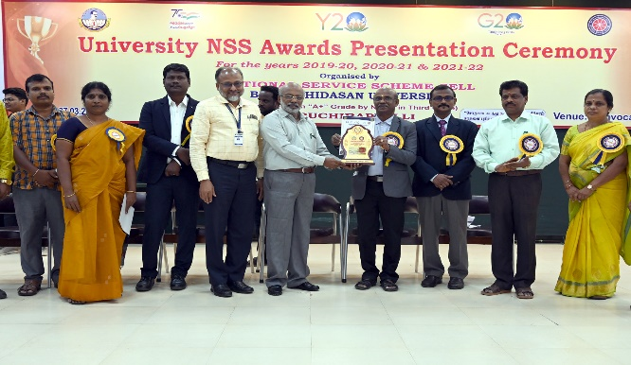 | 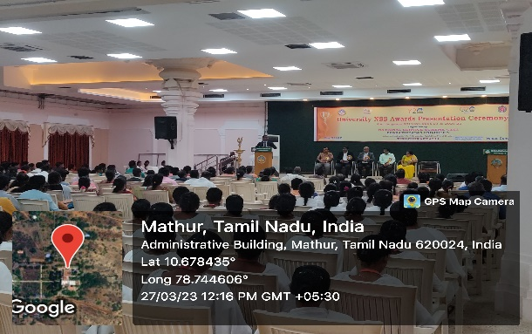
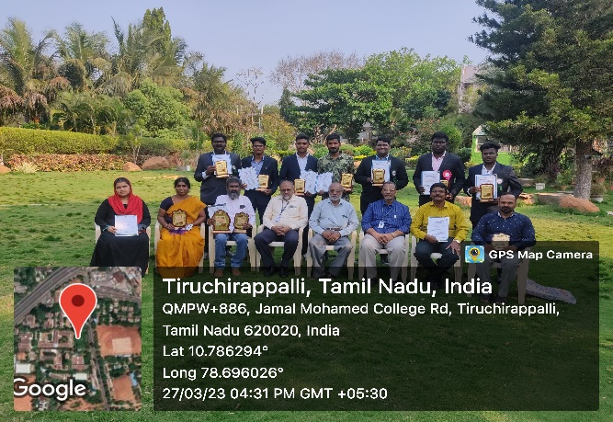 | 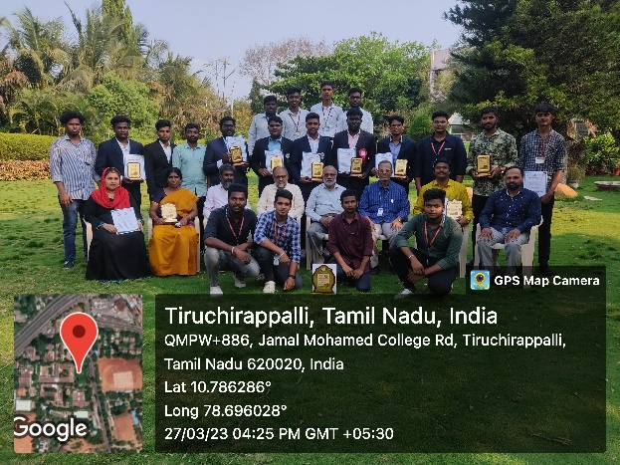

Naan Muthalvan Program at BDU

On the Date of 28/03/2023, 29/03/2023, Naan Muthalvan Program was organized by NSS Cell of Bharathidasan University. In this program, NSS Program Officers from different colleges participated in the program. The theme of this program was ‘To Create Awareness about Higher Studies among the passed out school students’. Dr. M. Selvam, Vice Chancellor of BDU, Dr. M. Senthil Kumar, State NSS Officer and some dignitaries from school education Department addressed the program. Our NSS Volunteers organized the program and provided breakfast and lunch for the paticipants. The program was completed in a good manner.

Number of NSS Volunteers Participated: 15 Date: 29/03/2023

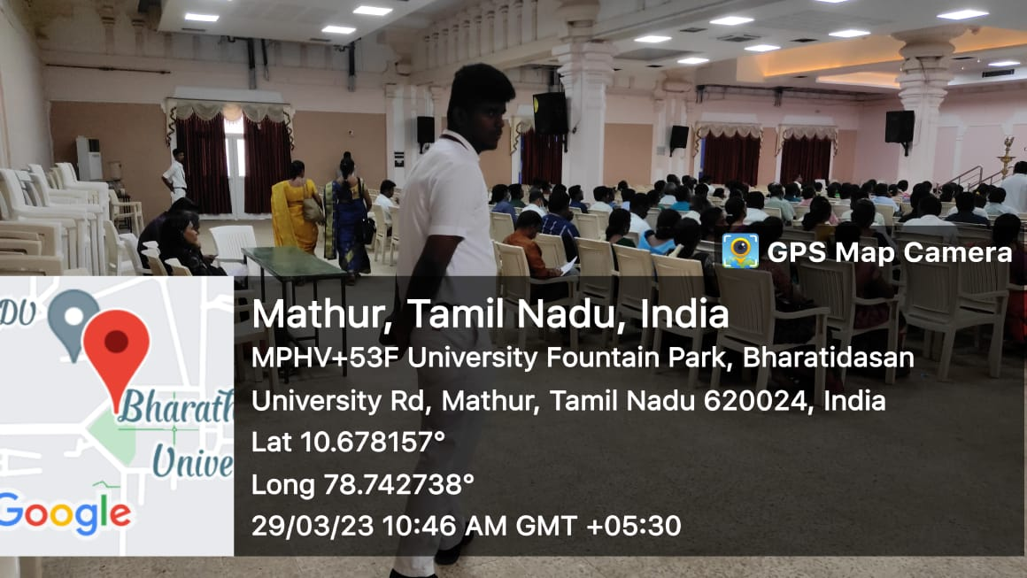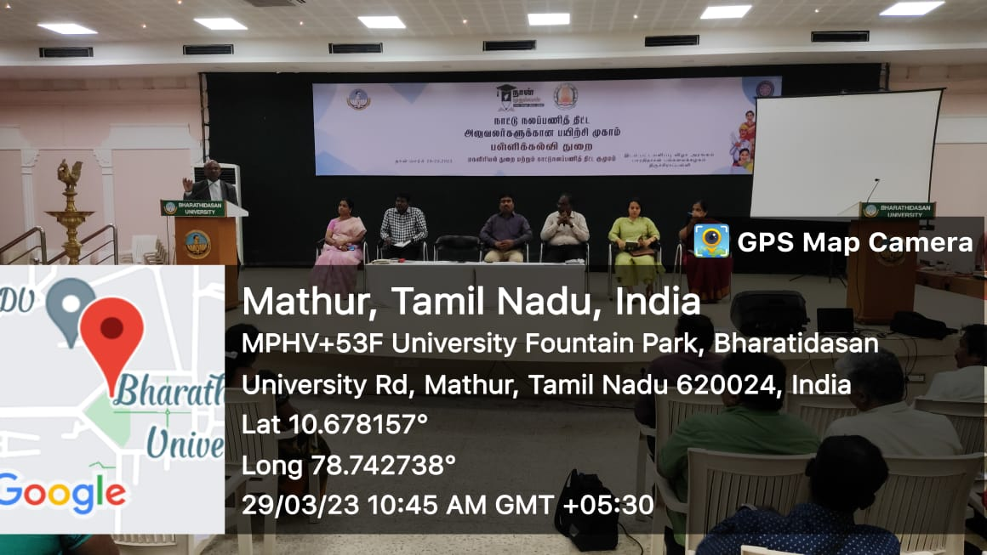

NSS Valedictory Function

On the Date of 31/03/2023, NSS Valedictory Function was organized in NM Khajamian Auditorium of Jamal Mohamed College. In this program, Our Former NSS Program Officer Dr. M. Anwar Sathiq gave special address and shared his thoughts and experiences gained when he was a NSS Program Officer and also tells about the Oppurtunities available in National Service Scheme. And also The SEVAI Book was released by our chief guest. The book contains the Activities and Achievements we did this year and also PPT Video was presented. Later, He Distributed Momento to the Program Officers, Volunteer Secretaries and Executive Members for their dedicated service and excellent work done during these years. After all these, Our Volunteers Performed Cultural Dances and enjoyed a lot. The program was completed in a good manner.

Number of NSS Volunteers Participated: 120 Date: 31/03/2023

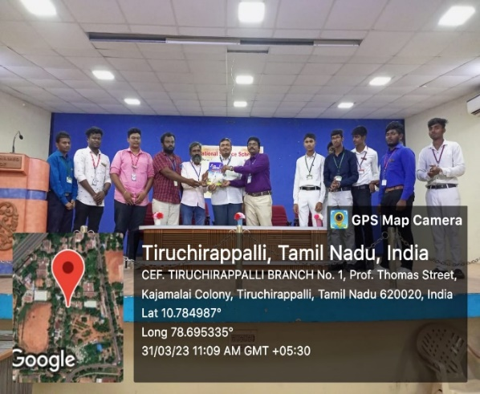 | 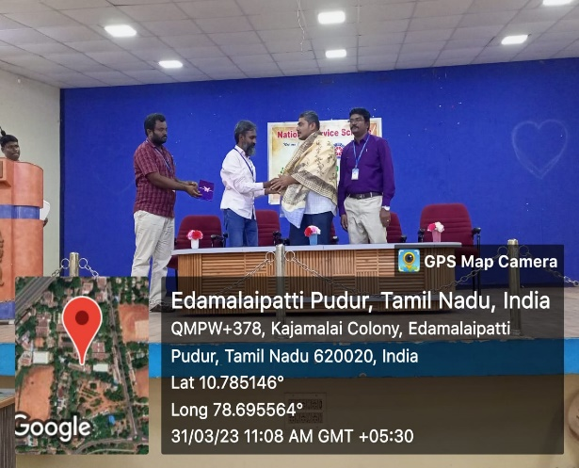
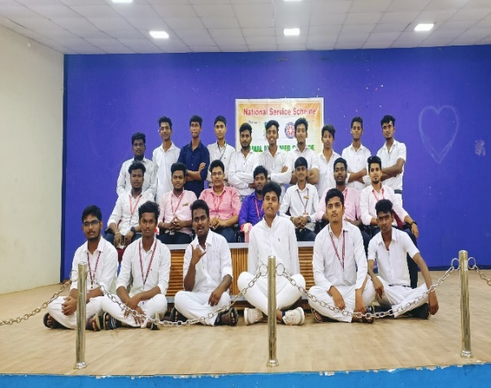 | 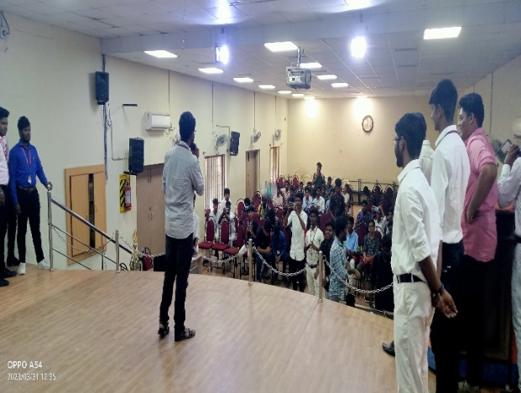

Juice Distribution Program

On the Date of 31/03/2023, Juice Distribution Program was organized by NSS Cell of Jamal Mohamed College. In this program, Our NSS Volunteers distributed Juices to the Traffic Police, Street Vendors, Bus Drivers and Conductors etc., The program was completed in a best way.

Number of NSS Volunteers Participated: 03 Date: 31/03/2023

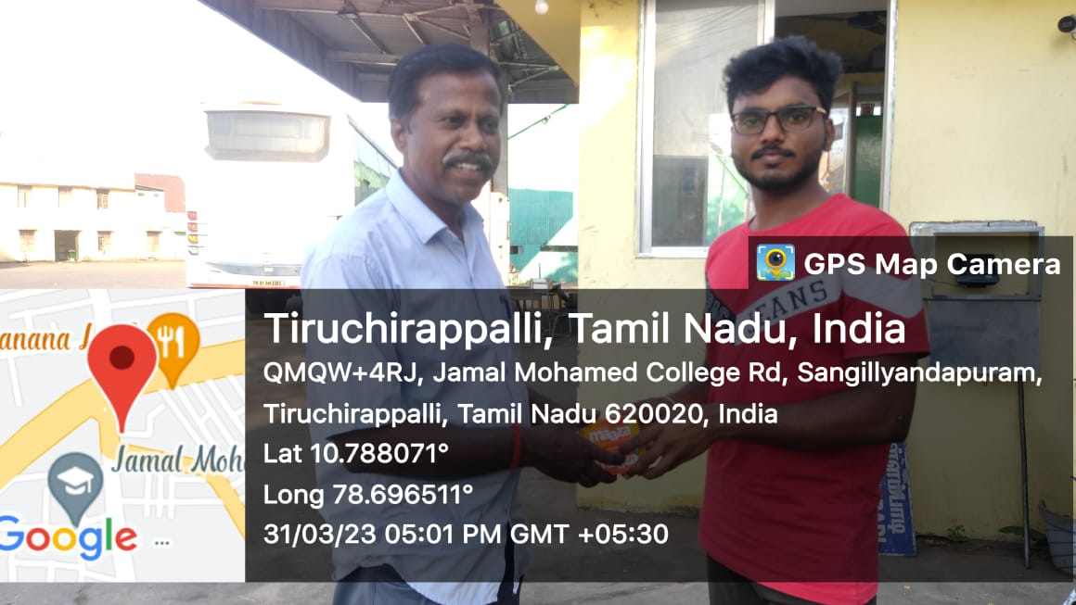 | 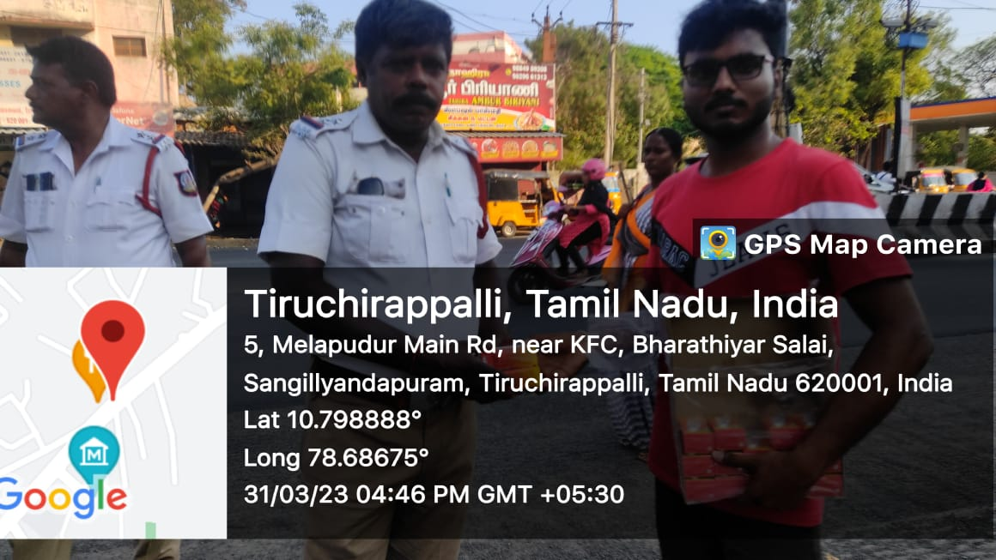
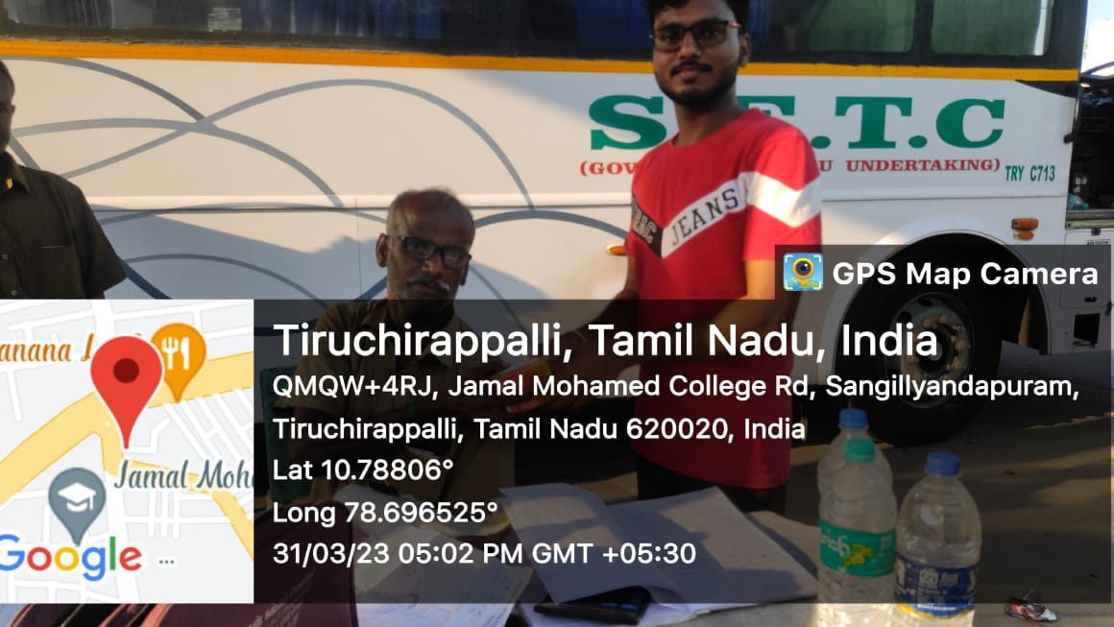 | 